Contents

1 Introduction 9

2 Overview 9

3 Data files specifications 10

4 Data model 11

Primary keys 11

Foreign keys 11

Data types 11

Char(size) 11

Number(precision,scale) 11

Number(precision) 12

Number 12

Boolean 12

Date 12

DateTime 12

Diagram symbols 12

Stereotype 12

Cardinality 13

Composite aggregation 13

Shared aggregation 14

Nested aggregation 14

4.1 SmartOrg 15

4.1.2 CustomSelection 15

4.1.2.1 CustomSelection – (Full) 16

4.1.2.2 CustomSelectionElement – (Full) 17

4.1.4 Employee 17

4.1.4.1 Employee – (Delta) 18

4.1.4.2 EmployeeUDF – (Delta) 19

4.1.4.3 EmployeeMetrics – (Delta) 19

4.1.4.4 DelegatedEmployee – (Delta) 20

4.1.4.5 MatrixManager – (Delta) 20

4.1.5 Foundation 21

4.1.5.1 BusinessOrganization – (Full) 22

4.1.5.2 Department – (Delta) 22

4.1.5.3 JobField – (Full) 23

4.1.5.4 Group – (Full) 23

4.1.5.5 Location – (Full) 24

4.1.5.6 Organization – (Full) 25

4.1.5.7 User – (Delta) 25

4.1.5.8 UserType – (Fiull) 27

4.1.5.9 User_Groups – (Delta) 27

4.1.5.10 User_Types – (Delta) 27

4.1.6 Lookup 27

4.1.6.1 AccountStatus – (Full) 27

4.1.6.2 AdminEntityStatus – (Full) 28

4.1.6.3 Certification – (Delta) 28

4.1.6.4 CieEmployer – (Delta) 28

4.1.6.5 CieInstitution – (Delta) 29

4.1.6.6 CieProgram – (Delta) 29

4.1.6.7 CompetencyCategory – (Full) – EMPTY 29

4.1.6.8 CompetencyGroup – (Full) – EMPTY 30

4.1.6.9 CompetencyProvider – (Full) 30

4.1.6.10 CompetencyType – (Full) 31

4.1.6.11 ConfigProfile – (Full) 31

4.1.6.12 ConfigurableMetric – (Full) 31

4.1.6.13 Currency – (Full) 32

4.1.6.14 EmployeePotential – (Full) 32

4.1.6.15 EmployeeRiskOfLoss – (Full) 33

4.1.6.16 EmployeeStatus – (Full) 33

4.1.6.17 EmploymentStatus – (Full) 33

4.1.6.18 Industry – (Full) 33

4.1.6.19 InfoFeeder – (Full) 34

4.1.6.20 InterestIntlAssignment – (Full) 34

4.1.6.21 JobLevel – (Full) 34

4.1.6.22 JobSchedule – (Full) 35

4.1.6.23 JobShift – (Full) 35

4.1.6.24 JobType – (Full) 35

4.1.6.25 Language – (Full) 36

4.1.6.26 NetworkJobField – (Full) 36

4.1.6.27 NetworkLocation – (Delta) 37

4.1.6.28 Origin – (Full) 37

4.1.6.29 PhoneType – (Full) 38

4.1.6.30 ProfileImportance – (Full) 38

4.1.6.31 ProgramType – (Full) 38

4.1.6.32 RaterType – (Full) 38

4.1.6.33 RatingDimensionType – (Full) 39

4.1.6.34 Reassignment – (Full) 39

4.1.6.35 StudyLevel – (Full) 39

4.1.6.36 TaleoTimeZone – (Full) 40

4.1.6.37 TypeOfInstitution – (Full) 40

4.1.6.38 WillingnessToTravel – (Full) 40

4.1.6.39 WillRelocate – (Full) 41

4.1.9 Talent User 41

4.1.9.1 TalentCompetency – (Delta) 42

4.1.9.2 TalentCompetencyValue – (Delta) 43

4.1.9.3 TalentUser – (Delta) 43

4.1.9.4 TalentUser_EmploymentStatuses – (Delta) 44

4.1.9.5 TalentUser_JobLevels – (Delta) 44

4.1.9.6 TalentUser_JobSchedules – (Delta) 44

4.1.9.7 TalentUser_JobTypes – (Delta) 45

4.1.9.8 TalentUser_Locations – (Delta) 45

4.1.9.9 TalentUser_Organizations – (Delta) 45

4.1.9.10 TalentUser_ StudyLevels – (Delta) 45

4.2 recruiting 46

4.2.1 Approval 46

4.2.1.1 Approval – (Delta) 46

4.2.1.2 ApprovalContext – (Delta) 47

4.2.2 Candidate 48

4.2.2.1 Candidate – (Delta) 49

4.2.2.2 Candidate_JobShifts – (Delta) 51

4.2.2.5 DiversityAnswer – (Delta) 52

4.2.2.6 MilitaryService – (Delta) 52

4.2.2.7 QuestionAnswer – (Delta) 53

4.2.3 Workflow 53

4.2.3.1 CSWMotive – (Full) 53

4.2.3.2 CSWStatus – (Full) 54

4.2.3.3 CSWStep – (Full) 54

4.2.3.4 CSWWorkflow – (Full) 55

4.2.5 Lookup 55

4.2.5.1 ApplicationMedium – (Full) 55

4.2.5.2 ApplicationState – (Full) 56

4.2.5.3 ApprovalStatus – (Full) 56

4.2.5.4 CandidateSelectionEvent – (Full) 56

4.2.5.5 CandidateSelectionEventCatg – (Full) 56

4.2.5.6 CitizenshipStatus – (Full) 57

4.2.5.7 CompletionLevel – (Full) 57

4.2.5.8 DisqualifierResult – (Full) 57

4.2.5.9 DiversityPossibleAnswerType – (Full) 58

4.2.5.10 DiversityQuestionType – (Full) 58

4.2.5.11 EmailState – (Full) 58

4.2.5.12 EmploymentEquityEstablishment – (Full) 59

4.2.5.13 EmploymentEquityJobCategory – (Full) 59

4.2.5.14 EmploymentEquityQuestionType – (Full) 59

4.2.5.15 ExpectationType – (Full) 60

4.2.5.16 ExtensionMechanism – (Full) 60

4.2.5.17 HireType – (Full) 60

4.2.5.18 JobBoardType – (Full) 61

4.2.5.19 JobTemplateState – (Full) 61

4.2.5.20 Justification – (Full) 61

4.2.5.21 MessageDeliveryTransport – (Full) 61

4.2.5.22 OfferStatus – (Full) 62

4.2.5.23 OfferTitle – (Full) 62

4.2.5.24 OvertimeStatus – (Full) 62

4.2.5.25 PayFrequencyBasis – (Full) 63

4.2.5.26 QuestionType – (Full) 63

4.2.5.27 RecruitmentSourceState – (Full) 63

4.2.5.28 RecruitmentSourceType – (Full) 64

4.2.5.29 RecruitmentSourceVisibility – (Full) 64

4.2.5.30 ReferenceType – (Full) 64

4.2.5.31 ReferralStatus – (Full) 64

4.2.5.32 RelationshipLength – (Full) 65

4.2.5.33 RequestMoreInfoState – (Full) 65

4.2.5.34 RequisitionParentState – (Full) 65

4.2.5.35 RequisitionState – (Full) 65

4.2.5.36 SourcingRequestStatus – (Full) 66

4.2.5.37 StartDate – (Full) 66

4.2.5.38 UDFType – (Full) 66

4.2.5.39 VacationType – (Full) 67

4.2.5.40 WorkAction – (Full) 67

4.2.5.41 WorkConditionHourLevel – (Full) 67

4.2.5.42 WorkerType – (Full) 68

4.2.7 Offer 68

4.2.7.1 ApplicationTrackingOfferItem – (Delta) 72

4.2.7.2 ATOfferItem_OfferMotives – (Delta) 73

4.2.7.3 CompetitiveOffer – (Delta) 74

4.2.7.4 CurrentJob – (Delta) 75

4.2.7.5 Expectation – (Delta) 77

4.2.7.6 Offer – (Delta) 78

4.2.7.7 OfferUDF – (Delta) 79

4.2.7.8 OfferUDSE – (Delta) 80

4.2.7.9 RequisitionOfferParameter – (Delta) 80

4.2.8 Profile_Application 82

4.2.8.1 Application – (Delta) 86

4.2.8.2 Application_LocationsAppliedTo – (Delta) 87

4.2.8.3 ApplicationCertification – (Delta) 87

4.2.8.4 ApplicationTrackingCSWItem – (Delta) 88

4.2.8.5 ApplicationCSWItem_HasCSWMotive – (Delta) 88

4.2.8.6 Experience – (Delta) 89

4.2.8.7 ExperienceUDF – (Delta) 89

4.2.8.8 ExperienceUDSE – (Delta) 90

4.2.8.9 Application_ProfileInformation – (Delta) 90

4.2.8.10 Reference – (Delta) 91

4.2.8.11 Study – (Delta) 92

4.2.8.12 StudyUDF – (Delta) 92

4.2.8.13 StudyUDSE – (Delta) 93

4.2.9 Question 93

4.2.9.1 DiversityPossibleAnswer – (Full) 94

4.2.9.2 DiversityQuestion – (Full) 95

4.2.9.3 PossibleAnswer – (Delta) 95

4.2.9.4 Question – (Delta) 96

4.2.10 Requisition 96

4.2.10.1 JobInformation – (Delta) 99

4.2.10.2 JobInformation_OtherLocations – (Delta) 101

4.2.10.3 JobInformationUDF – (Delta) 101

4.2.10.4 JobInformationUDSE – (Delta) 101

4.2.10.5 JobTemplate – (Delta) 102

4.2.10.6 Requisition – (Delta) 102

4.2.10.7 Requisition_Collaborators – (Delta) 104

4.2.10.8 RequisitionEvent – (Delta) 104

4.2.10.9 RequisitionHistory – (Delta) 104

4.2.11 Sourcing 105

4.2.11.1 JobBoard – (Full) 106

4.2.11.2 RecruitmentSource – (Full) 107

4.2.11.3 RecruitmentSourceEvent – (Full) 107

4.2.11.4 SourcingRequest – (Delta) 108

4.2.11.5 SourcingRequestHistory– (Delta) 108

4.2.12 UDF – (3) 109

4.2.12.1 UDFDefinition – (Full) 109

4.2.12.2 UDSElement – (Delta) 110

4.2.12.3 UserDefinedSelection – (Full) 110

5 Adding UDF & UDSE fields 111

5.1 Updating custom dictionaries 111

5.2 Adding custom field or selection to export 113

# 1 Introduction

The purpose of this document is to present the data model for the Taleo Data Warehouse extracts using Taleo Connect Client (TCC) technology.

The reader will find an overview of the data model; common data files specifications, summary data diagrams at the entity level, and detailed information at the field level.

# 2 Overview

The exports of the Data Warehouse specification are designed to closely match the Taleo SmartOrg and Recruiting Data Dictionaries. Most of the entities from those Data Dictionaries are extracted here. Some were left aside because they did not have a purpose in the context of data warehousing and reporting.

The data warehouse contains files that are extracted in Delta mode and others in Full mode. Delta files are extracted since the last successful run, which means they will typically contain changes since the export was last successfully run as the data warehouse extracts are extracted on a scheduled basis. Full files will be extracted in full on each run. Each table is categorized as Delta or Full in section 4.

In general, Delta extracts will use a filter based on the last modified date or its equivalent.

# 3 Data files specifications

Data files comply with the following common specifications.

|  |  |  |
| --- | --- | --- |
| **Specification** | **Taleo Standard (default)** | **Customer Decisions** |
| 1. Filename format | [Table  name]-[YYYYMMDD].csv | (default) |
| 2. Fields delimiter | Commas (,) | (default) |
| 3. Quotation Character | Double quotes (“)  Note: Appears only if a field value contains the delimiter, carriage return or quotation character itself. | (default) |
| 5. Header row with column names | Yes | (default) |
| 8. File delivery mode options: • File system  FTP  SFTP | File system – Local  \data\outbound folder | (default) |
| 9. Date format | YYYY-MM-DD | (default) |
| 10. DateTime format | YYYY-MM-DD HH24:MI:SS | (default) |

* Data is in CSV format, using the chosen delimiter.
* Character encoding is UTF-8.
* For multilingual fields, only English values are provided.
* Dates and times are provided in Eastern Time zone (EST or EDT depending on the period of the year).

# 4 Data model

This section presents the data model divided into packages. For each package, a diagram shows entities and their relations and then each entity is detailed at the field level in a tabular format. The information contained here is a complement to the Data Dictionary, table and field descriptions were not repeated here unless necessary. On the diagrams, the relation names are mentioned only where necessary to distinguish multiple relations between the same tables or to add clarity.

## Primary keys

Fields that are part of the primary key for each table are shown in **bold** face.

## Foreign keys

Foreign keys are recognizable by the Reference Table and Reference Field columns.

# Data types

## Char(size)

Variable length character data with specified maximum size

Number(precision,scale)

Fixed-point number precision: total number of digits

scale: places after the decimal point

## Number(precision)

Fixed-point number with no decimal. Equivalent to Number(precision,0)

## Number

Floating-point number with decimal precision 38

## Boolean

Boolean value represented by 0 (false) or 1 (true) and stored as Number(1) or Char(1)

## Date

Date in the format specified in section 3

## DateTime

DateTime in the format specified in section 3

## Diagram symbols

### Stereotype

The stereotype is used to here to indicate if the table is a Delta or Full extract.

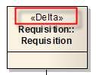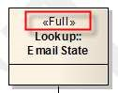

### Cardinality

Cardinality is shown only on the visible (or navigable) side of the relation. For example, DeletedCandidate references (or has a foreign key on) one Candidate.

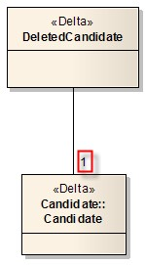

Cardinalities include:

* 1: One and only one (mandatory)
* 0..1: Zero or one (optional)
* 0..*: Zero to many
* 1..*: One to many

### Composite aggregation

Composite aggregation is a special kind of parent-child relation where the children are deleted when their parent is deleted (cascade deletion). In our case, this also means that the parent holds an inclusive last modified date for itself and all of its children, and all children records are extracted along with their parent.

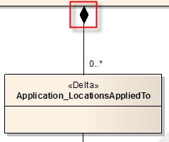

### Shared aggregation[1]

Shared aggregation is a weaker parent-child relation where the children are still deleted when their parent is deleted (cascade deletion), but children have their own last modified date and are not extracted along with their parent.

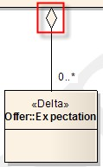

### Nested aggregation

Nested aggregation indicates that the child table is nested within its parent, meaning that all its fields are extracted as part of the parent table. This was used here to reduce de number of extracted records.

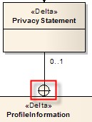

# 4.1 SmartOrg

## 4.1.2 CustomSelection

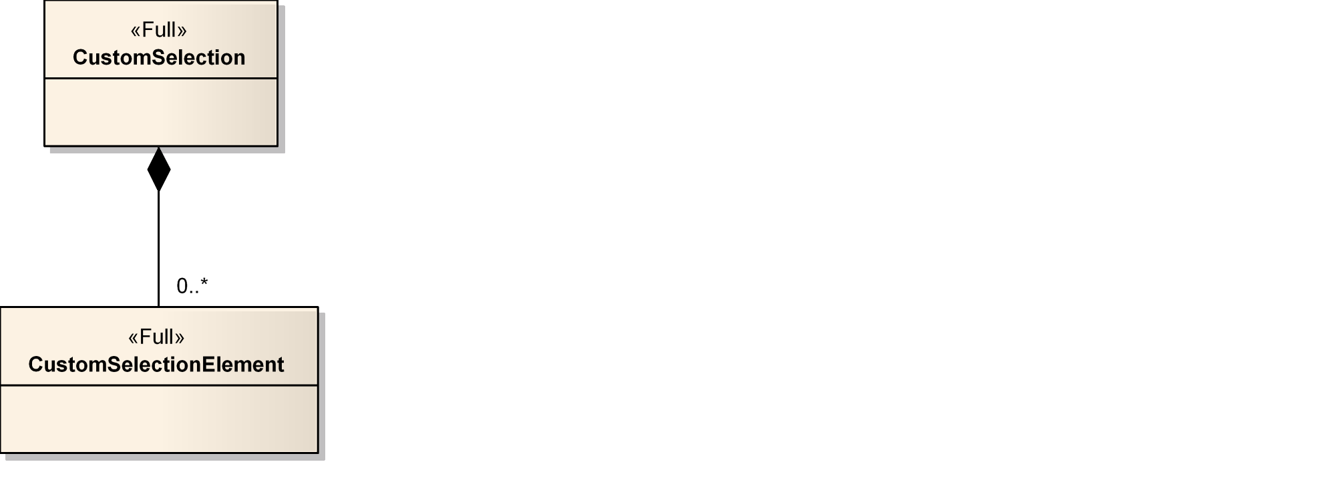

Figure 1- CustomSelection

### 4.1.2.1 CustomSelection – (Full)

Represents a user-defined selection in akirax.

|  |  |  |  |  |  |  |  |  |
| --- | --- | --- | --- | --- | --- | --- | --- | --- |
| **Field No** |  | **Field Name** | **Type** | **Nullable** |  | **Reference Table** | **Reference Field** | **Comments** |
| **1** | **Number** |  | **Number(18)** | **N** |  |  |  |  |
| 3 | Code |  | Char(50) | N |  |  |  |  |
| 3 | Name |  | Char(200) | Y |  |  |  |  |

### 4.1.2.2 CustomSelectionElement – (Full)

This entity represents an element of a custom-made selection. The description of this element is stored in TextTool resources.

|  |  |  |  |  |  |  |
| --- | --- | --- | --- | --- | --- | --- |
| **Field No** | **Field Name** | **Type** | **Nullable** | **Reference Table** | **Reference Field** | **Comments** |
| **1** | **Number** | **Number(18)** | **N** |  |  |  |
| 2 | Code | Char(50) | N |  |  |  |
| 3 | Name | Char(200) | Y |  |  |  |
| 4 | Sequence | Number(5) | N |  |  |  |
| 5 | Selection_Number | Number(18) | Y | CustomSelection | Number |  |
| 6 | Status_Number | Number(18) | N | AdminEntityStatus | Number |  |

## 4.1.4 Employee

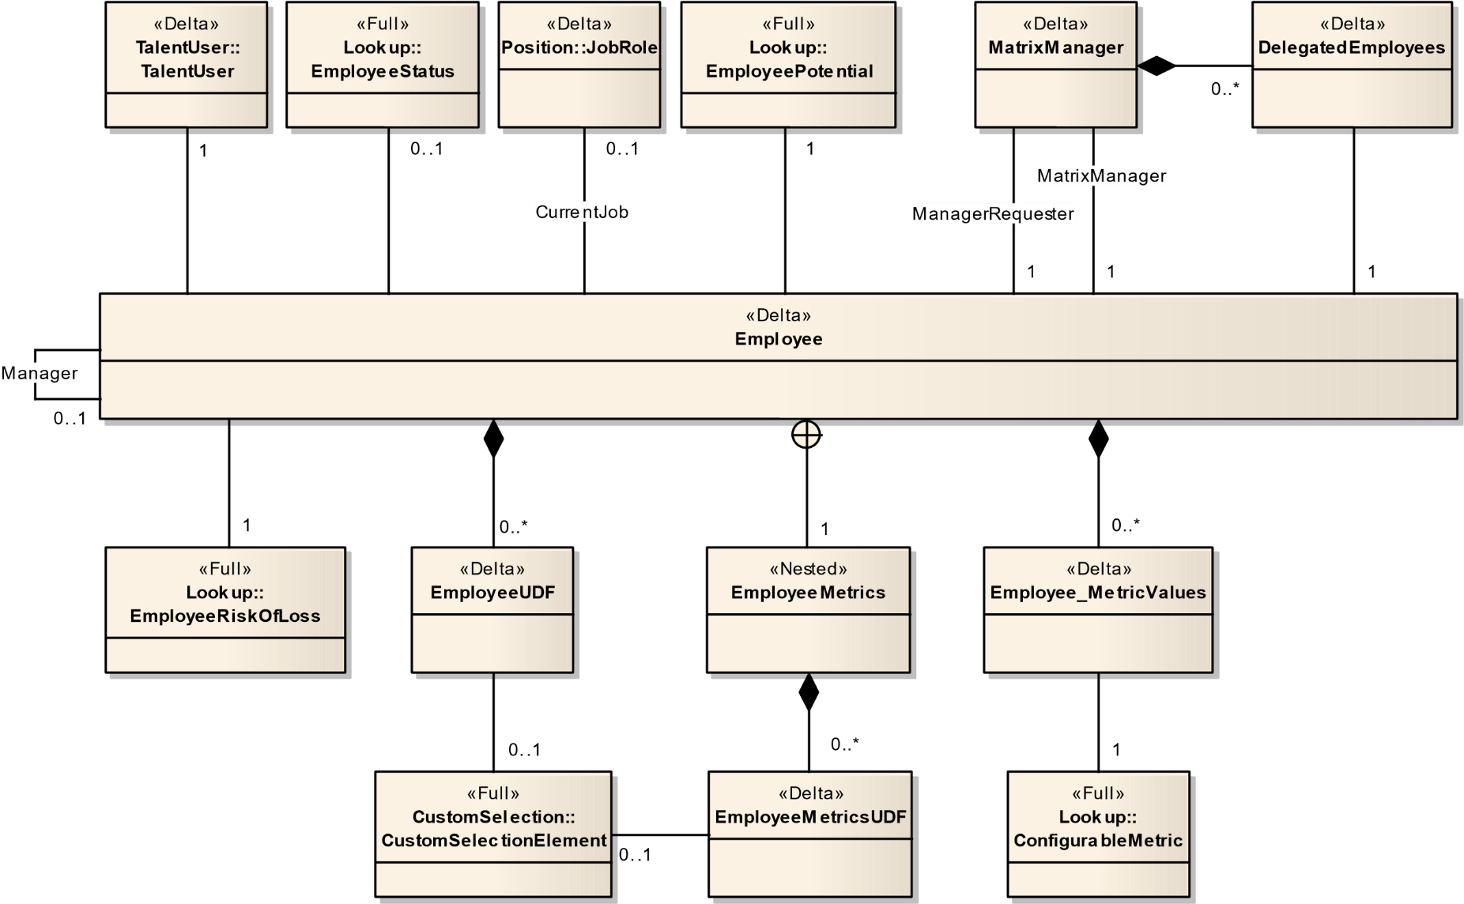

Figure 2 - Employee

### 4.1.4.1 Employee – (Delta)

An employee is the top-level object representing an employee. At this level, the information is distinct from the other possible types of talent users (candidate and contact). Only employee specific information is contained in this object. Most of the overall person information is contained in the related TalentUser and User objects.

|  |  |  |  |  |  |  |
| --- | --- | --- | --- | --- | --- | --- |
| **Field No** | **Field Name** | **Type** | **Nullable** | **Reference Table** | **Reference Field** | **Comments** |
| **1** | **Number** | **Number(18)** | **N** |  |  |  |
| 2 | LastModifiedDate | DateTime | N |  |  |  |
| 3 | Level | Number(10) | Y |  |  |  |
| 4 | ProfileMatched | Boolean | N |  |  |  |
| 5 | CurrentJob_Number | Number(18) | Y | JobRole | Number |  |
| 6 | EmployeeStatus_Number | Number(18) | Y | EmployeeStatus | Number |  |
| 7 | Location_Number | Number(18) | N | Location | Number |  |
| 8 | Manager_Number | Number(18) | Y | Employee | Number |  |
| 9 | Organization_Number | Number(18) | N | Organization | Number |  |
| 10 | TalentUser_Number | Number(18) | N | TalentUser | Number |  |

### 4.1.4.2 EmployeeMetrics – (Delta)

The employee metrics contains valuable and sensitive information regarding an employee.

|  |  |  |  |  |  |  |
| --- | --- | --- | --- | --- | --- | --- |
| **Field No** | **Field Name** | **Type** | **Nullable** | **Reference Table** | **Reference Field** | **Comments** |
| 1 | Employee_Number | Number(18) | N | Employee | Number |  |
| 2 | CompetencyScore | Number | Y |  |  |  |
| 3 | CompetencyScoreDate | DateTime | Y |  |  |  |
| 4 | GoalScore | Number | Y |  |  |  |
| 5 | GoalScoreDate | DateTime | Y |  |  |  |
| 6 | LastReviewScore | Number | Y |  |  |  |
| 7 | LastReviewScoreDate | DateTime | Y |  |  |  |
| 8 | PromotabilityReadinessEnd | Number(10) | Y |  |  |  |
| 9 | PromotabilityReadinessSetDate | DateTime | Y |  |  |  |
| 10 | PromotabilityReadinessStart | Number(10) | Y |  |  |  |
| 11 | EmployeePotential_Number | Number(18) | Y | EmployeePotential | Number |  |
| 12 | EmployeeRiskOfLoss_Number | Number(18) | Y | EmployeeRiskOfLoss | Number |  |
| 13 | MetricValues_Number | Number(18) | Y | MetricValues | Number |  |

### 4.1.4.3 EmployeeUDFs – (Delta)

|  |  |  |  |  |  |  |
| --- | --- | --- | --- | --- | --- | --- |
| Field No | Field Name | Type | Nullable | Reference Table | Reference Field | Comments |
| 1 | NUM | Number(18) | N | Employee | Number |  |
| 2 | UDFName | Number(18) | N |  |  |  |
| 3 | TextValue | Char(4000) | Y |  |  |  |
| 4 | CodeValue | Char(100) | Y |  |  |  |
| 5 | NumberValue | Number(18) | Y |  |  |  |
| 6 | SelectionLookup | Number(18) | Y |  |  |  |
| 7 | SelectionName | Char(255) | Y |  |  |  |
| 8 | SelectionLarge | Boolean | Y |  |  |  |

### 4.1.4.4 DelegatedEmployee – (Delta)

|  |  |  |  |  |  |  |
| --- | --- | --- | --- | --- | --- | --- |
| Field No | Field Name | Type | Nullable | Reference Table | Reference Field | Comments |
| 1 | MatrixManager_Number | Number(18) | N | MatrixManager | Number |  |
| 2 | DelegatedEmployee_Number | Number(18) | N | Employee | Number |  |

### 4.1.4.5 ***MatrixManager – (Delta)

|  |  |  |  |  |  |  |
| --- | --- | --- | --- | --- | --- | --- |
| Field No | Field Name | Type | Nullable | Reference Table | Reference Field | Comments |
| 1 | Number | Number(18) | N |  |  |  |
| 2 | DelegateTasks | Boolean | N |  |  |  |
| 3 | FromDate | DateTime | Y |  |  |  |
| 4 | LastModifiedDate | DateTime | Y |  |  |  |
| 5 | ToDate | DateTime | Y |  |  |  |
| 6 | ManagerRequester_Number | Number(18) | N | Employee | Number |  |
| 7 | MatrixManager_Number | Number(18) | N | Employee | Number |  |

## 4.1.5 Foundation

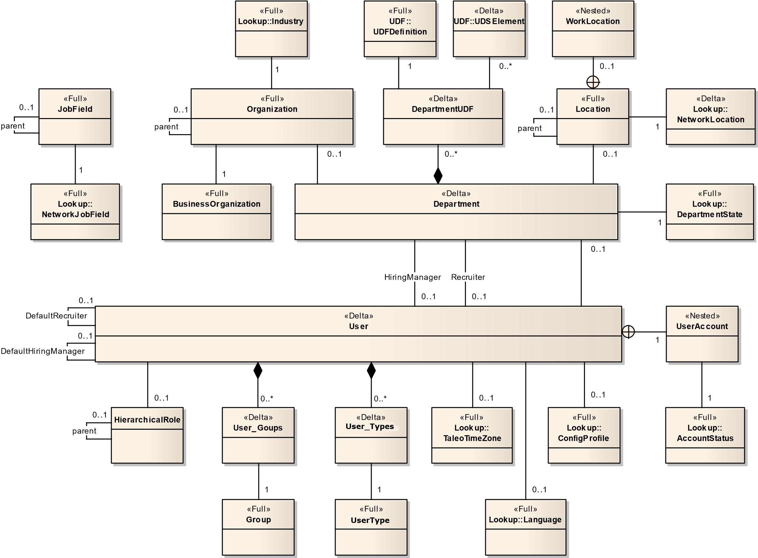

Figure 3 - Foundation

### 4.1.5.1 BusinessOrganization – (Full)

A business organization is a unit of the company. It has a common set of goals within a business plan. A business organization is an aggregated view of the HR organization structure. In some cases, the business organization structure may be the exact replica of the HR organization structure. Structure should be limited to 2 or 3 levels to keep it simple. Business unit. Division.

|  |  |  |  |  |  |  |
| --- | --- | --- | --- | --- | --- | --- |
| Field No | Field Name | Type | Nullable | Reference Table | Reference Field | Comments |
| 1 | Number | Number(18) | N |  |  |  |
| 2 | Code | Char(50) | N |  |  |  |
| 3 | CustomerID | Char(50) | Y |  |  |  |
| 4 | Level | Number(5) | N |  |  |  |
| 5 | Name | Char(200) | Y |  |  |  |
| 6 | Parent_Number | Numbe(18) | Y | BusinessOrganization | Number |  |
| 7 | Status_Number | Number(18) | Y | AdminEntityStatus | Number |  |

### 4.1.5.2 Department – (Delta)

Class that represents a department of the company.

|  |  |  |  |  |  |  |
| --- | --- | --- | --- | --- | --- | --- |
| Field No | Field Name | Type | Nullable | Reference Table | Reference Field | Comments |
| 1 | Number | Number(18) | N |  |  |  |
| 2 | Code | Char(50) | N |  |  |  |
| 3 | CostCenter | Char(255) | N |  |  |  |
| 4 | EffectiveFrom | Date | Y |  |  |  |
| 5 | EffectiveTill | Date | Y |  |  |  |
| 6 | LastModifiedDate | DateTime | Y |  |  |  |
| 7 | Name | Char(200) | Y |  |  |  |
| 8 | PayFactor | Number(12,2) | Y |  |  |  |
| 9 | HiringManager_UserNo | Number(18) | Y | User | UserNo |  |
| 10 | Location_Number | Number(18) | Y | Location | Number |  |
| 11 | Organization_Number | Number(18) | Y | Organization | Number |  |
| 12 | Parent_Number | Number(18) | Y | Department | Number |  |
| 13 | Recruiter_UserNo | Number(18) | Y | User | UserNo |  |
| 14 | State_Number | Number(18) | N | DepartmentState | Number |  |
| 15 | Status_Number | Number(18) | N | AdminEntityStatus | Number |  |

### 4.1.5.3 DepartmentUDFS – (Delta)

|  |  |  |  |  |  |  |
| --- | --- | --- | --- | --- | --- | --- |
| Field No | Field Name | Type | Nullable | Reference Table | Reference Field | Comments |
| 1 | NUM | Number(18) | N | Department | Number |  |
| 2 | UDFName | Number(18) | N |  |  |  |
| 3 | TextValue | Char(4000) | Y |  |  |  |
| 4 | CodeValue | Char(100) | Y |  |  |  |
| 5 | NumberValue | Number(18) | Y |  |  |  |
| 6 | SelectionLookup | Number(18) | Y |  |  |  |
| 7 | SelectionName | Char(255) | Y |  |  |  |
| 8 | SelectionLarge | Boolean | Y |  |  |  |

### 4.1.5.4 JobField – (Full)

Class that represents company-specific Job Fields. This is the list of company employment domains, with a hierarchical view.

|  |  |  |  |  |  |  |
| --- | --- | --- | --- | --- | --- | --- |
| Field No | Field Name | Type | Nullable | Reference Table | Reference Field | Comments |
| 1 | Number | Number(18) | N |  |  |  |
| 2 | Code | Char(50) | N |  |  |  |
| 3 | Complete | Boolean | Y |  |  |  |
| 4 | CustomerID | Char(50) | Y |  |  |  |
| 5 | Level | Number(5) | N |  |  |  |
| 6 | Locked | Boolean | N |  |  |  |
| 7 | Name | Char(200) | Y |  |  |  |
| 8 | NetworkJobField_Number | Number(18) | N | NetworkJobField | Number |  |
| 9 | Parent_Number | Number(18) | Y | JobField | Number |  |
| 10 | Sequence | Number(5) | Y |  |  |  |
| 11 | Status_Number | Number(18) | N | AdminEntityStatus | Number |  |

### 4.1.5.5 Group – (Full)

Group entity that defines a set of users.

|  |  |  |  |  |  |  |
| --- | --- | --- | --- | --- | --- | --- |
| Field No | Field Name | Type | Nullable | Reference Table | Reference Field | Comments |
| 1 | Number | Number(18) | N |  |  |  |
| 2 | Name | Char(255) | N |  |  |  |
| 3 | Description | Char(255) | N |  |  |  |

### 4.1.5.6 Location – (Full)

Class that represents a company’s specific location. A company location represents a geographical region. Only locations that are useful to the company are present in this structure. Location is used in the Application to define a country; it could also define a State (or province), a Region and a city. It usually describes locations where activities happen Within the company. As far as country, state and region are concerned, they Should be a subset of the reference location structure.

|  |  |  |  |  |  |  |
| --- | --- | --- | --- | --- | --- | --- |
| Field No | Field Name | Type | Nullable | Reference Table | Reference Field | Comments |
| 1 | Number | Number(18) | N |  |  |  |
| 2 | Abbreviation | Char(15) | Y |  |  |  |
| 3 | Code | Char(50) | N |  |  |  |
| 4 | Complete | Boolean | Y |  |  |  |
| 5 | CustomerID | Char(50) | Y |  |  |  |
| 6 | LastModifiedOn | Date | Y |  |  |  |
| 7 | Level | Number(5) | N |  |  |  |
| 8 | Name | Char(200) | Y |  |  |  |
| 9 | ZipCode | Char(60) | Y |  |  |  |
| 10 | NetworkLocation_Number | Number(18) | N | NetworkLocation | Number |  |
| 11 | Parent_Number | Number(18) | Y | Location | Number |  |
| 12 | Sequence | Number(5) | Y |  |  |  |
| 13 | Status_Number | Number(18) | N | AdminEntityStatus | Number |  |
| 14 | WorkLocation_Address1 | Char(400) | Y |  |  |  |
| 15 | WorkLocation_Address2 | Char(400) | Y |  |  |  |
| 16 | WorkLocation_City | Char(400) | Y |  |  |  |
| 17 | WorkLocation_Code | Char(200) | Y |  |  |  |

### 4.1.5.7 Organization – (Full)

Class that represents a company-specific Organization. It describes the divisional structure of the company. This includes, but is not restricted to, company, location, division, area, department and workgroup.

|  |  |  |  |  |  |  |
| --- | --- | --- | --- | --- | --- | --- |
| Field No | Field Name | Type | Nullable | Reference Table | Reference Field | Comments |
| 1 | Number | Number(18) | N |  |  |  |
| 2 | Code | Char(50) | N |  |  |  |
| 3 | Complete | Boolean | Y |  |  |  |
| 4 | CustomerID | Char(50) | Y |  |  |  |
| 5 | Level | Number(5) | N |  |  |  |
| 6 | Name | Char(200) | Y |  |  |  |
| 7 | BusinessOrganization_Number | Number(18) | Y | BusinessOrganization | Number |  |
| 8 | Industry_Number | Number(18) | Y | Industry | Number |  |
| 9 | Parent_Number | Number(18) | Y | Organization | Number |  |
| 10 | Sequence | Number(5) | Y |  |  |  |
| 11 | Status_Number | Number(18) | N | AdminEntityStatus | Number |  |

### 4.1.5.8 User – (Delta)

The user is the entity that defines a system user with his information.

|  |  |  |  |  |  |  |
| --- | --- | --- | --- | --- | --- | --- |
| Field No | Field Name | Type | Nullable | Reference Table | Reference Field | Comments |
| 1 | UserNo | Number(18) | N |  |  |  |
| 2 | City | Char(100) | Y |  |  |  |
| 3 | CorporateEmail | Char(100) | Y |  |  |  |
| 4 | CorrespondenceEmail | Char(100) | Y |  |  |  |
| 5 | CorrespondenceLanguage_ISO | Char(15) | N | Language | ISO |  |
| 6 | Country | Char(100) | Y |  |  |  |
| 7 | DepartmentName | Char(765) | Y |  |  |  |
| 8 | DepartmentNumber | Char(765) | Y |  |  |  |
| 9 | EmployeeID | Char(255) | Y |  |  |  |
| 10 | Fax | Char(50) | Y |  |  |  |
| 11 | FirstName | Char(255) | Y |  |  |  |
| 12 | HomePhone | Char(50) | Y |  |  |  |
| 13 | Initial | Char(3) | Y |  |  |  |
| 14 | LastModifiedDate | DateTime | N |  |  |  |
| 15 | LastName | Char(255) | Y |  |  |  |
| 16 | MobilePhone | Char(50) | Y |  |  |  |
| 17 | Pager | Char(50) | Y |  |  |  |
| 18 | PersonalEmail | Char(100) | Y |  |  |  |
| 19 | Prefix | Char(30) | Y |  |  |  |
| 20 | State | Char(100) | Y |  |  |  |
| 21 | StreetAddress | Char(100) | Y |  |  |  |
| 22 | StreetAddress2 | Char(100) | Y |  |  |  |
| 23 | StreetAddress3 | Char(100) | Y |  |  |  |
| 24 | Suffix | Char(3) | Y |  |  |  |
| 25 | SystemUser | Boolean | N |  |  |  |
| 26 | Title | Char(255) | Y |  |  |  |
| 27 | WorkPhone | Char(50) | Y |  |  |  |
| 28 | WorkphoneExtension | Char(50) | Y |  |  |  |
| 29 | Zipcode | Char(20) | Y |  |  |  |
| 30 | ConfigProfile_Code | Char(50) | Y | ConfigProfile | Code |  |
| 31 | DefaultRecruiter_UserNo | Number(18) | Y | User | UserNo |  |
| 32 | DefaultHiringManager_UserNo | Number(18) | Y | User | UserNo |  |
| 33 | Department_Number | Number(18) | Y | Department | Number |  |
| 34 | HierarchicalRole_RoleNo | Number(18) | Y | HierarchicalRole | RoleNo |  |
| 35 | TimeZone_Number | Number(18) | Y | TaleoTimeZone | Number |  |
| 36 | UserAccount_CreationDate | DateTime | N |  |  |  |
| 37 | UserAccount_EndValidity | DateTime | Y |  |  |  |
| 38 | UserAccount_StartValidity | DateTime | Y |  |  |  |
| 39 | UserAccount_ForceChangePwd | Boolean | N |  |  |  |
| 40 | UserAccount_LastPwdModif | DateTime | Y |  |  |  |
| 41 | UserAccount_Loginname | Char(255) | N |  |  |  |
| 42 | UserAccount_Status_Number | Number(18) | N | AccountStatus | Number |  |

### 4.1.5.9 UserType – (Fiull)

User Roles are sets of Functional Permissions that can be attributed to Users.

|  |  |  |  |  |  |  |
| --- | --- | --- | --- | --- | --- | --- |
| Field No | Field Name | Type | Nullable | Reference Table | Reference Field | Comments |
| 1 | User_UserNo | Number(18) | N | User |  | UserNo |
| 2 | Group_Number | Number(18) | N | Group |  | Number |

### 4.1.5.10 User_Groups – (Delta)

|  |  |  |  |  |  |  |
| --- | --- | --- | --- | --- | --- | --- |
| Field No | Field Name | Type | Nullable | Reference Table | Reference Field | Comments |
| 1 | UserNo | Number(18) | N |  |  |  |
| 2 | Group_Number | Number(18) | Y | Groups | Number |  |

### 4.1.5.11 User_Types – (Delta)

|  |  |  |  |  |  |  |
| --- | --- | --- | --- | --- | --- | --- |
| Field No | Field Name | Type | Nullable | Reference Table | Reference Field | Comments |
| 1 | UserNo | Number(18) | N |  |  |  |
| 2 | UserTypes_Code | Char(50)) | Y | UserTypes | Code |  |

## 4.1.6 Lookup

### 4.1.6.1 AccountStatus – (Full)

The user account status lookup. Values are: 1-active, 2-inactive, 3-locked, 4-deleted, 5-expired.

|  |  |  |  |  |  |  |
| --- | --- | --- | --- | --- | --- | --- |
| Field No | Field Name | Type | Nullable | Reference Table | Reference Field | Comments |
| 1 | Number | Number(18) | N |  |  |  |
| 2 | Code | Char(50) | N |  |  |  |
| 3 | Description | Char(150) | Y |  |  |  |

### 4.1.6.2 AdminEntityStatus – (Full)

Administration entity status.

|  |  |  |  |  |  |  |
| --- | --- | --- | --- | --- | --- | --- |
| Field No | Field Name | Type | Nullable | Reference Table | Reference Field | Comments |
| 1 | Number | Number(18) | N |  |  |  |
| 2 | Code | Char(50) | N |  |  |  |
| 3 | Description | Char(150) | Y |  |  |  |

### 4.1.6.3 Certification – (Delta)

A certification is one element that defines the talent profile of a candidate or employee. The notion of certification refers to an official recognition of skills and knowledge in a specific area. A certification is emitted by an authorized provider.

All certifications are defined in the standard Taleo library - it is not possible for customers to add new elements. However, customers can activate/deactivate elements.

|  |  |  |  |  |  |  |
| --- | --- | --- | --- | --- | --- | --- |
| Field No | Field Name | Type | Nullable | Reference Table | Reference Field | Comments |
| 1 | Number | Number(18) | N |  |  |  |
| 2 | Description | Char(1000) | Y |  |  |  |
| 3 | Status_Number | Number(18) | N | AdminEntityStatus | Number |  |

### 4.1.6.4 CieEmployer – (Delta)

This entity represents an employer where a candidate acquired work experience.

|  |  |  |  |  |  |  |
| --- | --- | --- | --- | --- | --- | --- |
| Field No | Field Name | Type | Nullable | Reference Table | Reference Field | Comments |
| 1 | Number | Number(18) | N |  |  |  |
| 2 | Description | Char(150) | Y |  |  |  |
| 3 | Status_Number | Number(18) | N | AdminEntityStatus | Number |  |

### 4.1.6.5 CieInstitution – (Delta)

This entity represents a place designated for learning. It is the educational institution where people learn specific knowledge.

|  |  |  |  |  |  |  |
| --- | --- | --- | --- | --- | --- | --- |
| Field No | Field Name | Type | Nullable | Reference Table | Reference Field | Comments |
| 1 | Number | Number(18) | N |  |  |  |
| 2 | Description | Char(1000) | Y |  |  |  |
| 3 | Location_Number | Number(18) | Y | NetworkLocation | Number |  |
| 4 | Status_Number | Number(18) | N | AdminEntityStatus | Number |  |
| 5 | Type_Number | Number(18) | Y | TypeOfInstitution | Number |  |

### 4.1.6.6 CieProgram – (Delta)

This entity represents an educational program. It's a field of study. For example: Information Technology, Journalism, Political Science, etc...

|  |  |  |  |  |  |  |
| --- | --- | --- | --- | --- | --- | --- |
| Field No | Field Name | Type | Nullable | Reference Table | Reference Field | Comments |
| 1 | Number | Number(18) | N |  |  |  |
| 2 | Description | Char(300) | Y |  |  |  |
| 3 | Status_Number | Number(18) | N | AdminEntityStatus | Number |  |

### 4.1.6.7 CompetencyCategory – (Full)

A competency category is a way for classifying competencies. Competencies are Mainly used for filtering purposes. A competency can be associated to many Categories.

|  |  |  |  |  |  |  |
| --- | --- | --- | --- | --- | --- | --- |
| Field No | Field Name | Type | Nullable | Reference Table | Reference Field | Comments |
| 1 | Number | Number(18) | N |  |  |  |
| 2 | Code | Char(50) | N |  |  |  |
| 3 | Description | Char(4000) | Y |  |  |  |
| 4 | Name | Char(200) | Y |  |  |  |
| 5 | Status_Number | Number(18) | N | AdminEntityStatus | Number |  |

### 4.1.6.8 CompetencyGroup – (Full)

A competency group is a way for classifying competencies. Groups are mainly Used for filtering and display grouping purposes. A competency can be associated to one group.

|  |  |  |  |  |  |  |
| --- | --- | --- | --- | --- | --- | --- |
| Field No | Field Name | Type | Nullable | Reference Table | Reference Field | Comments |
| 1 | Number | Number(18) | N |  |  |  |
| 2 | Code | Char(50) | N |  |  |  |
| 3 | Description | Char(4000) | Y |  |  |  |
| 4 | Name | Char(200) | Y |  |  |  |
| 5 | DisplaySequence | Number(10) | N |  |  |  |
| 6 | Status_Number | Number(18) | N | AdminEntityStatus | Number |  |

### 4.1.6.9 CompetencyProvider – (Full)

A competency provider owns a library of competencies and other related content that can be used by the client.

|  |  |  |  |  |  |  |
| --- | --- | --- | --- | --- | --- | --- |
| Field No | Field Name | Type | Nullable | Reference Table | Reference Field | Comments |
| 1 | Number | Number(18) | N |  |  |  |
| 2 | Code | Char(50) | N |  |  |  |
| 3 | Description | Char(3000) | Y |  |  |  |
| 4 | Name | Char(200) | Y |  |  |  |
| 5 | Status_Number | Number(18) | N | AdminEntityStatus | Number |  |

### 4.1.6.10 CompetencyType – (Full)

Competency types provide a way to group and organize competencies. There are three types of competencies: job specific, language, and behavioral competencies.

|  |  |  |  |  |  |  |
| --- | --- | --- | --- | --- | --- | --- |
| Field No | Field Name | Type | Nullable | Reference Table | Reference Field | Comments |
| 1 | Number | Number(18) | N |  |  |  |
| 2 | Code | Char(50) | N |  |  |  |
| 3 | Description | Char(150) | Y |  |  |  |

### 4.1.6.11 ConfigProfile – (Full)

Represents the base configuration for a specific user profile; settings shared between users.

|  |  |  |  |  |  |  |
| --- | --- | --- | --- | --- | --- | --- |
| Field No | Field Name | Type | Nullable | Reference Table | Reference Field | Comments |
| 1 | Number | Number(18) | N |  |  |  |
| 2 | Code | Char(50) | N |  |  |  |
| 3 | Name | Char(200) | Y |  |  |  |
| 4 | Status_Number | Number(18) | N | AdminEntityStatus | Number |  |

### 4.1.6.12 ConfigurableMetric – (Full)

This class is a lookup class that define all the possible values for the employee configurable metrics available in the system. The type specified the kind of metric we are dealing with. The description can be edited by the user, the user can add or remove an image associated to a possible choice of values. The possible values can be active or de-activated.

|  |  |  |  |  |  |  |
| --- | --- | --- | --- | --- | --- | --- |
| Field No | Field Name | Type | Nullable | Reference Table | Reference Field | Comments |
| 1 | Number | Number(18) | N |  |  |  |
| 2 | Code | Char(50) | N |  |  |  |
| 3 | DefaultValue | Boolean | N |  |  |  |
| 4 | Name | Char(200) | Y |  |  |  |
| 5 | Sequence | Number(5) | N |  |  |  |
| 6 | Status_Number | Number(18) | Y | AdminEntityStatus | Number |  |
| 7 | Type_Number | Number(18) | Y | MetricType | Number |  |

### 4.1.6.13 Currency – (Full)

This entity is a lookup representing a form of money that is in public circulation.

|  |  |  |  |  |  |  |
| --- | --- | --- | --- | --- | --- | --- |
| Field No | Field Name | Type | Nullable | Reference Table | Reference Field | Comments |
| 1 | Number | Number(18) | N |  |  |  |
| 2 | Active | Boolean | N |  |  |  |
| 3 | BaseCurrencyRatio | Number(30,10) | N |  |  |  |
| 4 | Code | Char(150) | N |  |  |  |
| 5 | Description | Char(150) | N |  |  |  |
| 6 | ISO4217Abbreviation | Char(9) | N |  |  |  |
| 7 | ISO4217Code | Number(5) | N |  |  |  |
| 8 | Sequence | Number(5) | N |  |  |  |
| 9 | Symbol | Char(150) | N |  |  |  |

### 4.1.6.14 EmployeePotential – (Full)

The potential of the employee to be promoted to another job or position.

|  |  |  |  |  |  |  |
| --- | --- | --- | --- | --- | --- | --- |
| Field No | Field Name | Type | Nullable | Reference Table | Reference Field | Comments |
| 1 | Number | Number(18) | N |  |  |  |
| 2 | Code | Char(50) | Y |  |  |  |
| 3 | Description | Char(150) | N |  |  |  |

### 4.1.6.15 EmployeeRiskOfLoss – (Full)

The risk of losing this employee to an internal transfer or an external company.

|  |  |  |  |  |  |  |
| --- | --- | --- | --- | --- | --- | --- |
| Field No | Field Name | Type | Nullable | Reference Table | Reference Field | Comments |
| 1 | Number | Number(18) | N |  |  |  |
| 2 | Code | Char(50) | N |  |  |  |
| 3 | Description | Char(150) | Y |  |  |  |

### 4.1.6.16 EmployeeStatus – (Full)

The current employment status of the employee.

|  |  |  |  |  |  |  |
| --- | --- | --- | --- | --- | --- | --- |
| Field No | Field Name | Type | Nullable | Reference Table | Reference Field | Comments |
| 1 | Number | Number(18) | N |  |  |  |
| 2 | Code | Char(50) | N |  |  |  |
| 3 | Description | Char(150) | Y |  |  |  |

### 4.1.6.17 EmploymentStatus – (Full)

Employee Status lookup values. It determines the desired person's employment status.

|  |  |  |  |  |  |  |
| --- | --- | --- | --- | --- | --- | --- |
| Field No | Field Name | Type | Nullable | Reference Table | Reference Field | Comments |
| 1 | Number | Number(18) | N |  |  |  |
| 2 | Active | Boolean | N |  |  |  |
| 3 | Code | Char(50) | N |  |  |  |
| 4 | Description | Char(200) | Y |  |  |  |
| 5 | Sequence | Number(5) | N |  |  |  |

### 4.1.6.18 Industry – (Full)

Class that represents the Taleo Reference Industry.

|  |  |  |  |  |  |  |
| --- | --- | --- | --- | --- | --- | --- |
| Field No | Field Name | Type | Nullable | Reference Table | Reference Field | Comments |
| 1 | Number | Number(18) | N |  |  |  |
| 2 | Code | Char(50) | N |  |  |  |
| 3 | Description | Char(150) | Y |  |  |  |

### 4.1.6.19 InfoFeeder – (Full)

This lookup entity indicates who has feed the information about a candidate (Recruiter, Agent, ...)

|  |  |  |  |  |  |  |
| --- | --- | --- | --- | --- | --- | --- |
| Field No | Field Name | Type | Nullable | Reference Table | Reference Field | Comments |
| 1 | Number | Number(18) | N |  |  |  |
| 2 | Code | Char(50) | N |  |  |  |
| 3 | Description | Char(150) | N |  |  |  |

### 4.1.6.20 InterestInternationalAssignment – (Full)

Interest International Assignment lookup values. It determines the level of interest for a person in being relocated internationally.

|  |  |  |  |  |  |  |
| --- | --- | --- | --- | --- | --- | --- |
| Field No | Field Name | Type | Nullable | Reference Table | Reference Field | Comments |
| 1 | Number | Number(18) | N |  |  |  |
| 2 | Code | Char(50) | N |  |  |  |
| 3 | Description | Char(150) | Y |  |  |  |

### 4.1.6.21 JobLevel – (Full)

Job Level lookup values. It determines the available job levels in the system.

|  |  |  |  |  |  |  |
| --- | --- | --- | --- | --- | --- | --- |
| Field No | Field Name | Type | Nullable | Reference Table | Reference Field | Comments |
| 1 | Number | Number(18) | N |  |  |  |
| 2 | Active | Boolean | N |  |  |  |
| 3 | Code | Char(50) | N |  |  |  |
| 4 | Description | Char(150) | Y |  |  |  |
| 5 | Sequence | Number(5) | Y |  |  |  |

### 4.1.6.22 JobSchedule – (Full)

Job Schedule lookup values. It determines the available job schedule types in the system.

|  |  |  |  |  |  |  |
| --- | --- | --- | --- | --- | --- | --- |
| Field No | Field Name | Type | Nullable | Reference Table | Reference Field | Comments |
| 1 | Number | Number(18) | N |  |  |  |
| 2 | Active | Boolean | N |  |  |  |
| 3 | Code | Char(150) | N |  |  |  |
| 4 | Description | Char(150) | Y |  |  |  |
| 5 | Sequence | Number(5) | N |  |  |  |

### 4.1.6.23 JobShift – (Full)

Job Shift lookup values. It determines the available job shifts in the system.

|  |  |  |  |  |  |  |
| --- | --- | --- | --- | --- | --- | --- |
| Field No | Field Name | Type | Nullable | Reference Table | Reference Field | Comments |
| 1 | Number | Number(18) | N |  |  |  |
| 2 | Active | Boolean | N |  |  |  |
| 3 | Code | Char(150) | N |  |  |  |
| 4 | Description | Char(150) | Y |  |  |  |
| 5 | Sequence | Number(5) | N |  |  |  |

### 4.1.6.24 JobType – (Full)

Job Type lookup values. It determines the available job types in the system.

|  |  |  |  |  |  |  |
| --- | --- | --- | --- | --- | --- | --- |
| Field No | Field Name | Type | Nullable | Reference Table | Reference Field | Comments |
| 1 | Number | Number(18) | N |  |  |  |
| 2 | Active | Boolean | N |  |  |  |
| 3 | Code | Char(150) | N |  |  |  |
| 4 | Description | Char(150) | Y |  |  |  |
| 5 | Sequence | Number(5) | N |  |  |  |

### 4.1.6.25 Language – (Full)

This entity represents a language that is supported by our applications.

|  |  |  |  |  |  |  |
| --- | --- | --- | --- | --- | --- | --- |
| Field No | Field Name | Type | Nullable | Reference Table | Reference Field | Comments |
| 1 | ISO | Char(15) | N |  |  |  |
| 2 | Code | Char(200) | N |  |  |  |
| 3 | Description | Char(200) | Y |  |  |  |

### 4.1.6.26 NetworkJobField – (Full)

Class that represents network Job Field. This is the list of employment domains, with a hierarchical view.

|  |  |  |  |  |  |  |
| --- | --- | --- | --- | --- | --- | --- |
| Field No | Field Name | Type | Nullable | Reference Table | Reference Field | Comments |
| 1 | Number | Number(18) | N |  |  |  |
| 2 | Code | Char(50) | N |  |  |  |
| 3 | Complete | Boolean | Y |  |  |  |
| 4 | Level | Number(5) | N |  |  |  |
| 5 | Name | Char(765) | Y |  |  |  |
| 6 | Sequence | Number(5) | Y |  |  |  |
| 7 | Parent_Number | Number(18) | Y | NetworkJobField | Number |  |
| 8 | Status_Number | Number(18) | N | AdminEntityStatus | Number |  |

### 4.1.6.27 NetworkLocation – (Delta)

Class that represents a network-specific location.

Taleo locations are a list of locations from around the world. They are usually used to generate the locations of a company, and they are also used in the Career Section to help a candidate select the actual location. They also represent the location used to do a posting, since posting is often done based on a "region" (which is less detailed than the city used in Location). The reference location structure has 3 levels: country, province/ state and region.

|  |  |  |  |  |  |  |
| --- | --- | --- | --- | --- | --- | --- |
| Field No | Field Name | Type | Nullable | Reference Table | Reference Field | Comments |
| 1 | Number | Number(18) | N |  |  |  |
| 2 | Abbreviation | Char(15) | Y |  |  |  |
| 3 | Code | Char(50) | Y |  |  |  |
| 4 | Complete | Boolean | N |  |  |  |
| 5 | ISO3166Alpha3 | Char(3) | Y |  |  |  |
| 6 | LastModifiedOn | DateTime | Y |  |  |  |
| 7 | Latitude | Number(30,10) | Y |  |  |  |
| 8 | Level | Number(1) | N |  |  |  |
| 9 | Longitude | Number(30,10) | Y |  |  |  |
| 10 | Name | Char(150) | N |  |  |  |
| 11 | ZipCode | Char(20) | Y |  |  |  |
| 12 | Sequence | Number(5) | Y |  |  |  |
| 13 | Parent_Number | Number(18) | Y | NetworkLocation | Number |  |
| 14 | Status_Number | Number(18) | N | AdminEntityStatus | Number |  |
| 15 | TimeZone_Number | Number(18) | Y | TaleoTimeZone | Number |  |

### 4.1.6.28 Origin – (Full)

Object origin entity. Determines the origin of an entity.

|  |  |  |  |  |  |  |
| --- | --- | --- | --- | --- | --- | --- |
| Field No | Field Name | Type | Nullable | Reference Table | Reference Field | Comments |
| 1 | Number | Number(18) | N |  |  |  |
| 2 | Code | Char(150) | N |  |  |  |
| 3 | Description | Char(150) | Y |  |  |  |

### 4.1.6.29 PhoneType – (Full)

This class is a lookup that display the phone type. I.e Home Phone, Work Phone, etc.

|  |  |  |  |  |  |  |
| --- | --- | --- | --- | --- | --- | --- |
| Field No | Field Name | Type | Nullable | Reference Table | Reference Field | Comments |
| 1 | Number | Number(18) | N |  |  |  |
| 2 | Description | Char(150) | N |  |  |  |

### 4.1.6.30 ProfileImportance – (Full)

The relative importance of a profile element.

|  |  |  |  |  |  |  |
| --- | --- | --- | --- | --- | --- | --- |
| Field No | Field Name | Type | Nullable | Reference Table | Reference Field | Comments |
| 1 | Number | Number(18) | N |  |  |  |
| 2 | Code | Char(50) | N |  |  |  |
| 3 | Description | Char(150) | Y |  |  |  |

### 4.1.6.31 RaterType – (Full)

Rater type lookup values. The rater type determines who has provided the competency answer.

|  |  |  |  |  |  |  |
| --- | --- | --- | --- | --- | --- | --- |
| Field No | Field Name | Type | Nullable | Reference Table | Reference Field | Comments |
| 1 | Number | Number(18) | N |  |  |  |
| 2 | Code | Char(50) | N |  |  |  |
| 3 | Description | Char(150) | Y |  |  |  |

### 4.1.6.32 RatingDimensionType – (Full)

The rating dimension type determines the usage pattern of this part of the evaluation.

The types LEVEL, INTEREST, EXPERIENCE and LAST_USED represent the dimensions also used in the recruiting product and candidate profiles. The SCORE dimension is the one mainly used in the Performance Management product for performance reviews.

|  |  |  |  |  |  |  |
| --- | --- | --- | --- | --- | --- | --- |
| Field No | Field Name | Type | Nullable | Reference Table | Reference Field | Comments |
| 1 | Number | Number(18) | N |  |  |  |
| 2 | Code | Char(50) | N |  |  |  |
| 3 | Description | Char(150) | Y |  |  |  |

### 4.1.6.33 Reassignment – (Full)

Reassignment lookup values. It determines the level of readiness for a person in being assigned for a different job.

|  |  |  |  |  |  |  |
| --- | --- | --- | --- | --- | --- | --- |
| Field No | Field Name | Type | Nullable | Reference Table | Reference Field | Comments |
| 1 | Number | Number(18) | N |  |  |  |
| 2 | Code | Char(50) | N |  |  |  |
| 3 | Description | Char(150) | Y |  |  |  |

### 4.1.6.34 StudyLevel – (Full)

Study Level lookup values. It determines the education levels a person has or intends to reach.

|  |  |  |  |  |  |  |
| --- | --- | --- | --- | --- | --- | --- |
| Field No | Field Name | Type | Nullable | Reference Table | Reference Field | Comments |
| 1 | Number | Number(18) | N |  |  |  |
| 2 | Active | Boolean | N |  |  |  |
| 3 | Code | Char(50) | N |  |  |  |
| 4 | Description | Char(765) | N |  |  |  |
| 5 | Sequence | Nunber(5) | N |  |  |  |

### 4.1.6.35 TaleoTimeZone – (Full)

Timezone accordingly to the meridian you are living.

|  |  |  |  |  |  |  |
| --- | --- | --- | --- | --- | --- | --- |
| Field No | Field Name | Type | Nullable | Reference Table | Reference Field | Comments |
| 1 | Number | Number(18) | N |  |  |  |
| 2 | TimezoneId | Char(765) | N |  |  |  |
| 3 | IsDisplacementOnly | Boolean | N |  |  |  |
| 4 | JavaTimeZone | Char(765) | N |  |  |  |
| 5 | OffsetDescription | Char(765) | N |  |  |  |
| 6 | OracleTimeZone | Char(765) | N |  |  |  |
| 7 | TimezoneDescription | Char(765) | N |  |  |  |

### 4.1.6.36 TypeOfInstitution – (Full)

This entity is a lookup representing the list of possible type of institution: for example: University, College, school, etc.

|  |  |  |  |  |  |  |
| --- | --- | --- | --- | --- | --- | --- |
| Field No | Field Name | Type | Nullable | Reference Table | Reference Field | Comments |
| 1 | Number | Number(18) | N |  |  |  |
| 2 | Code | Char(150) | N |  |  |  |
| 3 | Description | Char(150) | Y |  |  |  |

### 4.1.6.37 WillingnessToTravel – (Full)

Will Travel lookup values. It determines the person's likeliness to travel.

|  |  |  |  |  |  |  |
| --- | --- | --- | --- | --- | --- | --- |
| Field No | Field Name | Type | Nullable | Reference Table | Reference Field | Comments |
| 1 | Number | Number(18) | N |  |  |  |
| 2 | Code | Char(50) | N |  |  |  |
| 3 | Description | Char(150) | Y |  |  |  |

### 4.1.6.38 WillRelocate – (Full)

Will Relocate lookup values. It determines the level of interest for a person in being relocated.

|  |  |  |  |  |  |  |
| --- | --- | --- | --- | --- | --- | --- |
| Field No | Field Name | Type | Nullable | Reference Table | Reference Field | Comments |
| 1 | Number | Number(18) | N |  |  |  |
| 2 | Code | Char(50) | N |  |  |  |
| 3 | Description | Char(150) | Y |  |  |  |

## 4.1.9 Talent User

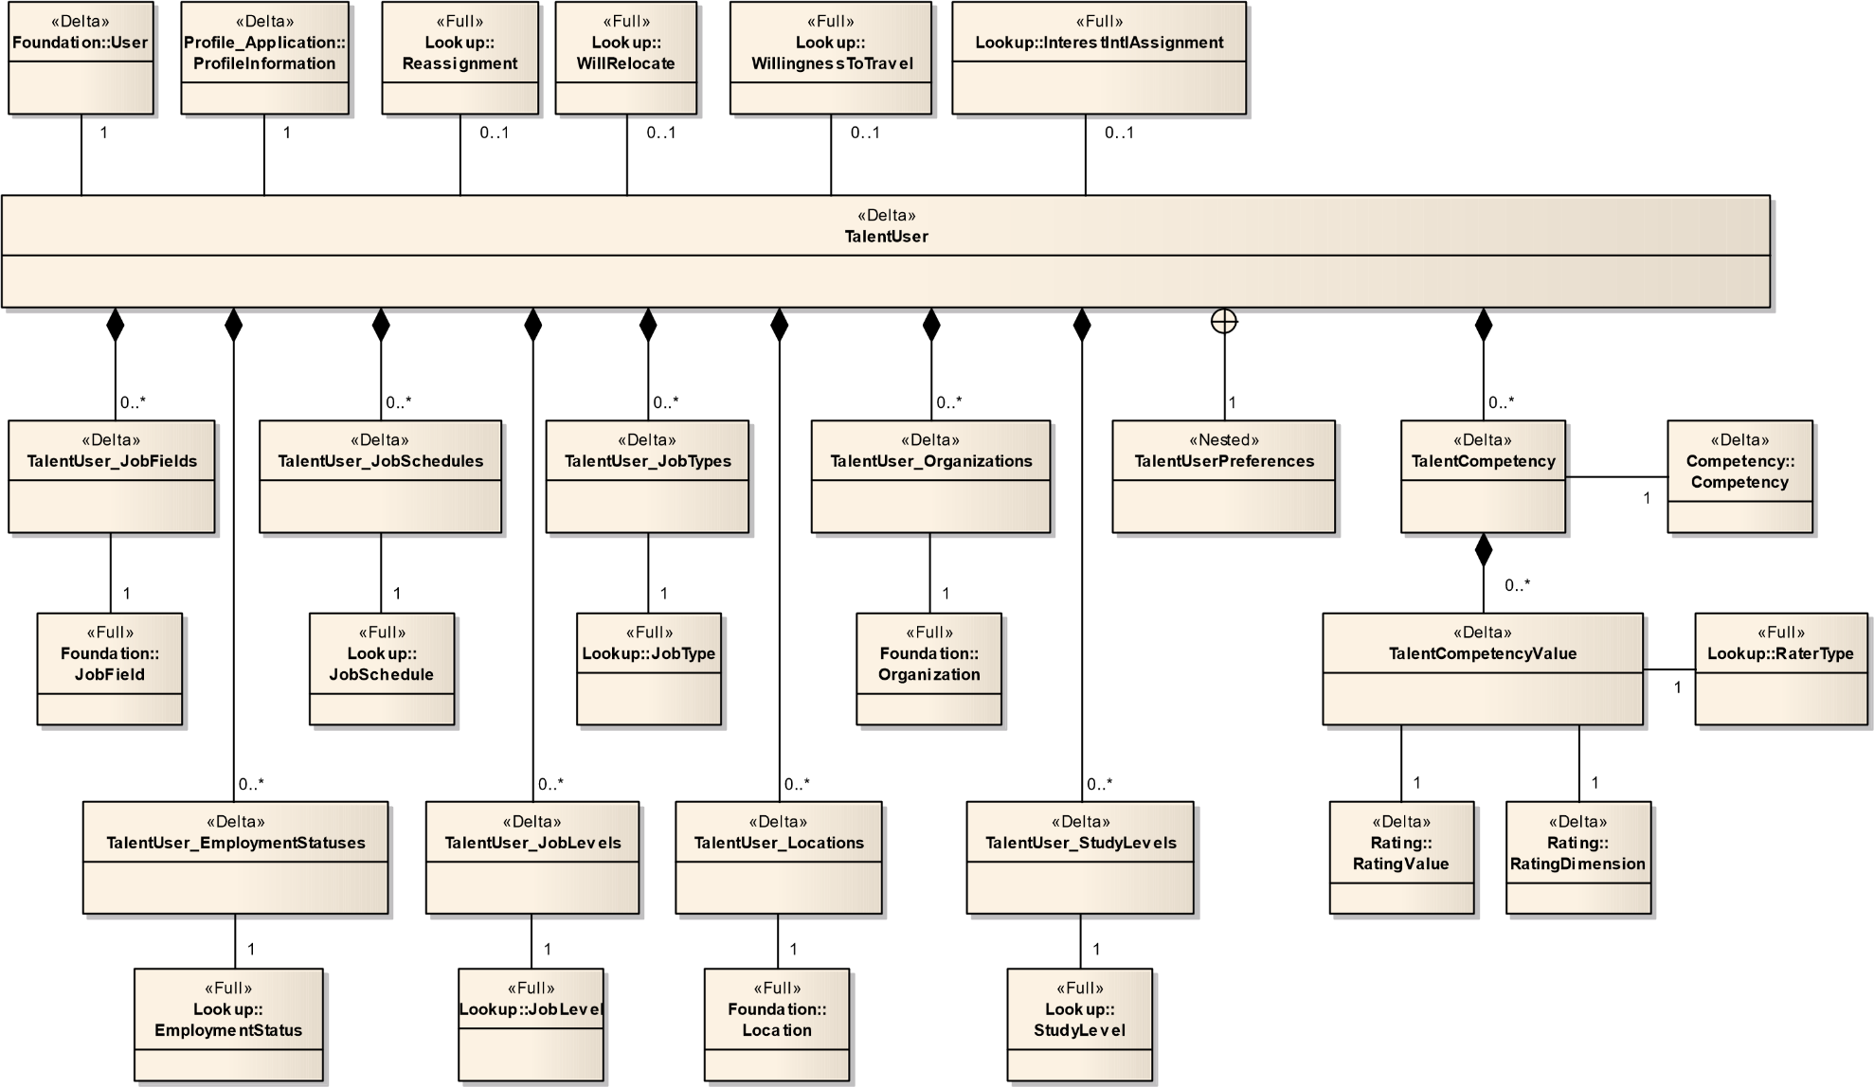

Figure 4 TalentUser

### 4.1.9.1 TalentUser – (Delta)

The talent user is the common person information layer. A person can be a Candidate, an employee, a contact, or any combination of these types. The talent user also contains a part of the person's profile and job Preferences. Remaining part of the profile is found via the profile Relationship. RemoveCheckOnCreate=true)

|  |  |  |  |  |  |  |
| --- | --- | --- | --- | --- | --- | --- |
| Field No | Field Name | Type | Nullable | Reference Table | Reference Field | Comments |
| 1 | Number | Number(18) | N |  |  |  |
| 2 | LastModifiedDate | DateTime | N |  |  |  |
| 3 | YearsInIndustry | Number(10) | Y |  |  |  |
| 4 | YearsOfManagementExperience | Number(10) | Y |  |  |  |
| 5 | ArUser_UserNo | Number(18) | Y | User | UserNo |  |
| 6 | Employee_Number | Number(18) | Y | Employee | Number |  |
| 7 | InterestIntlAssign_Number | Number(18) | Y | InterestIntlAssignment | Number |  |
| 8 | Profile_Number | Number(18) | N | ProfileInformation | Number |  |
| 9 | Reassignment_Number | Number(18) | Y | Reassignment | Number |  |
| 10 | WillingnessToTravel_Number | Number(18) | Y | WillingnessToTravel | Number |  |
| 11 | WillRelocate_Number | Number(18) | Y | WillRelocate | Number |  |
| 12 | CareerSiteLanguage_ISO | Char(15) | Y | Language | ISO |  |
| 13 | CorrespondenceLanguage_ISO | Char(15) | Y | Language | ISO |  |
| 14 | DoNotEmail | Boolean | Y |  |  |  |
| 15 | LastReferralListAccessDate | DateTime | Y |  |  |  |
| 16 | LastSubmissionListAccessDate | DateTime | Y |  |  |  |
| 17 | PreferredTimeZone_Number | Number(18) | Y | TaleoTimeZone | Number |  |
| 18 | SendApplicationAcknowledgement | Boolean | Y |  |  |  |
| 19 | SendJobPostingNotification | Boolean | Y |  |  |  |
| 20 | SendMyJobAgentsNotice | Boolean | Y |  |  |  |
| 21 | SendRejectionLetterNotice | Boolean | Y |  |  |  |

### 4.1.9.2 TalentUser_EmploymentStatuses – (Delta)

|  |  |  |  |  |  |  |
| --- | --- | --- | --- | --- | --- | --- |
| Field No | Field Name | Type | Nullable | Reference Table | Reference Field | Comments |
| 1 | Number | Number(18) | N | TalentUser | Number |  |
| 2 | EmploymentStatus_Number | Number(18) | N | EmploymentStatus | Number |  |

### 4.1.9.3 TalentUser_JobSchedules – (Delta)

|  |  |  |  |  |  |  |
| --- | --- | --- | --- | --- | --- | --- |
| Field No | Field Name | Type | Nullable | Reference Table | Reference Field | Comments |
| 1 | Number | Number(18) | N | TalentUser | Number |  |
| 2 | JobSchedule_Number | Number(18) | N | JobSchedule | Number |  |

### 4.1.9.4 TalentUser_Locations – (Delta)

|  |  |  |  |  |  |  |
| --- | --- | --- | --- | --- | --- | --- |
| Field No | Field Name | Type | Nullable | Reference Table | Reference Field | Comments |
| 1 | Number | Number(18) | N | TalentUser | Number |  |
| 2 | Location_Number | Number(18) | N | Location | Number |  |

### 4.1.9.5 TalentUser_Organizations – (Delta)

|  |  |  |  |  |  |  |
| --- | --- | --- | --- | --- | --- | --- |
| Field No | Field Name | Type | Nullable | Reference Table | Reference Field | Comments |
| 1 | Number | Number(18) | N | TalentUser | Number |  |
| 2 | Organization_Number | Number(18) | N | Organization | Number |  |

### 4.1.9.6 TalentUser_ StudyLevels – (Delta)

|  |  |  |  |  |  |  |
| --- | --- | --- | --- | --- | --- | --- |
| Field No | Field Name | Type | Nullable | Reference Table | Reference Field | Comments |
| 1 | Number | Number(18) | N | TalentUser | Number |  |
| 2 | StudyLevel_Number | Number(18) | N | StudyLevel | Number |  |

# 4.2 recruiting

## 4.2.1 Approval

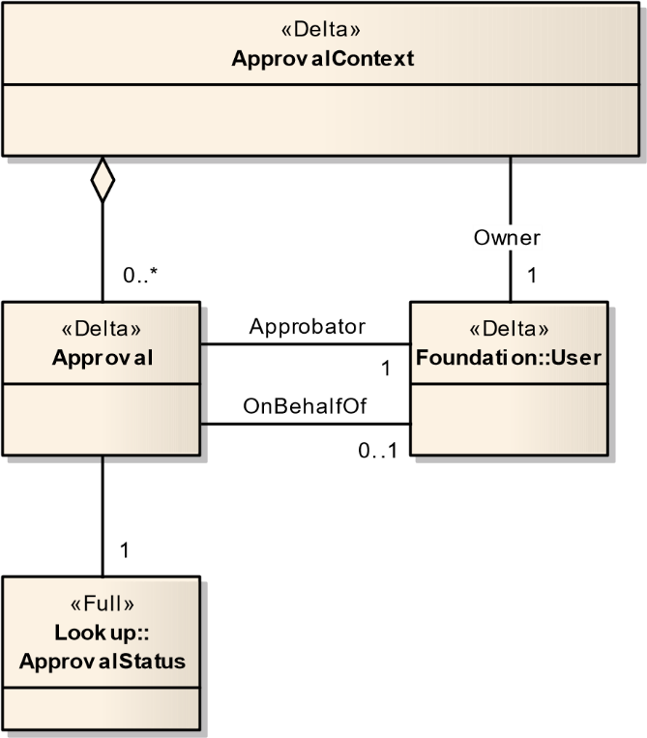

Figure 5 - Approval

### 4.2.1.1 Approval – (Delta)

This is an approbation state. It keeps comment and decision for one user during one approbation process.

|  |  |  |  |  |  |  |
| --- | --- | --- | --- | --- | --- | --- |
| Field No | Field Name | Type | Nullable | Reference Table | Reference Field | Comments |
| 1 | No | Number(18) | N |  |  |  |
| 2 | CreationDate | DateTime | N |  |  |  |
| 3 | Comment | Char(4000) | Y |  |  |  |
| 4 | Sequence | Number(5) | N |  |  |  |
| 5 | Approbator_UserNo | Number(18) | N | User | UserNo |  |
| 6 | ApprovalContext_No | Number(18) | N | ApprovalContext | No |  |
| 7 | ApprovalStatus_Number | Number(18) | N | ApprovalStatus | Number |  |
| 8 | OnBehalfOfUser_UserNo | Number(18) | Y | User | UserNo |  |

### 4.2.1.2 ApprovalContext – (Delta)

ApprovalContext makes links between the approbation process (defined by the [ProcessDefinition]) and approbations states made during approbation process.

|  |  |  |  |  |  |  |
| --- | --- | --- | --- | --- | --- | --- |
| Field No | Field Name | Type | Nullable | Reference Table | Reference Field | Comments |
| 1 | No | Number(18) | N |  |  |  |
| 2 | CreationDate | DateTime | N |  |  |  |
| 3 | ApprovalRequestorComment | Char(4000) | Y |  |  |  |
| 4 | Approbations_Number | Number(18) | Y | Approbations | Number |  |
| 5 | Owner_UserNo | Number(18) | N | User | UserNo |  |

## 4.2.2 Candidate

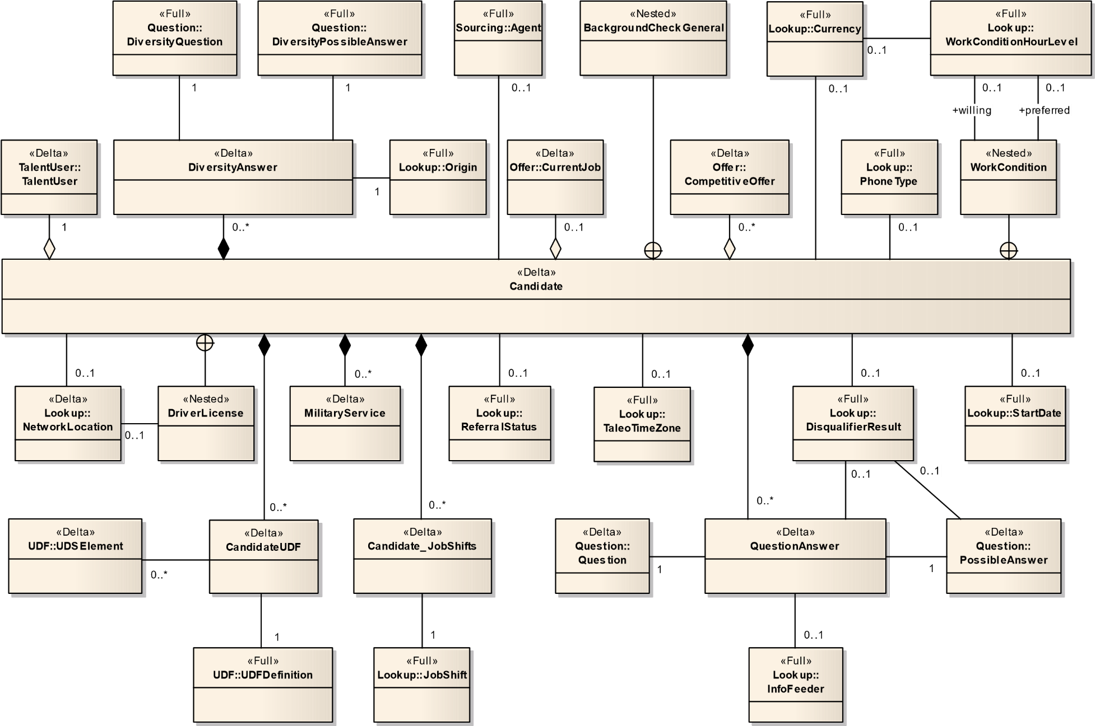

Figure 6 - Candidate

### 4.2.2.1 Candidate – (Delta)

Candidate is one of the most important aspect in the recruitment process. A candidate is an individual about whom a customer possesses relevant information, such as his/her Profile and Personal Info. This information may be acquired as follows:

- Most often, the candidate provides it when he/she applies on a position using a requisition or through unsolicited manner. This can be done using an electronic application or through regular mail.

- In some cases, the candidate may not have provided some information. The candidate can be an individual that do not work for the company or it can be an internal employee.

|  |  |  |  |  |  |  |
| --- | --- | --- | --- | --- | --- | --- |
| Field No | Field Name | Type | Nullable | Reference Table | Reference Field | Comments |
| 1 | Number | Number(18) | N |  |  |  |
| 2 | ActiveApplicationCount | Number(18) | Y |  |  |  |
| 3 | Address | Char(100) | Y |  |  |  |
| 4 | Address2 | Char(100) | Y |  |  |  |
| 5 | Anonymous | Boolean | Y |  |  |  |
| 6 | AvailabilityDate | Date | Y |  |  |  |
| 7 | Birthday | Date | Y |  |  |  |
| 8 | City | Char(100) | Y |  |  |  |
| 9 | CreationDate | DateTime | N |  |  |  |
| 10 | CSWLatestDate | DateTime | Y |  |  |  |
| 11 | DisqualifierResultDate | DateTime | Y |  |  |  |
| 12 | EmailAddress | Char(100) | Y |  |  |  |
| 13 | EmployeeCreationDate | Date | Y |  |  |  |
| 14 | EmployeeNumber | Char(50) | Y |  |  |  |
| 15 | Fax | Char(50) | Y |  |  |  |
| 16 | FirstName | Char(255) | Y |  |  |  |
| 17 | HasReferred | Boolean | N |  |  |  |
| 18 | HomePhone | Char(50) | Y |  |  |  |
| 19 | Hourly | Boolean | N |  |  |  |
| 20 | IdentificationMissing | Boolean | Y |  |  |  |
| 21 | InclusiveLastModifiedDate | DateTime | Y |  |  |  |
| 22 | InHiringProcess | Boolean | N |  |  |  |
| 23 | InternalApplication | Boolean | N |  |  |  |
| 24 | IsApplicant | Boolean | N |  |  |  |
| 25 | IsPersonalInfoMasked | Boolean | N |  |  |  |
| 26 | LastActivityDate | Date | Y |  |  |  |
| 27 | LastApplicationDate | Date | Y |  |  |  |
| 28 | LastModifiedDate | DateTime | Y |  |  |  |
| 29 | LastName | Char(255) | Y |  |  |  |
| 30 | MiddleInitial | Char(60) | Y |  |  |  |
| 31 | MobilePhone | Char(50) | Y |  |  |  |
| 32 | NotifyByEmail | Boolean | Y |  |  |  |
| 33 | PagerPhone | Char(50) | Y |  |  |  |
| 34 | PersonalInfoValidated | Boolean | N |  |  |  |
| 35 | Prefix | Char(30) | Y |  |  |  |
| 36 | ReferenceDate | DateTime | Y |  |  |  |
| 37 | ReferenceEndDate | DateTime | Y |  |  |  |
| 38 | ReferralType | Chart(100) | Y |  |  |  |
| 39 | Referred | Boolean | Y |  |  |  |
| 40 | Salary | Number(30,15) | Y |  |  |  |
| 41 | SocialSecurityNumber | Char(50) | Y |  |  |  |
| 42 | SubscribeURL | Char(255) | Y |  |  |  |
| 43 | Suffix | Char(30) | Y |  |  |  |
| 44 | WebSite | Char(255) | Y |  |  |  |
| 45 | WorkPhone | Char(50) | Y |  |  |  |
| 46 | ZipCode | Char(20) | Y |  |  |  |
| 47 | AdvanceNotice_Number | Number(18) | Y | StartDate | Number |  |
| 48 | CandidateReferrer_Number | Number(18) | Y | CandidateReferrer | Number |  |
| 49 | Credentials_SSOID | Char(255) | Y | Credentials | SSOID |  |
| 50 | Credentials_Number | Char(100) | N | Credentials | Username |  |
| 51 | Currency_Number | Number(18) | Y | Currency | Number |  |
| 52 | DisqualifierResult_Number | Number(18) | Y | DisqualifierResult | Number |  |
| 53 | DriverLicenseNumber | Char(50) | Y |  |  |  |
| 54 | DriverLicenseLocation_Number | Number(18) | Y | NetworkLocation | Number |  |
| 55 | OwnerAgent_Number | Number(18) | Y | Agent | Number |  |
| 56 | PreferredPhone_Number | Number(18) | Y | PhoneType | Number |  |
| 57 | ReferralStatus_Number | Number(18) | Y | ReferralStatus | Number |  |
| 58 | ResidenceLocation_Number | Number(18) | Y | NetworkLocation | Number |  |
| 59 | RLCountry_Number | Number(18) | Y | NetworkLocation | Number |  |
| 60 | RLRegion_Number | Number(18) | Y | NetworkLocation | Number |  |
| 61 | RLState_Number | Number(18) | Y | NetworkLocation |  |  |
| 62 | TalentUser_Number | Number(18) | N | TalentUser | Number |  |
| 63 | TimeZone_Number | Number(18) | Y | TaleoTimeZone | Number |  |
| 64 | AvailableHolidays | Boolean | Y |  |  |  |
| 65 | AvailableWeekends | Boolean | Y |  |  |  |
| 66 | HourlyPayRateExpected | Number(15,3) | Y |  |  |  |
| 67 | HoursPerWeekPreferred_Number | Number(18) | Y | HoursPerWeekPreferred | Number |  |
| 68 | HoursPerWeekPreferred_Number | Number(18) | Y | HoursPerWeekWilling | Number |  |

### 4.2.2.2 CandidateUDFs – (Delta) Contains user defined field and user defined selection elements related to the candidate entity.

### 4.2.2.3 Candidate_JobShifts – (Delta)

|  |  |  |  |  |  |  |
| --- | --- | --- | --- | --- | --- | --- |
| Field No | Field Name | Type | Nullable | Reference Table | Reference Field | Comments |
| 1 | Candidate_Number | Number(18) | N | Candidate | Number |  |
| 2 | JobShift_Number | Number(18) | N | JobShifts | Number |  |

### 4.2.2.4 DiversityAnswer – (Delta)

This is the concrete entity of an answer used for regulation purposes.

|  |  |  |  |  |  |  |
| --- | --- | --- | --- | --- | --- | --- |
| Field No | Field Name | Type | Nullable | Reference Table | Reference Field | Comments |
| 1 | Number | Number(18) | N |  |  |  |
| 2 | Candidate_Number | Number(18) | N | Candidate | Number |  |
| 3 | CreationDate | DateTime | N |  |  |  |
| 4 | Question_Number | Number(18) | N | DiversityQuestion | Number |  |
| 5 | PossibleAnswer_Number | Number(18) | N | DiversityPossibleAnswer | Number |  |
| 6 | Origin_Number | Number(18) | Y | Origin | Number |  |

### 4.2.2.5 QuestionAnswer – (Delta)

Represents an answer to a question by a given candidate. If the answer has a textual explanation, then there is no possible answer nor disqualifier result associated to it. Otherwise, the answer has a possible answer which corresponds to a choice presented to the candidate. A disqualifier result may be associated when the question is a disqualification question type. The question answer can be provided by the candidate or by any user of the system owning the required privileges.

|  |  |  |  |  |  |  |
| --- | --- | --- | --- | --- | --- | --- |
| Field No | Field Name | Type | Nullable | Reference Table | Reference Field | Comments |
| 1 | Number | Number(18) | N |  |  |  |
| 2 | Candidate_Number | Number(18) | N | Candidate | Number |  |
| 3 | CreationDate | DateTime | N |  |  |  |
| 4 | Question_Number | Number(18) | N | Question | Number |  |
| 5 | Answer_Number | Number(18) | Y | PossibleAnswer | Number |  |
| 6 | Explanation | Char(1000) | Y |  |  |  |
| 7 | DisqualifierResult_Number | Number(18) | Y | DisqualifierResult | Number |  |
| 8 | InfoFeeder_Number | Number(18) | Y | InfoFeeder | Number |  |

## 4.2.3 Workflow

«Full»

**CSWWorkflow**

«Full»

**CSWStep**

«Full»

**CSWStatus**

«Full»

**CSWMotive**

### 4.2.3.1 CSWMotive – (Full)

The CSWMotive entity represents a motive that can be created to describe an event (for example, 'Canceled the interview'). The CSWMotive also has a mnemonic and an availability flag which are inherited from the CSWObject. The CSWMotive is described as a Qualifier in the application administration section.

|  |  |  |  |  |  |  |
| --- | --- | --- | --- | --- | --- | --- |
| Field No | Field Name | Type | Nullable | Reference Table | Reference Field | Comments |
| 1 | Number | Number(18) | N |  |  |  |
| 2 | Available | Boolean | N |  |  |  |
| 3 | Description | Char(765) | Y |  |  |  |
| 4 | Mnemonic | Char(765) | N |  |  |  |
| 5 | Name | Char(765) | Y |  |  |  |

### 4.2.3.2 CSWStatus – (Full)

The CSW Status represents a portion of a Step. The steps are made of statuses and when these statuses are completed, the step is considered complete.

|  |  |  |  |  |  |  |
| --- | --- | --- | --- | --- | --- | --- |
| Field No | Field Name | Type | Nullable | Reference Table | Reference Field | Comments |
| 1 | Number | Number(18) | N |  |  |  |
| 2 | Available | Boolean | N |  |  |  |
| 3 | Description | Char(765) | Y |  |  |  |
| 4 | Mnemonic | Char(765) | N |  |  |  |
| 5 | Name | Char(765) | Y |  |  |  |
| 6 | ApplicationState_Number | Number(18) | N | ApplicationState | Number |  |

### 4.2.3.3 CSWStatusUsage – (Full)

[Purpose]

|  |  |  |  |  |  |  |
| --- | --- | --- | --- | --- | --- | --- |
| Field No | Field Name | Type | Nullable | Reference Table | Reference Field | Comments |
| 1 | Sequence | Number(18) | N |  |  |  |
| 2 | Active | Boolean | N |  |  |  |
| 3 | AllConstraintsMustBeValid | Boolean | Y |  |  |  |
| 4 | AutoFlow | Boolean | N |  |  |  |
| 5 | ConditionnalCompletenessAllowed | Boolean | Y |  |  |  |
| 6 | Initial | Boolean | N | ApplicationState | Number |  |
| 7 | MeetingCompliant | Boolean | Y |  |  |  |
| 8 | NewEntryNotificationNumber | Number(30,15) | Y |  |  |  |
| 9 | QueueAndRouteShortcutNumber | Number(30,15) | Y |  |  |  |
| 10 | RsCSWAskForCommentModeNumber | Number(30,15) | Y |  |  |  |
| 11 | RsCSWAskForMotiveModeNumber | Number(30,15) | Y |  |  |  |
| 12 | ProgressionLevel_Number | Number(18) | Y | CSWStepProgressionLevel | Number |  |
| 13 | Status_Number | Number(18) | Y | CSWStatus | Number |  |
| 14 | Step_Number | Number(18) | Y | CSWStep | Number |  |

### 4.2.3.4 CSWStep – (Full)

The CSWStep represents the elements of a workflow. A workflow contains steps which contain statuses. Usage entities are used to group these elements together.

|  |  |  |  |  |  |  |
| --- | --- | --- | --- | --- | --- | --- |
| Field No | Field Name | Type | Nullable | Reference Table | Reference Field | Comments |
| 1 | Number | Number(18) | N |  |  |  |
| 2 | Available | Boolean | N |  |  |  |
| 3 | Description | Char(765) | Y |  |  |  |
| 4 | Mnemonic | Char(765) | N |  |  |  |
| 5 | Name | Char(765) | Y |  |  |  |
| 6 | ShortName | Char(150) | Y |  |  |  |
| 7 | ApplicationState_Number | Number(18) | N | ApplicationState | Number |  |
| 8 | StatusUsage_Sequence | Number(5) | Y | StatusUsages | Sequence |  |

### 4.2.3.5 CSWStepUsage – (Full)

|  |  |  |  |  |  |  |
| --- | --- | --- | --- | --- | --- | --- |
| Field No | Field Name | Type | Nullable | Reference Table | Reference Field | Comments |
| 1 | Sequence | Number(18) | Y |  |  |  |
| 2 | Active | Boolean | Y |  |  |  |
| 3 | ConditionalEntryAllowed | Boolean | Y |  |  |  |
| 4 | Mandatory | Boolean | Y |  |  |  |
| 5 | NewEntryNotificationNumber | Number(18) | Y |  |  |  |
| 6 | Restricted | Boolean | Y |  |  |  |
| 7 | Step_Number | Number(18) | Y | CSWStep | Number |  |
| 8 | Workflow_Number | Number(18) | Y | CSWWorkflow | Number |  |

### 4.2.3.6 CSWWorkflow – (Full)

A CSWWorkflow is basically a set of steps a candidate will go through. Flags, actions, conditions, etc. can be associated to these steps.

|  |  |  |  |  |  |  |
| --- | --- | --- | --- | --- | --- | --- |
| Field No | Field Name | Type | Nullable | Reference Table | Reference Field | Comments |
| 1 | Number | Number(18) | N |  |  |  |
| 2 | Available | Boolean | N |  |  |  |
| 3 | Description | Char(765) | Y |  |  |  |
| 4 | IsDefault | Boolean | N |  |  |  |
| 5 | Mnemonic | Char(765) | N |  |  |  |
| 6 | Name | Char(765) | Y |  |  |  |
| 7 | StepUsage_Sequence | Number(18) | Y | StepUsage | Sequence |  |

### 4.2.3.7 EntityDeletedReport – (Delta)

|  |  |  |  |  |  |  |
| --- | --- | --- | --- | --- | --- | --- |
| Field No | Field Name | Type | Nullable | Reference Table | Reference Field | Comments |
| 1 | EntityTypeReport_Description | Char(255) | Y |  |  |  |
| 2 | EntityTypeReport_Code | Char(255) | Y |  |  |  |
| 3 | EntityTypeReport_Number | Number(18) | Y |  |  |  |
| 4 | EntityNumbers | Char(255) | Y |  |  |  |
| 5 | ActionType | Number(18) | Y |  |  |  |
| 6 | ExecutionDate | DateTime | Y |  |  |  |

## 4.2.5 Lookup

### 4.2.5.1 ApplicationMedium – (Full)

This entity is a lookup containing the information on how did we learn about the candidate for a specific application.

|  |  |  |  |  |  |  |
| --- | --- | --- | --- | --- | --- | --- |
| Field No | Field Name | Type | Nullable | Reference Table | Reference Field | Comments |
| 1 | Number | Number(18) | N |  |  |  |
| 2 | Code | Char(150) | N |  |  |  |
| 3 | Description | Char(150) | Y |  |  |  |

### 4.2.5.2 ApplicationState – (Full)

This entity is a lookup containing the information about. The status representing the progression of an application within a specific step.

|  |  |  |  |  |  |  |
| --- | --- | --- | --- | --- | --- | --- |
| Field No | Field Name | Type | Nullable | Reference Table | Reference Field | Comments |
| 1 | Number | Number(18) | N |  |  |  |
| 2 | Description | Char(150) | Y |  |  |  |

### 4.2.5.3 ApprovalStatus – (Full)

|  |  |  |  |  |  |  |
| --- | --- | --- | --- | --- | --- | --- |
| Field No | Field Name | Type | Nullable | Reference Table | Reference Field | Comments |
| 1 | Number | Number(18) | N |  |  |  |
| 2 | Description | Char(150) | Y |  |  |  |

### 4.2.5.4 CandidateSelectionEvent – (Full)

This class is a lookup. It contains all the possible events that can occurred when a change happened during the selection process of the candidate.

|  |  |  |  |  |  |  |
| --- | --- | --- | --- | --- | --- | --- |
| Field No | Field Name | Type | Nullable | Reference Table | Reference Field | Comments |
| 1 | Number | Number(18) | N |  |  |  |
| 2 | Code | Char(200) | N |  |  |  |
| 3 | Description | Char(300) | Y |  |  |  |
| 4 | DetailDescription | Char(300) | Y |  |  |  |
| 5 | Category_Number | Number(18) | N | CandidateSelectionEventCatg | Number |  |

### 4.2.5.5 CandidateSelectionEventCategory – (Full)

This is a lookup class. It contains all the categories of the events that can occured when a change happened during the selection process of the candidate.

|  |  |  |  |  |  |  |
| --- | --- | --- | --- | --- | --- | --- |
| Field No | Field Name | Type | Nullable | Reference Table | Reference Field | Comments |
| 1 | Number | Number(18) | N |  |  |  |
| 2 | Code | Char(150) | N |  |  |  |
| 3 | Description | Char(150) | Y |  |  |  |

### 4.2.5.6 CitizenshipStatus – (Full)

Represents the different citizenship statuses.

|  |  |  |  |  |  |  |
| --- | --- | --- | --- | --- | --- | --- |
| Field No | Field Name | Type | Nullable | Reference Table | Reference Field | Comments |
| 1 | Number | Number(18) | N |  |  |  |
| 2 | Description | Char(150) | Y |  |  |  |

### 4.2.5.7 CompletionLevel – (Full)

The completion level for an entity. Requisition: for approval, for saving, etc. Candidate: for saving. Offer: for saving.

|  |  |  |  |  |  |  |
| --- | --- | --- | --- | --- | --- | --- |
| Field No | Field Name | Type | Nullable | Reference Table | Reference Field | Comments |
| 1 | Number | Number(18) | N |  |  |  |
| 2 | Code | Char(150) | N |  |  |  |
| 3 | Description | Char(150) | Y |  |  |  |

### 4.2.5.8 DisqualifierResult – (Full)

This is a disqualifier result. Each possible answer of a disqualification question must have a disqualifier result. It indicates the behavior result to the system when the candidate provides its answers to disqualification questions. Possible values can be Passed, To Be Verified or Failed.

|  |  |  |  |  |  |  |
| --- | --- | --- | --- | --- | --- | --- |
| Field No | Field Name | Type | Nullable | Reference Table | Reference Field | Comments |
| 1 | Number | Number(18) | N |  |  |  |
| 2 | Description | Char(150) | Y |  |  |  |

### 4.2.5.9 DiversityPossibleAnswerType – (Full)

This is the type of a possible answers. Possible values Undisclosed, Not Specified are applicable for all regulation question types. Other types only apply to one question type.

|  |  |  |  |  |  |  |
| --- | --- | --- | --- | --- | --- | --- |
| Field No | Field Name | Type | Nullable | Reference Table | Reference Field | Comments |
| 1 | Number | Number(18) | N |  |  |  |
| 2 | Code | Char(50) | N |  |  |  |
| 3 | Name | Char(200) | Y |  |  |  |
| 4 | Origin_Number | Number(18) | N | Origin |  | Number |
| 5 | Status_Number | Number(18) | N | AdminEntityStatus |  | Number |

### 4.2.5.10 DiversityQuestionType – (Full)

This is the type of regulation question. Ethnicity, race and gender are a few examples configured in the system. This information is set for a question only when QuestionType = REGULATION.

|  |  |  |  |  |  |  |
| --- | --- | --- | --- | --- | --- | --- |
| Field No | Field Name | Type | Nullable | Reference Table | Reference Field | Comments |
| 1 | Number | Number(18) | N |  |  |  |
| 2 | Code | Char(50) | N |  |  |  |
| 3 | Name | Char(200) | Y |  |  |  |
| 4 | Origin_Number | Number(18) | N | Origin |  | Number |
| 5 | Status_Number | Number(18) | N | AdminEntityStatus |  | Number |

### 4.2.5.11 EmailState – (Full)

This class contains the states that an email can have.

|  |  |  |  |  |  |  |
| --- | --- | --- | --- | --- | --- | --- |
| Field No | Field Name | Type | Nullable | Reference Table | Reference Field | Comments |
| 1 | Number | Number(18) | N |  |  |  |
| 2 | Code | Char(150) | N |  |  |  |
| 3 | Description | Char(150) | Y |  |  |  |

### 4.2.5.12 EmploymentEquityEstablishment – (Full)

This is the employment equity establishment.

|  |  |  |  |  |  |  |
| --- | --- | --- | --- | --- | --- | --- |
| Field No | Field Name | Type | Nullable | Reference Table | Reference Field | Comments |
| 1 | Number | Number(18) | N |  |  |  |
| 2 | Description | Char(150) | Y |  |  |  |

### 4.2.5.13 EmploymentEquityJobCategory – (Full)

This is the employment equity job category. Each job category is associated to a Taleo location. Job categories are organized in a hierarchical structure. The first level represents the category; the second level is the group. Job categories are also organized by version so there can be more than one structure for each location.

|  |  |  |  |  |  |  |
| --- | --- | --- | --- | --- | --- | --- |
| Field No | Field Name | Type | Nullable | Reference Table | Reference Field | Comments |
| 1 | Number | Number(18) | N |  |  |  |
| 2 | Description | Char(150) | N |  |  |  |
| 3 | TheLocale | Char(150) | Y |  |  |  |
| 4 | NetworkLocation_Number | Number(18) | N | NetworkLocation | Number |  |

### 4.2.5.14 EmploymentEquityQuestionType – (Full)

This is the type of employment equity question. Ethnicity, race and gender are a few examples configured in the system. This information is se: for a question only when TypeOfQuestion = EEO.

|  |  |  |  |  |  |  |
| --- | --- | --- | --- | --- | --- | --- |
| Field No | Field Name | Type | Nullable | Reference Table | Reference Field | Comments |
| 1 | Number | Number(18) | N |  |  |  |
| 2 | Description | Char(150) | Y |  |  |  |

### 4.2.5.15 ExpectationType – (Full)

At design time, the initial values are "willAccept", "desires" and "willRefuse". Please refer to class implementation for the most up-to-date list of values.

|  |  |  |  |  |  |  |
| --- | --- | --- | --- | --- | --- | --- |
| Field No | Field Name | Type | Nullable | Reference Table | Reference Field | Comments |
| 1 | Number | Number(18) | N |  |  |  |
| 2 | Description | Char(150) | Y |  |  |  |

### 4.2.5.16 ExtensionMechanism – (Full)

The ExtensionMechanism is a multilingual lookup enumerating the valid mechanisms to extend an offer. These values are not customizable. The initial values are "e-mail", "verbally", "letter" and "e-offer". Please refer to database for currently used values.

|  |  |  |  |  |  |  |
| --- | --- | --- | --- | --- | --- | --- |
| Field No | Field Name | Type | Nullable | Reference Table | Reference Field | Comments |
| 1 | Number | Number(18) | N |  |  |  |
| 2 | Description | Char(150) | Y |  |  |  |

### 4.2.5.17 HireType – (Full)

This lookup entity indicates the hire type used (Professional, Hourly, Campus, etc.).

|  |  |  |  |  |  |  |
| --- | --- | --- | --- | --- | --- | --- |
| Field No | Field Name | Type | Nullable | Reference Table | Reference Field | Comments |
| 1 | Number | Number(18) | N |  |  |  |
| 2 | Active | Boolean | N |  |  |  |
| 3 | Code | Char(50) | N |  |  |  |
| 4 | Description | Char(200) | Y |  |  |  |
| 5 | Sequence | Number(5) | N |  |  |  |

### 4.2.5.18 JobBoardType – (Full)

This class contains all the jobboard type for a jobboard.

|  |  |  |  |  |  |  |
| --- | --- | --- | --- | --- | --- | --- |
| Field No | Field Name | Type | Nullable | Reference Table | Reference Field | Comments |
| 1 | Number | Number(18) | N |  |  |  |
| 2 | Description | Char(150) | Y |  |  |  |

### 4.2.5.19 JobTemplateState – (Full)

Represents the different states of a job template: active, draft, inactive, deleted.

|  |  |  |  |  |  |  |
| --- | --- | --- | --- | --- | --- | --- |
| Field No | Field Name | Type | Nullable | Reference Table | Reference Field | Comments |
| 1 | Number | Number(18) | N |  |  |  |
| 2 | Description | Char(150) | Y |  |  |  |

### 4.2.5.20 Justification – (Full)

Represents the justification for a requisition: new position, replacement, etc.

|  |  |  |  |  |  |  |
| --- | --- | --- | --- | --- | --- | --- |
| Field No | Field Name | Type | Nullable | Reference Table | Reference Field | Comments |
| 1 | Number | Number(18) | N |  |  |  |
| 2 | Active | Boolean | N |  |  |  |
| 3 | Code | Char(150) | N |  |  |  |
| 4 | Description | Char(150) | Y |  |  |  |
| 5 | Sequence | Number(5) | N |  |  |  |

### 4.2.5.21 MessageDeliveryTransport – (Full)

Email, fax.

|  |  |  |  |  |  |  |
| --- | --- | --- | --- | --- | --- | --- |
| Field No | Field Name | Type | Nullable | Reference Table | Reference Field | Comments |
| 1 | Number | Number(18) | N |  |  |  |
| 2 | Description | Char(150) | Y |  |  |  |

### 4.2.5.22 OfferStatus – (Full)

The ArtOfferStatus represents the possible states of the offer; these are only applicable for an ArtOffer since it is the only one that can evolve. When an ArtOffer is created, the default value is DRAFT. The process starts till a final state, such as REFUSED or ACCEPTED. Many other states are possible.

|  |  |  |  |  |  |  |
| --- | --- | --- | --- | --- | --- | --- |
| Field No | Field Name | Type | Nullable | Reference Table | Reference Field | Comments |
| 1 | Number | Number(18) | N |  |  |  |
| 2 | Description | Char(150) | Y |  |  |  |

### 4.2.5.23 OfferTitle – (Full)

The ArtOfferTitle is a multilingual representation of the different titles that an Offer can have. These titles provide descriptive information. The initial values are "Current Offer," "Offer," "Requisition," "Will Refuse," "Current Job," "Will Accept," "Competitive Offer Terms," "Extended Offer," "Counter Offer," etc.. Please refer to the database for currently used values.

|  |  |  |  |  |  |  |
| --- | --- | --- | --- | --- | --- | --- |
| Field No | Field Name | Type | Nullable | Reference Table | Reference Field | Comments |
| 1 | Number | Number(18) | N |  |  |  |
| 2 | Description | Char(150) | Y |  |  |  |

### 4.2.5.24 OvertimeStatus – (Full)

Represents the different overtime statuses (exempt, non-exempt).

|  |  |  |  |  |  |  |
| --- | --- | --- | --- | --- | --- | --- |
| Field No | Field Name | Type | Nullable | Reference Table | Reference Field | Comments |
| 1 | Number | Number(18) | N |  |  |  |
| 2 | Description | Char(150) | Y |  |  |  |

### 4.2.5.25 PayFrequencyBasis – (Full)

The ArtPayFrequencyBasis is used to express the frequency the user will be paid. Many values are possible from DAILY to YEARLY.

|  |  |  |  |  |  |  |
| --- | --- | --- | --- | --- | --- | --- |
| Field No | Field Name | Type | Nullable | Reference Table | Reference Field | Comments |
| 1 | Number | Number(18) | N |  |  |  |
| 2 | Description | Char(150) | Y |  |  |  |

### 4.2.5.26 QuestionType – (Full)

This is the type of question. It determines the usage of the question. Prescreening, Security and EmployementEquity are some exemples.

|  |  |  |  |  |  |  |
| --- | --- | --- | --- | --- | --- | --- |
| Field No | Field Name | Type | Nullable | Reference Table | Reference Field | Comments |
| 1 | Number | Number(18) | N |  |  |  |
| 2 | Description | Char(150) | Y |  |  |  |

### 4.2.5.27 RecruitmentSourceState – (Full)

This Class is a lookup class that define all the recruitment state (active/ inactive) for a recruitment source.

|  |  |  |  |  |  |  |
| --- | --- | --- | --- | --- | --- | --- |
| Field No | Field Name | Type | Nullable | Reference Table | Reference Field | Comments |
| 1 | Number | Number(18) | N |  |  |  |
| 2 | Code | Char(150) | N |  |  |  |
| 3 | Description | Char(150) | Y |  |  |  |

### 4.2.5.28 RecruitmentSourceType – (Full)

This Class is a lookup class that define all the recruitment source type available for a recruitment source.

|  |  |  |  |  |  |  |
| --- | --- | --- | --- | --- | --- | --- |
| Field No | Field Name | Type | Nullable | Reference Table | Reference Field | Comments |
| 1 | Number | Number(18) | N |  |  |  |
| 2 | Code | Char(150) | N |  |  |  |
| 3 | Description | Char(150) | Y |  |  |  |

### 4.2.5.29 RecruitmentSourceVisibility – (Full)

This class define the visibility associated with recruitment source.

|  |  |  |  |  |  |  |
| --- | --- | --- | --- | --- | --- | --- |
| Field No | Field Name | Type | Nullable | Reference Table | Reference Field | Comments |
| 1 | Number | Number(18) | N |  |  |  |
| 2 | Code | Char(150) | N |  |  |  |
| 3 | Description | Char(150) | Y |  |  |  |

### 4.2.5.30 ReferenceType – (Full)

This class define the type of reference the candidate can have. I.e Personal, Occupational, etc.

|  |  |  |  |  |  |  |
| --- | --- | --- | --- | --- | --- | --- |
| Field No | Field Name | Type | Nullable | Reference Table | Reference Field | Comments |
| 1 | Number | Number(18) | N |  |  |  |
| 2 | Description | Char(150) | Y |  |  |  |

### 4.2.5.31 ReferralStatus – (Full)

This class define the possible referral status a candidate can have according the referral process.

|  |  |  |  |  |  |  |
| --- | --- | --- | --- | --- | --- | --- |
| Field No | Field Name | Type | Nullable | Reference Table | Reference Field | Comments |
| 1 | Number | Number(18) | N |  |  |  |
| 2 | Code | Char(150) | N |  |  |  |
| 3 | Description | Char(150) | Y |  |  |  |

### 4.2.5.32 RelationshipLength – (Full)

This class is used to define the default values use to fill the field length of relationship in the reference class.

|  |  |  |  |  |  |  |
| --- | --- | --- | --- | --- | --- | --- |
| Field No | Field Name | Type | Nullable | Reference Table | Reference Field | Comments |
| 1 | Number | Number(18) | N |  |  |  |
| 2 | Description | Char(150) | Y |  |  |  |

### 4.2.5.33 RequestMoreInfoState – (Full)

This class contains all the states for the "Request More Info" letter.

|  |  |  |  |  |  |  |
| --- | --- | --- | --- | --- | --- | --- |
| Field No | Field Name | Type | Nullable | Reference Table | Reference Field | Comments |
| 1 | Number | Number(18) | N |  |  |  |
| 2 | Description | Char(150) | Y |  |  |  |

### 4.2.5.34 RequisitionParentState – (Full)

The general status (more of a global state) of the requisition.

|  |  |  |  |  |  |  |
| --- | --- | --- | --- | --- | --- | --- |
| Field No | Field Name | Type | Nullable | Reference Table | Reference Field | Comments |
| 1 | Number | Number(18) | N |  |  |  |
| 2 | Description | Char(150) | Y |  |  |  |

### 4.2.5.35 RequisitionState – (Full)

The detailed status (a more specific state) of the requisition.

|  |  |  |  |  |  |  |
| --- | --- | --- | --- | --- | --- | --- |
| Field No | Field Name | Type | Nullable | Reference Table | Reference Field | Comments |
| 1 | Number | Number(18) | N |  |  |  |
| 2 | Description | Char(150) | N |  |  |  |
| 3 | ParentState_Number | Number(18) | N | RequisitionParentState | Number |  |

### 4.2.5.36 SourcingRequestStatus – (Full)

This entity indicates the status of a posted job. A requisition can, for instance be posted, be unposted, or be expired on a job board.

|  |  |  |  |  |  |  |
| --- | --- | --- | --- | --- | --- | --- |
| Field No | Field Name | Type | Nullable | Reference Table | Reference Field | Comments |
| 1 | Number | Number(18) | N |  |  |  |
| 2 | Description | Char(150) | Y |  |  |  |

### 4.2.5.37 StartDate – (Full)

This is a lookup class. It contains the possible values that can be given by a cadidate or an operator for the advanced notice that the candidate must give to is current employer.

|  |  |  |  |  |  |  |
| --- | --- | --- | --- | --- | --- | --- |
| Field No | Field Name | Type | Nullable | Reference Table | Reference Field | Comments |
| 1 | Number | Number(18) | N |  |  |  |
| 2 | Active | Boolean | N |  |  |  |
| 3 | Code | Char(150) | N |  |  |  |
| 4 | Description | Char(150) | Y |  |  |  |

### 4.2.5.38 UDFType – (Full)

Defines the possible types of User Defined Fields.

|  |  |  |  |  |  |  |
| --- | --- | --- | --- | --- | --- | --- |
| Field No | Field Name | Type | Nullable | Reference Table | Reference Field | Comments |
| 1 | Number | Number(18) | N |  |  |  |
| 2 | Description | Char(150) | Y |  |  |  |

### 4.2.5.39 VacationType – (Full)

The ArtVactionType is a multilingual lookup entity representing the different possible vacation units: weeks, days, percent.

|  |  |  |  |  |  |  |
| --- | --- | --- | --- | --- | --- | --- |
| Field No | Field Name | Type | Nullable | Reference Table | Reference Field | Comments |
| 1 | Number | Number(18) | N |  |  |  |
| 2 | Description | Char(150) | Y |  |  |  |

### 4.2.5.40 WorkAction – (Full)

Available task to process (work action).

|  |  |  |  |  |  |  |
| --- | --- | --- | --- | --- | --- | --- |
| Field No | Field Name | Type | Nullable | Reference Table | Reference Field | Comments |
| 1 | Number | Number(18) | N |  |  |  |
| 2 | Description | Char(150) | Y |  |  |  |

### 4.2.5.41 WorkConditionHourLevel – (Full)

This class is a lookup to display the value of the following fields. WorkingCondition - hoursPerWeekWilling. WorkingCondition - hoursPerWeekPreferred.

|  |  |  |  |  |  |  |
| --- | --- | --- | --- | --- | --- | --- |
| Field No | Field Name | Type | Nullable | Reference Table | Reference Field | Comments |
| 1 | Number | Number(18) | N |  |  |  |
| 2 | Description | Char(150) | Y |  |  |  |

### 4.2.5.42 WorkerType – (Full)

This class is use in the contingent world and define a US income tax distinction as to how the contractor is paid.

|  |  |  |  |  |  |  |
| --- | --- | --- | --- | --- | --- | --- |
| Field No | Field Name | Type | Nullable | Reference Table | Reference Field | Comments |
| 1 | Number | Number(18) | N |  |  |  |
| 2 | Description | Char(150) | Y |  |  |  |

## 4.2.7 Offer

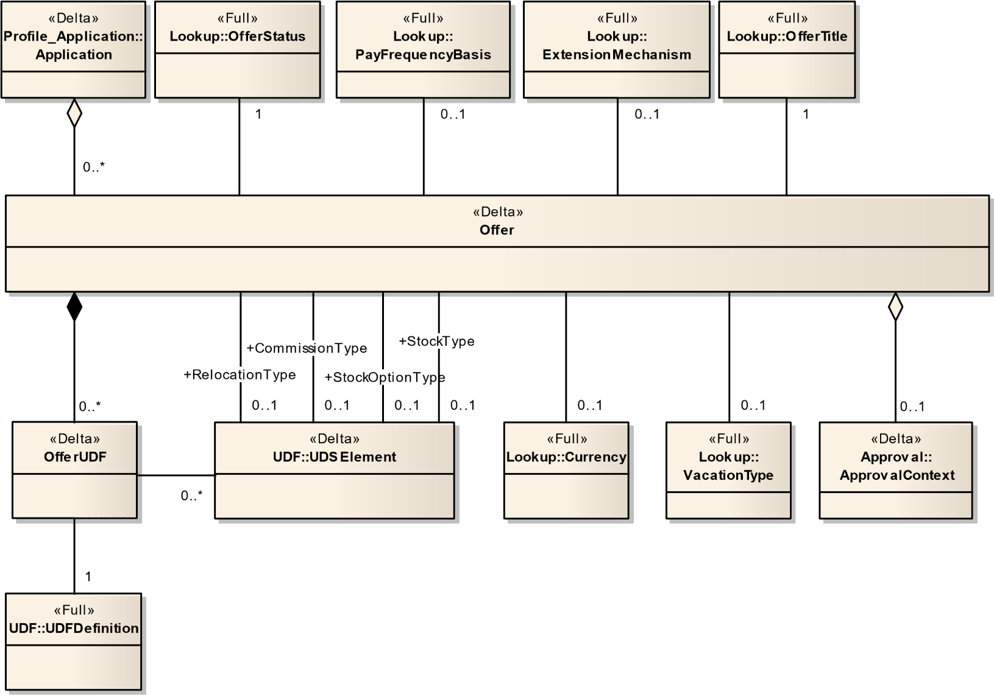

Figure 7 – Offer

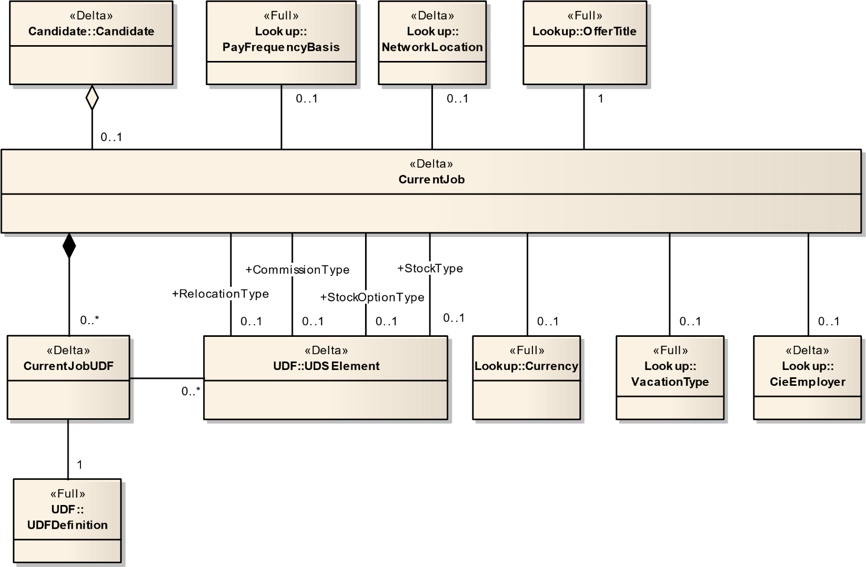

Figure 8 – CurrentJob

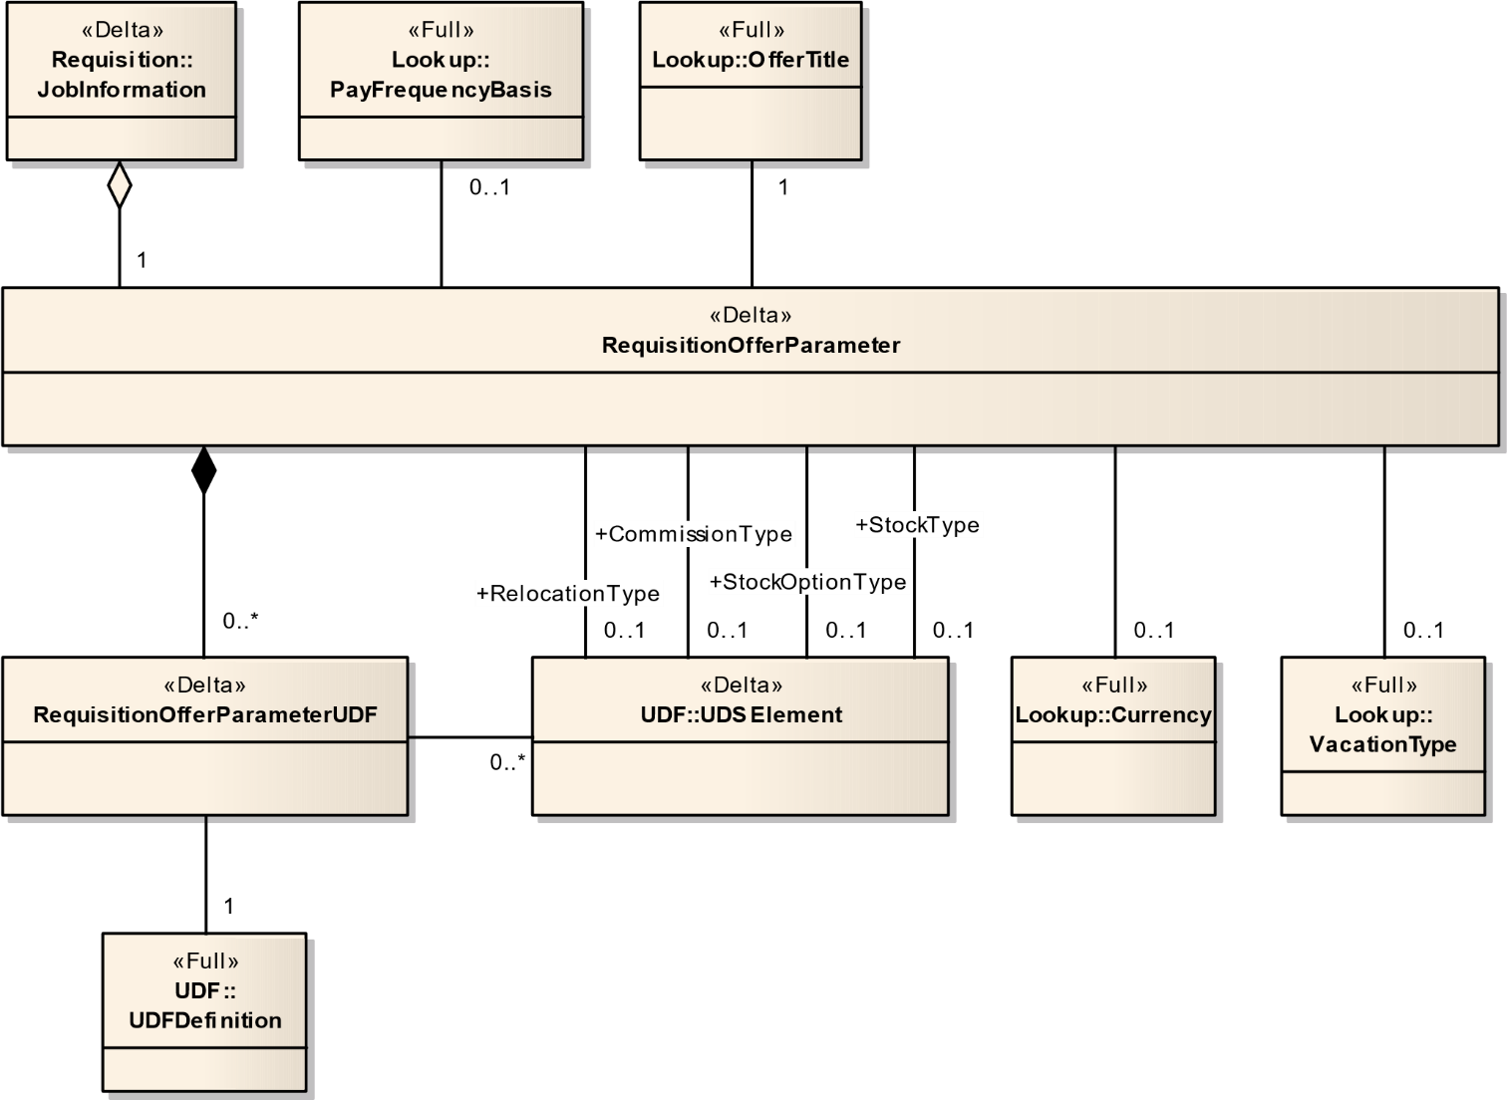

Figure 9 – RequisitionOfferParameter

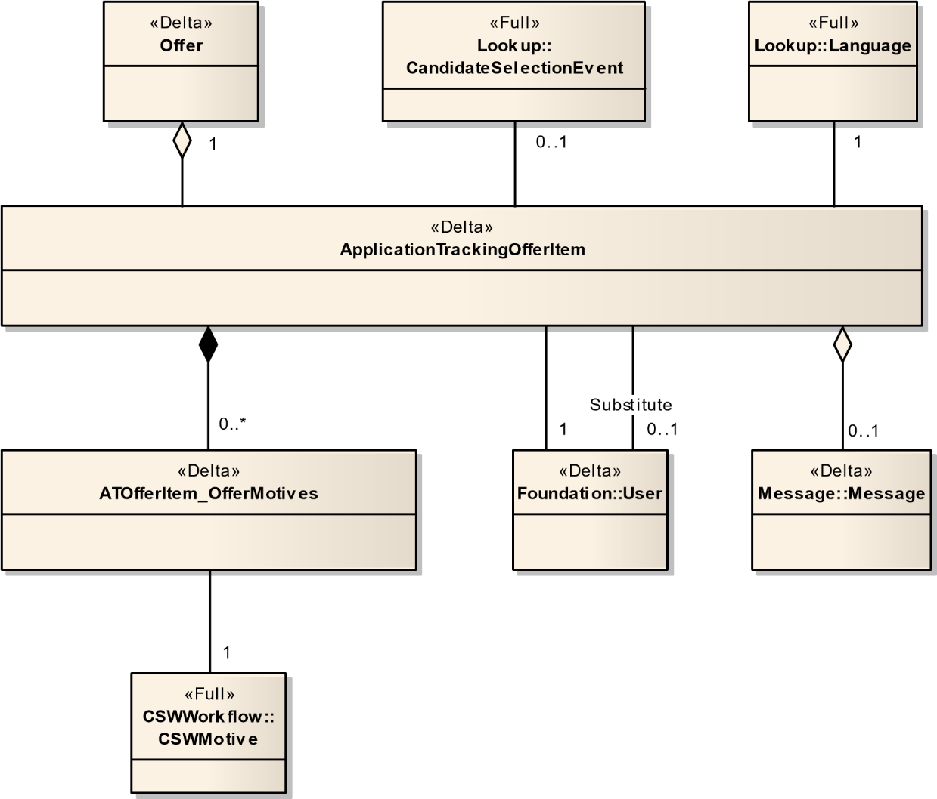

Figure 10 – ApplicationTrackingOfferItem

### 4.2.7.1 ApplicationTrackingOfferItem – (Delta)

An application tracking history item used to track candidate offer changes. (removeCheckOnCreate=true,removeCheckOnRead=true, removeCheckOnUpdate=true, RemoveCheckOnDelete=true)

|  |  |  |  |  |  |  |
| --- | --- | --- | --- | --- | --- | --- |
| Field No | Field Name | Type | Nullable | Reference Table | Reference Field | Comments |
| 1 | Number | Number(18) | N |  |  |  |
| 2 | CommentText | Char(4000) | Y |  |  |  |
| 3 | CreationDate | DateTime | N |  |  |  |
| 4 | Detail | Char(4000) | Y |  |  |  |
| 5 | EventDate | DateTime | Y |  |  |  |
| 6 | IsConditional | Boolean | Y |  |  |  |
| 7 | IsNewStartDateTentative | Boolean | Y |  |  |  |
| 8 | IsOldOfferAccepted | Boolean | Y |  |  |  |
| 9 | IsOldStartDateTentative | Boolean | Y |  |  |  |
| 10 | NewExpirationDate | DateTime | Y |  |  |  |
| 11 | NewStartDate | DateTime | Y |  |  |  |
| 12 | OfferAcceptedDate | DateTime | Y |  |  |  |
| 13 | OfferExtendedDate | DateTime | Y |  |  |  |
| 14 | OldExpirationDate | DateTime | Y |  |  |  |
| 15 | OldStartDate | DateTime | Y |  |  |  |
| 16 | ProfileLocale_ISO | Char(15) | Y | Language | ISO |  |
| 17 | Reverted | Boolean |  |  |  |  |
| 18 | Event_Number | Number(18) | Y | CandidateSelectionEvent | Number |  |
| 19 | Offer_Number | Number(18) | N | Offer | Number |  |
| 20 | Message_Number | Number(18) | Y | Message | Number |  |
| 21 | Substitute_UserNo | Number(18) | Y | User | UserNo |  |
| 22 | User_UserNo | Number(18) | N | User | UserNo |  |

### 4.2.7.2 ApplicationTrackingOfferMotive – (Delta)

|  |  |  |  |  |  |  |
| --- | --- | --- | --- | --- | --- | --- |
| Field No | Field Name | Type | Nullable | Reference Table | Reference Field | Comments |
| 1 | ATOfferItem_Number | Number(18) | N | ApplicationTrackingOfferItem | Number |  |
| 2 | OfferMotive_Number | Number(18) | Y | CSWMotives | Number |  |

### 4.2.7.3 CompetitiveOffer – (Delta)

The competitive offer information accompanies the candidate and indicates at what levels offers were made. This is useful in determining whether or not an offer is to be made to the candidate, and it serves as a. Guideline to the type (level) of offer that must be made. In future versions, this information will also be useful in providing market information for specific jobs.

|  |  |  |  |  |  |  |
| --- | --- | --- | --- | --- | --- | --- |
| Field No | Field Name | Type | Nullable | Reference Table | Reference Field | Comments |
| 1 | Number | Number(18) | N |  |  |  |
| 2 | AnnualBonus | Char(150) | Y |  |  |  |
| 3 | CaptureDate | DateTime | N |  |  |  |
| 4 | CarAllowance | Char(150) | Y |  |  |  |
| 5 | CommissionAmount | Char(150) | Y |  |  |  |
| 6 | CompetitiveJobDescription | Char(765) | Y |  |  |  |
| 7 | CompetitiveJobTitle | Char(765) | Y |  |  |  |
| 8 | CompetitiveOfferDate | DateTime | Y |  |  |  |
| 9 | CompetitiveOtherEmployer | Char(765) | Y |  |  |  |
| 10 | CompetitiveSequence | Number(5) | Y |  |  |  |
| 11 | DaysPerWeek | Number(5,2) | Y |  |  |  |
| 12 | ExpenseAccount | Char(150) | Y |  |  |  |
| 13 | HoursPerDay | Number(5,2) | Y |  |  |  |
| 14 | LastModifiedDate | DateTime | Y |  |  |  |
| 15 | Name | Char(765) | Y |  |  |  |
| 16 | Notes | Char(765) | Y |  |  |  |
| 17 | OtherBonus | Char(150) | Y |  |  |  |
| 18 | OtherCompensation | Char(150) | Y |  |  |  |
| 19 | PayValue | Number(30,15) | Y |  |  |  |
| 20 | RelocationAmount | Number(30,15) | Y |  |  |  |
| 21 | Salary | Number(30,15) | Y |  |  |  |
| 22 | SignOnBonus | Number(30,15) | Y |  |  |  |
| 23 | StockAmount | Char(150) | Y |  |  |  |
| 24 | StockOption | Char(150) | Y |  |  |  |
| 25 | TargetStartDate | DateTime | Y |  |  |  |
| 26 | Vacation | Number(5) | Y |  |  |  |
| 27 | Candidate_Number | Number(18) | Y | Candidate | Number |  |
| 28 | CommissionType_Number | Number(18) | Y | UDSElement | Number |  |
| 29 | CommissionType_UDS_Number | Number(18) | Y | UDSElement | UserDefinedSelectionNumber |  |
| 30 | CompetitiveCieEmployer_Number | Number(18) | Y | CieEmployer | Number |  |
| 31 | CompetitiveCieJobField_Number | Number(18) | Y | JobField | Number |  |
| 32 | CompetitiveCieLocation_Number | Number(18) | Y | NetworkLocation | Number |  |
| 33 | Currency_Number | Number(18) | Y | Currency | Number |  |
| 34 | OfferTitle_Number | Number(18) | N | OfferTitle | Number |  |
| 35 | PayFrequencyBasis_Number | Number(18) | Y | PayFrequencyBasis | Number |  |
| 36 | RelocationType_Number | Number(18) | Y | UDSElement | Number |  |
| 37 | RelocationType_UDS_Number | Number(18) | Y | UDSElement | UserDefinedSelectionNumber |  |
| 38 | StockOptionType_Number | Number(18) | Y | UDSElement | Number |  |
| 39 | StockOptionType_UDS_Number | Number(18) | Y | UDSElement | UserDefinedSelectionNumber |  |
| 40 | StockType_Number | Number(18) | Y | UDSElement | Number |  |
| 41 | StockType_UDS_Number | Number(18) | Y | UDSElement | UserDefinedSelectionNumber |  |
| 42 | VacationType_Number | Number(18) | Y | VacationType | Number |  |

### 4.2.7.4 CurrentJob – (Delta)

The ArtCurrentJob is used to provide information about the candidate current job when applicable. The ArtCurrentJob extends ArtAbstractOffer and provides also all the necessary information about the current candidate wage.

|  |  |  |  |  |  |  |
| --- | --- | --- | --- | --- | --- | --- |
| Field No | Field Name | Type | Nullable | Reference Table | Reference Field | Comments |
| **1** | **Number** | **Number(18)** | **N** |  |  |  |
| 2 | AnnualBonus | Char(150) | Y |  |  |  |
| 3 | CaptureDate | DateTime | N |  |  |  |
| 4 | CarAllowance | Char(150) | Y |  |  |  |
| 5 | CommissionAmount | Char(150) | Y |  |  |  |
| 6 | CurrentJobDescription | Char(765) | Y |  |  |  |
| 7 | CurrentJobTitle | Char(765) | Y |  |  |  |
| 8 | CurrentJobOfferDate | DateTime | Y |  |  |  |
| 9 | CurrentJobOtherEmployer | Char(765) | Y |  |  |  |
| 10 | DaysPerWeek | Number(5,2) | Y |  |  |  |
| 11 | ExpenseAccount | Char(150) | Y |  |  |  |
| 12 | HoursPerDay | Number(5,2) | Y |  |  |  |
| 13 | LastModifiedDate | DateTime | Y |  |  |  |
| 14 | Name | Char(765) | Y |  |  |  |
| 15 | Notes | Char(765) | Y |  |  |  |
| 16 | OtherBonus | Char(150) | Y |  |  |  |
| 17 | OtherCompensation | Char(150) | Y |  |  |  |
| 18 | PayValue | Number(30,15) | Y |  |  |  |
| 19 | RelocationAmount | Number(30,15) | Y |  |  |  |
| 20 | Salary | Number(30,15) | Y |  |  |  |
| 21 | SignOnBonus | Number(30,15) | Y |  |  |  |
| 22 | StockAmount | Char(150) | Y |  |  |  |
| 23 | StockOption | Char(150) | Y |  |  |  |
| 24 | TargetStartDate | DateTime | Y |  |  |  |
| 25 | Vacation | Number(5) | Y |  |  |  |
| 26 | Candidate_Number | Number(18) | Y | Candidate | Number |  |
| 27 | CommissionType_Number | Number(18) | Y | UDSElement | Number |  |
| 28 | CommissionType_UDS_Number | Number(18) | Y | UDSElement | UserDefinedSelectionNumber |  |
| 29 | Currency_Number | Number(18) | Y | Currency | Number |  |
| 30 | CurrentJobCieEmployer_Number | Number(18) | Y | CieEmployer | Number |  |
| 31 | CurrentJobCieJobField_Number | Number(18) | Y | JobField | Number |  |
| 32 | CurrentJobCieLocation_Number | Number(18) | Y | NetworkLocation | Number |  |
| 33 | OfferTitle_Number | Number(18) | N | OfferTitle | Number |  |
| 34 | PayFrequencyBasis_Number | Number(18) | Y | PayFrequencyBasis | Number |  |
| 35 | RelocationType_Number | Number(18) | Y | UDSElement | Number |  |
| 36 | RelocationType_UDS_Number | Number(18) | Y | UDSElement | UserDefinedSelectionNumber |  |
| 37 | StockOptionType_Number | Number(18) | Y | UDSElement | Number |  |
| 38 | StockOptionType_UDS_Number | Number(18) | Y | UDSElement | UserDefinedSelectionNumber |  |
| 39 | StockType_Number | Number(18) | Y | UDSElement | Number |  |
| 40 | StockType_UDS_Number | Number(18) | Y | UDSElement | UserDefinedSelectionNumber |  |
| 41 | VacationType_Number | Number(18) | Y | VacationType | Number |  |

### 4.2.7.5 Expectation – (Delta)

Represents a basic meta-entity that captures the expectations from a candidate who applied on a given requisition at any time (as long as the application exists). Candidate expectations are basically the terms that the candidate would admittedly accept or refuse. These are gathered through a process that some may refer to as the "Test offer". It provides the user with crucial data regarding candidate expectations at both ends of the spectrum (low end range = will definitely refuse, high end range = Can't refuse or Will definitely accept). Candidate expectations also include the information as to the terms that the candidate enjoys in his "current job".

|  |  |  |  |  |  |  |
| --- | --- | --- | --- | --- | --- | --- |
| Field No | Field Name | Type | Nullable | Reference Table | Reference Field | Comments |
| **1** | **Number** | **Number(18)** | **N** |  |  |  |
| 2 | AnnualBonus | Char(150) | Y |  |  |  |
| 3 | CaptureDate | DateTime | N |  |  |  |
| 4 | CarAllowance | Char(150) | Y |  |  |  |
| 5 | CommissionAmount | Char(150) | Y |  |  |  |
| 6 | DaysPerWeek | Number(5,2) | Y |  |  |  |
| 7 | ExpectationOfferDate | DateTime | Y |  |  |  |
| 8 | ExpenseAccount | Char(150) | Y |  |  |  |
| 9 | HoursPerDay | Number(5,2) | Y |  |  |  |
| 10 | LastModifiedDate | DateTime | Y |  |  |  |
| 11 | Name | Char(765) | Y |  |  |  |
| 12 | Notes | Char(765) | Y |  |  |  |
| 13 | OtherBonus | Char(150) | Y |  |  |  |
| 14 | OtherCompensation | Char(150) | Y |  |  |  |
| 15 | PayValue | Number(30,15) | Y |  |  |  |
| 16 | RelocationAmount | Number(30,15) | Y |  |  |  |
| 17 | Salary | Number(30,15) | Y |  |  |  |
| 18 | SignOnBonus | Number(30,15) | Y |  |  |  |
| 19 | StockAmount | Char(150) | Y |  |  |  |
| 20 | StockOption | Char(150) | Y |  |  |  |
| 21 | TargetStartDate | DateTime | Y |  |  |  |
| 22 | Vacation | Number(5) | Y |  |  |  |
| 23 | Application_Number | Number(18) | Y | Application | Number |  |
| 24 | CommissionType_Number | Number(18) | Y | UDSElement | Number |  |
| 25 | CommissionType_UDS_Number | Number(18) | Y | UDSElement | UserDefinedSelectionNumber |  |
| 26 | Currency_Number | Number(18) | Y | Currency | Number |  |
| 27 | ExpectationType_Number | Number(18) | N | ExpectationType | Number |  |
| 28 | OfferTitle_Number | Number(18) | N | OfferTitle | Number |  |
| 29 | PayFrequencyBasis_Number | Number(18) | Y | PayFrequencyBasis | Number |  |
| 30 | RelocationType_Number | Number(18) | Y | UDSElement | Number |  |
| 31 | RelocationType_UDS_Number | Number(18) | Y | UDSElement | UserDefinedSelectionNumber |  |
| 32 | StockOptionType_Number | Number(18) | Y | UDSElement | Number |  |
| 33 | StockOptionType_UDS_Number | Number(18) | Y | UDSElement | UserDefinedSelectionNumber |  |
| 34 | StockType_Number | Number(18) | Y | UDSElement | Number |  |
| 35 | StockType_UDS_Number | Number(18) | Y | UDSElement | UserDefinedSelectionNumber |  |
| 36 | VacationType_Number | Number(18) | Y | VacationType | Number |  |

### 4.2.7.6 Offer – (Delta)

ArtOffer represents an employment proposition to be eventually communicated to a specific candidate.

|  |  |  |  |  |  |  |
| --- | --- | --- | --- | --- | --- | --- |
| Field No | Field Name | Type | Nullable | Reference Table | Reference Field | Comments |
| **1** | **Number** | **Number(18)** | **N** |  |  |  |
| 2 | AcceptedDate | DateTime | Y |  |  |  |
| 3 | ActualStartDate | DateTime | Y |  |  |  |
| 4 | AnnualBonus | Char(150) | Y |  |  |  |
| 5 | ApprovedDate | DateTime | Y |  |  |  |
| 6 | CaptureDate | DateTime | N |  |  |  |
| 7 | CarAllowance | Char(150) | Y |  |  |  |
| 8 | CommissionAmount | Char(150) | Y |  |  |  |
| 9 | DaysPerWeek | Number(5,2) | Y |  |  |  |
| 10 | ExpenseAccount | Char(150) | Y |  |  |  |
| 11 | ExpirationDate | DateTime | Y |  |  |  |
| 12 | ExtendDate | DateTime | Y |  |  |  |
| 13 | HoursPerDay | Number(5,2) | Y |  |  |  |
| 14 | LastModifiedDate | DateTime | Y |  |  |  |
| 15 | Name | Char(765) | Y |  |  |  |
| 16 | Notes | Char(765) | Y |  |  |  |
| 17 | OtherBonus | Char(150) | Y |  |  |  |
| 18 | OtherCompensation | Char(150) | Y |  |  |  |
| 19 | PayValue | Number(30,15) | Y |  |  |  |
| 20 | RefusedDate | DateTime | Y |  |  |  |
| 21 | RelocationAmount | Number(30,15) | Y |  |  |  |
| 22 | Salary | Number(30,15) | Y |  |  |  |
| 23 | Sequence | Number(5) | Y |  |  |  |
| 24 | SignOnBonus | Number(30,15) | Y |  |  |  |
| 25 | StockAmount | Char(150) | Y |  |  |  |
| 26 | StockOption | Char(150) | Y |  |  |  |
| 27 | TargetStartDate | DateTime | Y |  |  |  |
| 28 | Tentative | Boolean | Y |  |  |  |
| 29 | Vacation | Number(5) | Y |  |  |  |
| 30 | Application_Number | Number(18) | Y | Application | Number |  |
| 31 | ApprovalContext_No | Number(18) | Y | ApprovalContext | No |  |
| 32 | CommissionType_Number | Number(18) | Y | UDSElement | Number |  |
| 33 | CommissionType_UDS_Number | Number(18) | Y | UDSElement | UserDefinedSelectionNumber |  |
| 34 | Currency_Number | Number(18) | Y | Currency | Number |  |
| 35 | ExtensionMechanism_Number | Number(18) | Y | ExtensionMechanism | Number |  |
| 36 | OfferTitle_Number | Number(18) | N | OfferTitle | Number |  |
| 37 | PayFrequencyBasis_Number | Number(18) | Y | PayFrequencyBasis | Number |  |
| 38 | RelocationType_Number | Number(18) | Y | UDSElement | Number |  |
| 39 | RelocationType_UDS_Number | Number(18) | Y | UDSElement | UserDefinedSelectionNumber |  |
| 40 | Status_Number | Number(18) | Y | OfferStatus | Number |  |
| 41 | StockOptionType_Number | Number(18) | Y | UDSElement | Number |  |
| 42 | StockOptionType_UDS_Number | Number(18) | Y | UDSElement | UserDefinedSelectionNumber |  |
| 43 | StockType_Number | Number(18) | Y | UDSElement | Number |  |
| 44 | StockType_UDS_Number | Number(18) | Y | UDSElement | UserDefinedSelectionNumber |  |
| 45 | VacationType_Number | Number(18) | Y | VacationType | Number |  |
| 46 | UserAfterApprvSuccess_UserNo | Number(18) | Y | User | UserNo |  |

### 4.2.7.7 OfferUDFs – (Delta)

|  |  |  |  |  |  |  |
| --- | --- | --- | --- | --- | --- | --- |
| Field No | Field Name | Type | Nullable | Reference Table | Reference Field | Comments |
| 1 | NUM | Number(18) | N | Offer | Number |  |
| 2 | UDFName | Number(18) | N |  |  |  |
| 3 | TextValue | Char(4000) | Y |  |  |  |
| 4 | CodeValue | Char(100) | Y |  |  |  |
| 5 | NumberValue | Number(18) | Y |  |  |  |
| 6 | SelectionLookup | Number(18) | Y |  |  |  |
| 7 | SelectionName | Char(255) | Y |  |  |  |
| 8 | SelectionLarge | Boolean | Y |  |  |  |

### 4.2.7.8 RequisitionOfferParameter – (Delta)

The ArtRequisitionOfferParameter represents a meta-entity encapsulating the offer parameters and behavior of the Offer aspects for a Requisition.

|  |  |  |  |  |  |  |
| --- | --- | --- | --- | --- | --- | --- |
| Field No | Field Name | Type | Nullable | Reference Table | Reference Field | Comments |
| 1 | Number | Number(18) | **N** |  |  |  |
| 2 | AnnualBonus | Char(150) | Y |  |  |  |
| 3 | CaptureDate | DateTime | N |  |  |  |
| 4 | CarAllowance | Char(150) | Y |  |  |  |
| 5 | CommissionAmount | Char(150) | Y |  |  |  |
| 6 | DaysPerWeek | Number(5,2) | Y |  |  |  |
| 7 | ExpenseAccount | Char(150) | Y |  |  |  |
| 8 | HoursPerDay | Number(5,2) | Y |  |  |  |
| 9 | LastModifiedDate | DateTime | Y |  |  |  |
| 10 | MaximumSalary | Number(30,15) | Y |  |  |  |
| 11 | MaximumSalaryReference | Number(30,15) | Y |  |  |  |
| **12** | Name | Char(765) | Y |  |  |  |
| **13** | Notes | Char(765) | Y |  |  |  |
| 14 | OtherBonus | Char(150) | Y |  |  |  |
| 15 | OtherCompensation | Char(150) | Y |  |  |  |
| 16 | PayValue | Number(30,15) | Y |  |  |  |
| 17 | RelocationAmount | Number(30,15) | Y |  |  |  |
| 18 | Salary | Number(30,15) | Y |  |  |  |
| 19 | SignOnBonus | Number(30,15) | Y |  |  |  |
| 20 | StockAmount | Char(150) | Y |  |  |  |
| 21 | StockOption | Char(150) | Y |  |  |  |
| 22 | TargetStartDate | DateTime | Y |  |  |  |
| 23 | Vacation | Number(5) | Y |  |  |  |
| 24 | CommissionType_Number | Number(18) | Y | UDSElement | Number |  |
| 25 | CommissionType_UDS_Number | Number(18) | Y | UDSElement | UserDefinedSelectionNumber |  |
| 26 | Currency_Number | Number(18) | Y | Currency | Number |  |
| 27 | OfferTitle_Number | Number(18) | N | OfferTitle | Number |  |
| 28 | PayFrequencyBasis_Number | Number(18) | Y | PayFrequencyBasis | Number |  |
| 29 | RelocationType_Number | Number(18) | Y | UDSElement | Number |  |
| 30 | RelocationType_UDS_Number | Number(18) | Y | UDSElement | UserDefinedSelectionNumber |  |
| 31 | StockOptionType_Number | Number(18) | Y | UDSElement | Number |  |
| 32 | StockOptionType_UDS_Number | Number(18) | Y | UDSElement | UserDefinedSelectionNumber |  |
| 33 | StockType_Number | Number(18) | Y | UDSElement | Number |  |
| 34 | StockType_UDS_Number | Number(18) | Y | UDSElement | UserDefinedSelectionNumber |  |
| 35 | VacationType_Number | Number(18) | Y | VacationType | Number |  |

### 4.2.7.9 RequisitionOfferParameterUDFs – (Delta)

|  |  |  |  |  |  |  |
| --- | --- | --- | --- | --- | --- | --- |
| Field No | Field Name | Type | Nullable | Reference Table | Reference Field | Comments |
| 1 | NUM | Number(18) | N | RequisitionOfferParameter | Number |  |
| 2 | UDFName | Number(18) | N |  |  |  |
| 3 | TextValue | Char(4000) | Y |  |  |  |
| 4 | CodeValue | Char(100) | Y |  |  |  |
| 5 | NumberValue | Number(18) | Y |  |  |  |
| 6 | SelectionLookup | Number(18) | Y |  |  |  |
| 7 | SelectionName | Char(255) | Y |  |  |  |
| 8 | SelectionLarge | Boolean | Y |  |  |  |

## 4.2.8 Profile_Application

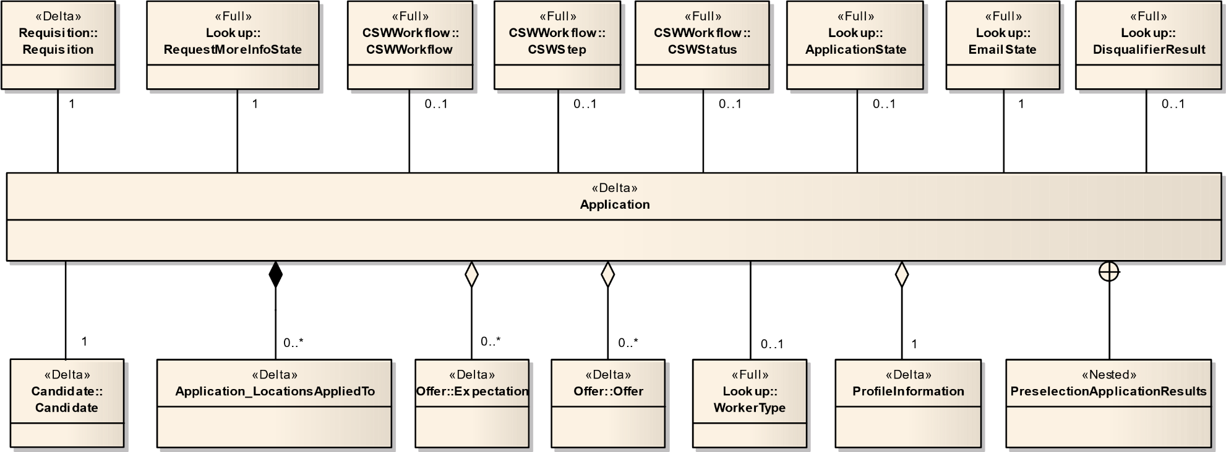

Figure 11 – Application

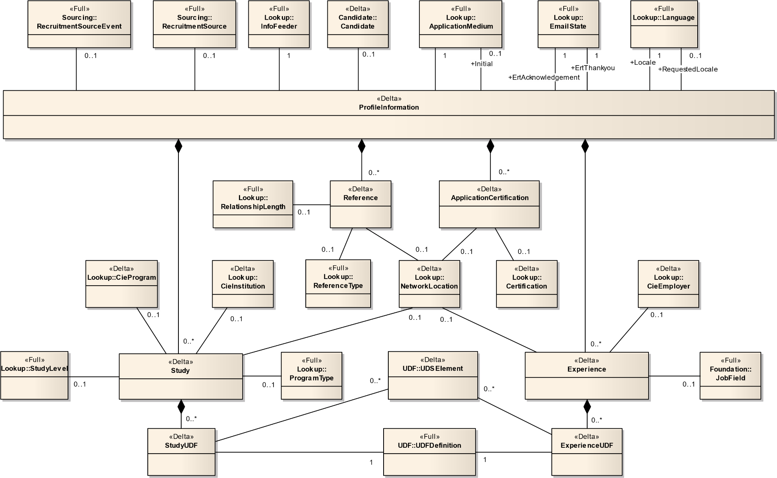

Figure 12 – ApplicationProfileInformation

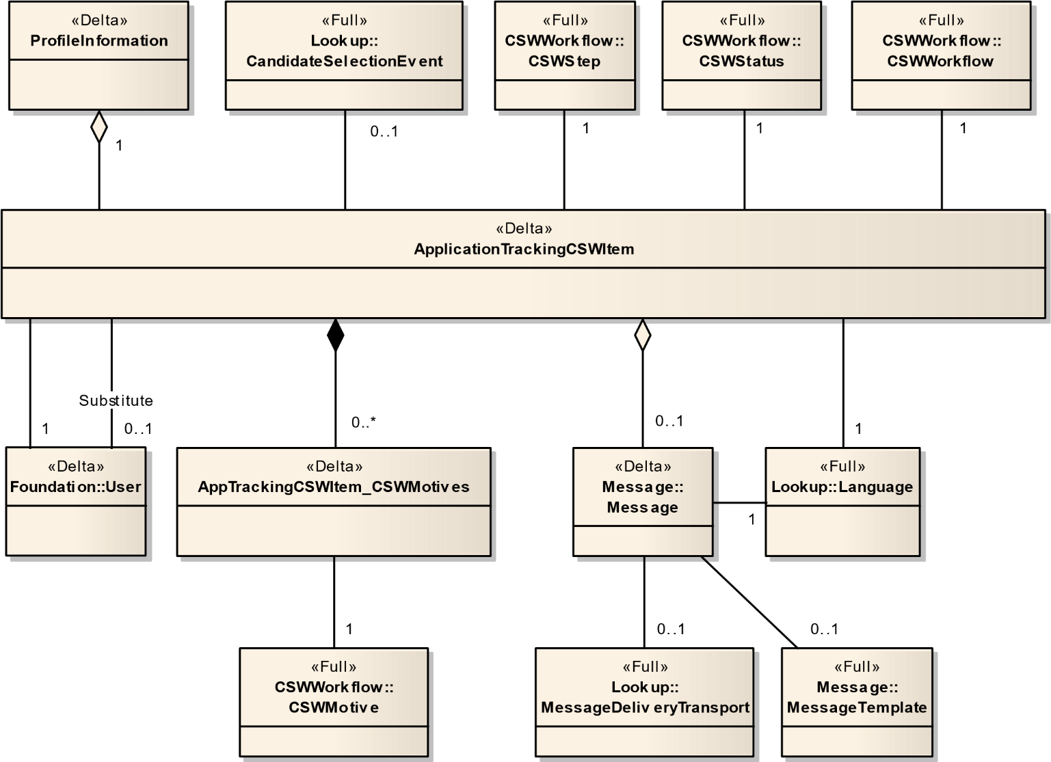

Figure 13 – ApplicationTrackingCSWItem

### 4.2.8.1 Application – (Delta)

Kind of application that represents an application of a candidate on a specific requisition. The application can be entered by the candidate, a recruiter, a referrer or an agent. As for the general application, the specific application contains information. Like: - The candidate's skills assessment and answers to the requisition questions. - The candidate's resume (structured and/or not) - The candidate's score and ranking. - The studies and experiences of the candidate. - Potential comments. This information may be different from the general application information.

|  |  |  |  |  |  |  |
| --- | --- | --- | --- | --- | --- | --- |
| Field No | Field Name | Type | Nullable | Reference Table | Reference Field | Comments |
| 1 | Number | Number(18) | **N** |  |  |  |
| 2 | BillRate | Number | Y |  |  |  |
| 3 | ChargeSalesTax | Boolean | Y |  |  |  |
| 4 | CSWLatestDate | DateTime | Y |  |  |  |
| 5 | DateOfEntry | DateTime | Y |  |  |  |
| 6 | DisqualifierResultDate | DateTime | Y |  |  |  |
| 7 | EEOInfoRequestDate | DateTime | Y |  |  |  |
| 8 | ExpirationDate | DateTime | Y |  |  |  |
| 9 | Grade | Number(18) | Y |  |  |  |
| 10 | IsOnRestrictedStep | Boolean | Y |  |  |  |
| 11 | IsSubmissionExpired | Boolean | Y |  |  |  |
| 12 | LastModifiedDate | DateTime | N |  |  |  |
| 13 | LastSubmissionDate | DateTime | Y |  |  |  |
| 14 | LetterSendRegretLetter | DateTime | Y |  |  |  |
| 15 | NewApplication | Boolean | Y |  |  |  |
| 16 | NbOfDayBeforeSubmisnExpiration | Number(3) | Y |  |  |  |
| 17 | OnboardingProcessDefinitionNumber | Char(100) | Y |  |  |  |
| 18 | PayRate | Number | Y |  |  |  |
| 19 | QueueRouteShortcutNumber | Number(18) | Y |  |  |  |
| 20 | ReferenceDate | DateTime | Y |  |  |  |
| 21 | ReferenceEndDate | DateTime | Y |  |  |  |
| 22 | ReferralType | Char(255) | Y |  |  |  |
| 23 | Referred | Boolean | Y |  |  |  |
| 24 | RelatedEntityKey | Number | Y |  |  |  |
| 25 | RelatedMetaClass | Char(255) | Y |  |  |  |
| 26 | RmiCompletedDate | DateTime | Y |  |  |  |
| 27 | RmiSentDate | DateTime | Y |  |  |  |
| 28 | SupplierOrderNumber | Char(300) | Y |  |  |  |
| 29 | SupplierWorkerID | Char(300) | Y |  |  |  |
| 30 | AceAlertStatus_Number | Number(18) | Y | EmailState | Number |  |
| 31 | AppReq_ReqTotalAssets | Number(18) | Y |  |  |  |
| 32 | AppReq_ReqTotalAssetsExt | Number(18) | Y |  |  |  |
| 33 | AppReq_ReqTotalAssetsInternal | Number(18) | Y |  |  |  |
| 34 | AppReq_ReqTotalRequired | Number(18) | Y |  |  |  |
| 35 | AppReq_ReqTotalRequiredExt | Number(18) | Y |  |  |  |
| 36 | AppReq_ReqTotalRequiredInt | Number(18) | Y |  |  |  |
| 37 | ApplicationState_Number | Number(18) | Y | ApplicationState | Number |  |
| 38 | Candidate_Number | Number(18) | N | Candidate | Number |  |
| 39 | CandidateReferrer_Number | Number(18) | Y | Candidate | Number |  |
| 40 | CSWLatestStatus_Number | Number(18) | Y | CSWStatus | Number |  |
| 41 | CSWLatestStep_Number | Number(18) | Y | CSWStep | Number |  |
| 42 | CSWWorkflow_Number | Number(18) | Y | CSWWorkflow | Number |  |
| 43 | CurrentOffer_Number | Number(18) | Y | Offer | Number |  |
| 44 | DisqualifierResult_Number | Number(18) | Y | DisqualifierResult | Number |  |
| 45 | DisqualifierResult_Description | Char(100) | Y | DisqualifierResult | Description |  |
| 46 | MatchedFromRequisition_Number | Number(18) | Y | Requisition | Number |  |
| 47 | OwnerAgent_Number | Number(18) | Y | Agent | Number |  |
| 48 | PreslnResults_HasAllRequired | Boolean | Y |  |  |  |
| 49 | PreslnResults_IsAceCandidate | Boolean | Y |  |  |  |
| 50 | PreslnResults_NbAchievedAssets | Number(5) | Y |  |  |  |
| 51 | PreslnResults_NbAchievedReqd | Number(5) | Y |  |  |  |
| 52 | PreslnResults_Score | Number(5) | Y |  |  |  |
| 53 | ProfileInformation_Number | Number(18) | N | ProfileInformation | Number |  |
| 54 | ReferralStatus_Number | Number(18) | Y | ReferralStatus | Number |  |
| 55 | Requisition_Number | Number(18) | N | Requisition | Number |  |
| 56 | RmiStatus_Number | Number(18) | N | RequestMoreInfoState | Number |  |
| 57 | RmiStatus_Description | Char(100) | Y | RmiStatus | Description |  |
| 58 | WorkerType_Number | Number(18) | Y | WorkerType | Number |  |
| 59 | WorkerType_Description | Char(100) | Y | WorkerType | Description |  |

### 4.2.8.2 Application_LocationsAppliedTo – (Delta)

|  |  |  |  |  |  |  |
| --- | --- | --- | --- | --- | --- | --- |
| Field No | Field Name | Type | Nullable | Reference Table | Reference Field | Comments |
| 1 | Application_Number | Number(18) | N | Application | Number |  |
| 2 | Location_Number | Number(18) | N | Location | Number |  |

### 4.2.8.3 Application_ProfileInformation – (Delta)

|  |  |  |  |  |  |  |
| --- | --- | --- | --- | --- | --- | --- |
| Field No | Field Name | Type | Nullable | Reference Table | Reference Field | Comments |
| 1 | Application_Number | Number(18) | N | Application | Number |  |
| 2 | ProfileInformation_Number | Number(18) | N | ProfileInformation | Number |  |

### 4.2.8.4 Application_Requests – (Delta)

|  |  |  |  |  |  |  |
| --- | --- | --- | --- | --- | --- | --- |
| Field No | Field Name | Type | Nullable | Reference Table | Reference Field | Comments |
| 1 | Number | Number(18) | N |  |  |  |
| 2 | Requests_No | Number(18) | N | ScreeningRequest |  |  |

### 4.2.8.5 ApplicationCertification – (Delta)

Application certifications are the certifications that the candidate has entered in the context of the application.

|  |  |  |  |  |  |  |
| --- | --- | --- | --- | --- | --- | --- |
| Field No | Field Name | Type | Nullable | Reference Table | Reference Field | Comments |
| 1 | No | Number(18) | N |  |  |  |
| 2 | ProfileInformation_Number | Number(18) | N | ProfileInformation | Number |  |
| 3 | DateReceived | Date | Y |  |  |  |
| 4 | DisplaySequence | Number(5) | N |  |  |  |
| 5 | ExpirationDate | Date | Y |  |  |  |
| 6 | IssuingOrganization | Char(100) | Y |  |  |  |
| 7 | NumberId | Char(30) | Y |  |  |  |
| 8 | OtherCertificationName | Char(100) | Y |  |  |  |
| 9 | Certification_Number | Number(18) | Y | Certification | Number |  |
| 10 | Location_Number | Number(18) | Y | NetworkLocation | Number |  |

### 4.2.8.6 ApplicationTrackingCSWItem – (Delta)

This kind of application tracking history is created when the candidate progress in the flow of the recruiting process. Example are: change the status. Of the candidate, make an offer to the candidate, hire the candidate, etc. (removeCheckOnCreate=true,removeCheckOnRead=true, removeCheckOnUpdate=true, RemoveCheckOnDelete=true)

|  |  |  |  |  |  |
| --- | --- | --- | --- | --- | --- |
| Field No | Type | Nullable | Reference Table | Reference Field | Comments |
| 1 | Number | Number(18) | N |  |  |
| 2 | ProfileInformation_Number | Number(18) | Y | ProfileInformation | Number |
| 3 | HistoryItem_Number | Number(18) | Y | HistoryItem | Number |
| 4 | CommentText | Char(4000) | Y |  |  |
| 5 | CreationDate | DateTime | N |  |  |
| 6 | Detail | Char(4000) | Y |  |  |
| 7 | EventDate | DateTime | Y |  |  |
| 8 | IsConditional | Boolean | Y |  |  |
| 9 | Reverted | Boolean | Y |  |  |
| 10 | ProfileLocale_ISO | Char(15) | Y | Language | ISO |
| 11 | Event_Number | Number(18) | Y | CandidateSelectionEvent | Number |
| 12 | Message_Number | Number(18) | Y | Message | Number |
| 13 | ProfileInformation_Number | Number(18) | N | ProfileInformation | Number |
| 14 | Status_Number | Number(18) | N | CSWStatus | Number |
| 15 | Step_Number | Number(18) | N | CSWStep | Number |
| 16 | Substitute_UserNo | Number(18) | Y | User | UserNo |
| 17 | User_UserNo | Number(18) | N | User | UserNo |
| 18 | Workflow_Number | Number(18) | N | CSWWorkflow | Number |

### 4.2.8.7 ApplicationCSWItemMotive – (Delta)

|  |  |  |  |  |  |
| --- | --- | --- | --- | --- | --- |
| Field No | Type | Nullable | Reference Table | Reference Field | Comments |
| 1 | HistoryItem_Number | Number(18) | N | ApplicationTrackingCSWItem | Number |
| 2 | CSWMotive_Number | Number(18) | N | CSWMotive | Number |

### 4.2.8.8 ApplicationUDFs – (Delta)

|  |  |  |  |  |  |  |
| --- | --- | --- | --- | --- | --- | --- |
| Field No | Field Name | Type | Nullable | Reference Table | Reference Field | Comments |
| 1 | NUM | Number(18) | N | Application | Number |  |
| 2 | UDFName | Number(18) | N |  |  |  |
| 3 | TextValue | Char(4000) | Y |  |  |  |
| 4 | CodeValue | Char(100) | Y |  |  |  |
| 5 | NumberValue | Number(18) | Y |  |  |  |
| 6 | SelectionLookup | Number(18) | Y |  |  |  |
| 7 | SelectionName | Char(255) | Y |  |  |  |
| 8 | SelectionLarge | Boolean | Y |  |  |  |

### 4.2.8.9 Experience – (Delta)

This entity represents an experience that a person has working, or working in a specific field or occupation. (removeCheckOnCreate=true,removeCheckOnRead=true, removeCheckOnUpdate=true, RemoveCheckOnDelete=true)

|  |  |  |  |  |  |  |
| --- | --- | --- | --- | --- | --- | --- |
| Field No | Field Name | Type | Nullable | Reference Table | Reference Field | Comments |
| 1 | Number | Number(18) | N |  |  |  |
| 2 | ProfileInformation_Number | Number(18) | N | ProfileInformation | Number |  |
| 3 | BeginDate | Date | Y |  |  |  |
| 4 | CurrentEmployer | Boolean | N |  |  |  |
| 5 | DisplaySequence | Number(5) | N |  |  |  |
| 6 | EndDate | Date | Y |  |  |  |
| 7 | LastModifiedDate | DateTime | Y |  |  |  |
| 8 | NameWhileEmployed | Char(100) | Y |  |  |  |
| 9 | OtherEmployerName | Char(100) | Y |  |  |  |
| 10 | OtherJobTitle | Char(100) | Y |  |  |  |
| 11 | PermissionToContact | Boolean | Y |  |  |  |
| 12 | ReasonForLeaving | Char(4000) | Y |  |  |  |
| 13 | Responsibility | Char(4000) | Y |  |  |  |
| 14 | Supervisor | Char(100) | Y |  |  |  |
| 15 | SupervisorEmail | Char(100) | Y |  |  |  |
| 16 | SupervisorPhone | Char(50) | Y |  |  |  |
| 17 | SupervisorTitle | Char(100) | Y |  |  |  |
| 18 | Employer_Number | Number(18) | N | CieEmployer | Number |  |
| 19 | JobFunction_Number | Number(18) | Y | JobField | Number |  |
| 20 | Location_Number | Number(18) | Y | NetworkLocation | Number |  |

### 4.2.8.10 ExperienceUDFs – (Delta)

|  |  |  |  |  |  |  |
| --- | --- | --- | --- | --- | --- | --- |
| Field No | Field Name | Type | Nullable | Reference Table | Reference Field | Comments |
| 1 | NUM | Number(18) | N | Experience | Number |  |
| 2 | UDFName | Number(18) | N |  |  |  |
| 3 | TextValue | Char(4000) | Y |  |  |  |
| 4 | CodeValue | Char(100) | Y |  |  |  |
| 5 | NumberValue | Number(18) | Y |  |  |  |
| 6 | SelectionLookup | Number(18) | Y |  |  |  |
| 7 | SelectionName | Char(255) | Y |  |  |  |
| 8 | SelectionLarge | Boolean | Y |  |  |  |

### 4.2.8.11 ProfileInformation – (Delta)

Application is the centerpiece of the selection process. All actions and events are based and take place on the application. An application is created as soon as a candidate is matched to a requisition, whatever the way (mail application, use of career section, automatic match, reference).

|  |  |  |  |  |  |  |
| --- | --- | --- | --- | --- | --- | --- |
| Field No | Field Name | Type | Nullable | Reference Table | Reference Field | Comments |
| 1 | ProfileInformation_Number | Number(18) | N |  |  |  |
| 2 | ApplicationDate | DateTime | N |  |  |  |
| 3 | BlockCoverage | Char(765) | Y |  |  |  |
| 4 | Completed | Boolean | N |  |  |  |
| 5 | CompletedDate | DateTime | Y |  |  |  |
| 6 | CreationDate | DateTime | N |  |  |  |
| 7 | ExperienceValidated | Boolean | N |  |  |  |
| 8 | IsInternal | Boolean | N |  |  |  |
| 9 | LastModifiedDate | DateTime | N |  |  |  |
| 10 | LastTrackingDate | DateTime | Y |  |  |  |
| 11 | Locale_ISO | Char(15) | N | Language | ISO |  |
| 12 | RecruitementSourceAutoFilled | Boolean | Y |  |  |  |
| 13 | RecruitmentSourceDetail | Char(1000) | Y |  |  |  |
| 14 | RequestedLocale | Char(15) | Y | Language | ISO |  |
| 15 | ResumeValidated | Boolean | N |  |  |  |
| 16 | SendAcknowledgement | DateTime | Y |  |  |  |
| 17 | StudyValidated | Boolean | N |  |  |  |
| 18 | BckgndCheck_Consent | Boolean | Y |  |  |  |
| 19 | BckgndCheck_InquiryReportReqd | Boolean | Y |  |  |  |
| 20 | Candidate_Number | Number(18) | N | Candidate | Number |  |
| 21 | ErtAckgmntStatus_Number | Number(18) | N | EmailState | Number |  |
| 22 | ErtThankyouStatus_Number | Number(18) | N | EmailState | Number |  |
| 23 | ESignature_DateTimeSigned | DateTime | Y |  |  |  |
| 24 | ESignature_EmailAddress | Char(100) | Y |  |  |  |
| 25 | ESignature_Identifier | Char(100) | Y |  |  |  |
| 26 | ESignature_Initials | Char(10) | Y |  |  |  |
| 27 | ESignature_IPAddress | Char(40) | Y |  |  |  |
| 28 | ESignature_Name | Char(100) | Y |  |  |  |
| 29 | InfoFeeder_Number | Number(18) | N | InfoFeeder | Number |  |
| 30 | InitialAppMedium_Number | Number(18) | Y | ApplicationMedium | Number |  |
| 31 | Medium_Number | Number(18) | N | ApplicationMedium | Number |  |
| 32 | RecruitmentSource_Number | Number(18) | Y | RecruitmentSource | Number |  |
| 33 | RecruitmentSourceEvent_Number | Number(18) | Y | RecruitmentSourceEvent | Number |  |

### 4.2.8.12 Reference – (Delta)

Minimal information enabling to identify or reach a person. A reference can be a person a supervisor or boss in the case of work experience.

|  |  |  |  |  |  |  |
| --- | --- | --- | --- | --- | --- | --- |
| Field No | Field Name | Type | Nullable | Reference Table | Reference Field | Comments |
| 1 | Number | Number(18) | N |  |  |  |
| 2 | ProfileInformation_Number | Number(18) | N | ProfileInformation | Number |  |
| 3 | Company | Char(100) | Y |  |  |  |
| 4 | DisplaySequence | Number(5) | N |  |  |  |
| 5 | EmailAddress | Char(100) | Y |  |  |  |
| 6 | Fax | Char(50) | Y |  |  |  |
| 7 | FirstName | Char(255) | Y |  |  |  |
| 8 | LastName | Char(255) | Y |  |  |  |
| 9 | MiddleInitial | Char(60) | Y |  |  |  |
| 10 | PhoneNumber | Char(50) | Y |  |  |  |
| 11 | Relationship | Char(100) | Y |  |  |  |
| 12 | Title | Char(100) | Y |  |  |  |
| 13 | Country_Number | Number(18) | Y | NetworkLocation | Number |  |
| 14 | ReferenceType_Number | Number(18) | Y | ReferenceType | Number |  |
| 15 | RelationshipLength_Number | Number(18) | Y | RelationshipLength | Number |  |

### 4.2.8.13 Study – (Delta)

This entity represents a part of candidate's resume. It describes one of his/her educational degree and history. (removeCheckOnCreate=true,removeCheckOnRead=true, removeCheckOnUpdate=true, removeCheckOnDelete=true)

|  |  |  |  |  |  |  |
| --- | --- | --- | --- | --- | --- | --- |
| Field No | Field Name | Type | Nullable | Reference Table | Reference Field | Comments |
| 1 | Number | Number(18) | N |  |  |  |
| 2 | ProfileInformation_Number | Number(18) | N | ProfileInformation | Number |  |
| 3 | DisplaySequence | Number(5) | N |  |  |  |
| 4 | Gpa | Number(7) | Y |  |  |  |
| 5 | GpaRange | Number(7) | Y |  |  |  |
| 6 | Graduated | Boolean | Y |  |  |  |
| 7 | GraduationDate | Date | Y |  |  |  |
| 8 | GraduationDateProjected | Boolean | Y |  |  |  |
| 9 | LastModifiedDate | DateTime | Y |  |  |  |
| 10 | NameWhileAttending | Char(100) | Y |  |  |  |
| 11 | OtherCourseTitle | Char(255) | Y |  |  |  |
| 12 | OtherInstitutionCity | Char(100) | Y |  |  |  |
| 13 | OtherInstitutionName | Char(100) | Y |  |  |  |
| 14 | StartDate | Date | Y |  |  |  |
| 15 | Institution_Number | Number(18) | Y | CieInstitution | Number |  |
| 16 | OtherInstnLocation_Number | Number(18) | Y | NetworkLocation | Number |  |
| 17 | Program_Number | Number(18) | Y | CieProgram | Number |  |
| 18 | ProgramType_Number | Number(18) | Y | ProgramType | Number |  |
| 19 | StudyLevel_Number | Number(18) | Y | StudyLevel | Number |  |

### 4.2.8.14 StudyUDFs – (Delta)

|  |  |  |  |  |  |  |
| --- | --- | --- | --- | --- | --- | --- |
| Field No | Field Name | Type | Nullable | Reference Table | Reference Field | Comments |
| 1 | NUM | Number(18) | N | Study | Number |  |
| 2 | UDFName | Number(18) | N |  |  |  |
| 3 | TextValue | Char(4000) | Y |  |  |  |
| 4 | CodeValue | Char(100) | Y |  |  |  |
| 5 | NumberValue | Number(18) | Y |  |  |  |
| 6 | SelectionLookup | Number(18) | Y |  |  |  |
| 7 | SelectionName | Char(255) | Y |  |  |  |
| 8 | SelectionLarge | Boolean | Y |  |  |  |

## 4.2.9 Question

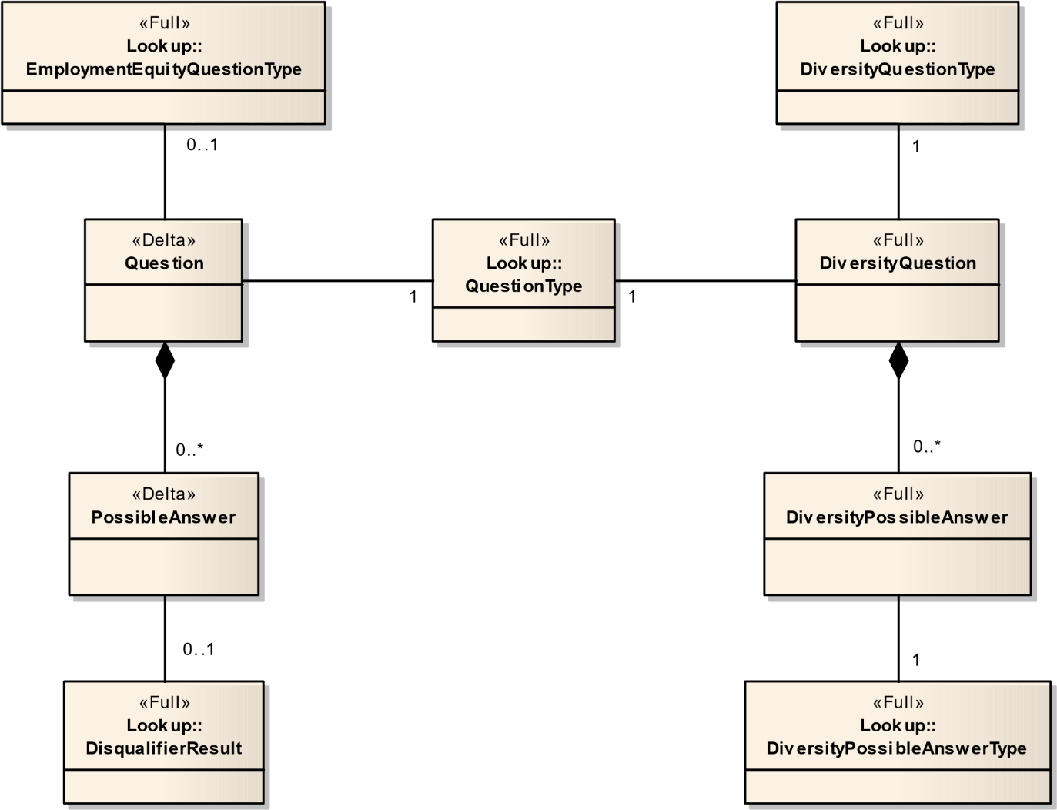

Figure 14 – Question

### 4.2.9.1 DiversityPossibleAnswer – (Full)

This is the concrete entity of a possible answer used for regulation purposes.

|  |  |  |  |  |  |  |
| --- | --- | --- | --- | --- | --- | --- |
| Field No | Field Name | Type | Nullable | Reference Table | Reference Field | Comments |
| 1 | Number | Number(18) | N |  |  |  |
| 2 | Question_Number | Number(18) | N | DiversityQuestion | Number |  |
| 3 | Description | Char(1000) | Y |  |  |  |
| 4 | Sequence | Number(5) | N |  |  |  |
| 5 | PossibleAnswerType_Number | Number(18) | N | DiversityPossibleAnswerType | Number |  |
| 6 | Origin_Number | Number(18) | Y | Origin | Number |  |

### 4.2.9.2 DiversityQuestion – (Full)

This is the concrete entity of a question used for regulation purposes.

|  |  |  |  |  |  |  |
| --- | --- | --- | --- | --- | --- | --- |
| Field No | Field Name | Type | Nullable | Reference Table | Reference Field | Comments |
| 1 | Number | Number(18) | N |  |  |  |
| 2 | Code | Char(50) | Y |  |  |  |
| 3 | Name | Char(200) | Y |  |  |  |
| 4 | QuestionType_Number | Number(18) | N | QuestionType | Number |  |
| 5 | RegulationQuestionType_Number | Number(18) | N | DiversityQuestionType | Number |  |
| 6 | Status_Number | Number(18) | N | AdminEntityStatus | Number |  |

### 4.2.9.3 PossibleAnswer – (Delta)

This is a possible answer. It is associated to only one question and represents one of the possible answers a candidate can choose from when answering to a question. The format of the question must be single or multiple answer, not text answer.

|  |  |  |  |  |  |  |
| --- | --- | --- | --- | --- | --- | --- |
| Field No | Field Name | Type | Nullable | Reference Table | Reference Field | Comments |
| 1 | Number | Number(18) | N |  |  |  |
| 2 | Question_Number | Number(18) | N | Question | Number |  |
| 3 | Description | Char(1000) | Y |  |  |  |
| 4 | DisplaySequence | Number(5) | N |  |  |  |
| 5 | ExplanationNeeded | Boolean | Y |  |  |  |
| 6 | NotSpecified | Boolean | N |  |  |  |
| 7 | DisqualifierResult_Number | Number(18) | N | DisqualifierResult | Number |  |

### 4.2.9.4 Question – (Delta)

This is a question. Question can be used for many purposes but a given question is used in only one creno. The TypeOfQuestion indicates the creno (Prescreening, Disqualification, Employment Equity, etc.) when the format of the question is not Text Answer, the question comes with a set of possible answers from which the user can choose from. If it is a disqualification question, each possible answer comes with a disqualifier result. A disqualifier question its format cannot be Text Answer.

|  |  |  |  |  |  |  |
| --- | --- | --- | --- | --- | --- | --- |
| Field No | Field Name | Type | Nullable | Reference Table | Reference Field | Comments |
| 1 | Number | Number(18) | N |  |  |  |
| 2 | Code | Char(50) | Y |  |  |  |
| 3 | CreationDate | DateTime | N |  |  |  |
| 4 | Description | Char(1000) | Y |  |  |  |
| 5 | ExplanationIntro | Char(255) | Y |  |  |  |
| 6 | LastModifiedDate | DateTime | Y |  |  |  |
| 7 | Name | Char(200) | Y |  |  |  |
| 8 | EEOUSAVersion | Number(18) | Y |  |  |  |
| 9 | EEQuestionType_Number | Number(18) | Y | EmploymentEquityQuestionType | Number |  |
| 10 | Status_Number | Number(18) | N | AdminEntityStatus | Number |  |
| 11 | TypeOfQuestion_Number | Number(18) | N | QuestionType | Number |  |

### 4.2.9.5 DiversityForm_Location – (Full)

|  |  |  |  |  |  |  |
| --- | --- | --- | --- | --- | --- | --- |
| Field No | Field Name | Type | Nullable | Reference Table | Reference Field | Comments |
| 1 | Number | Number(18) | N | DiversityForm | Number |  |
| 2 | Location_Number | Number(18) | N |  |  |  |

## 4.2.10 Requisition

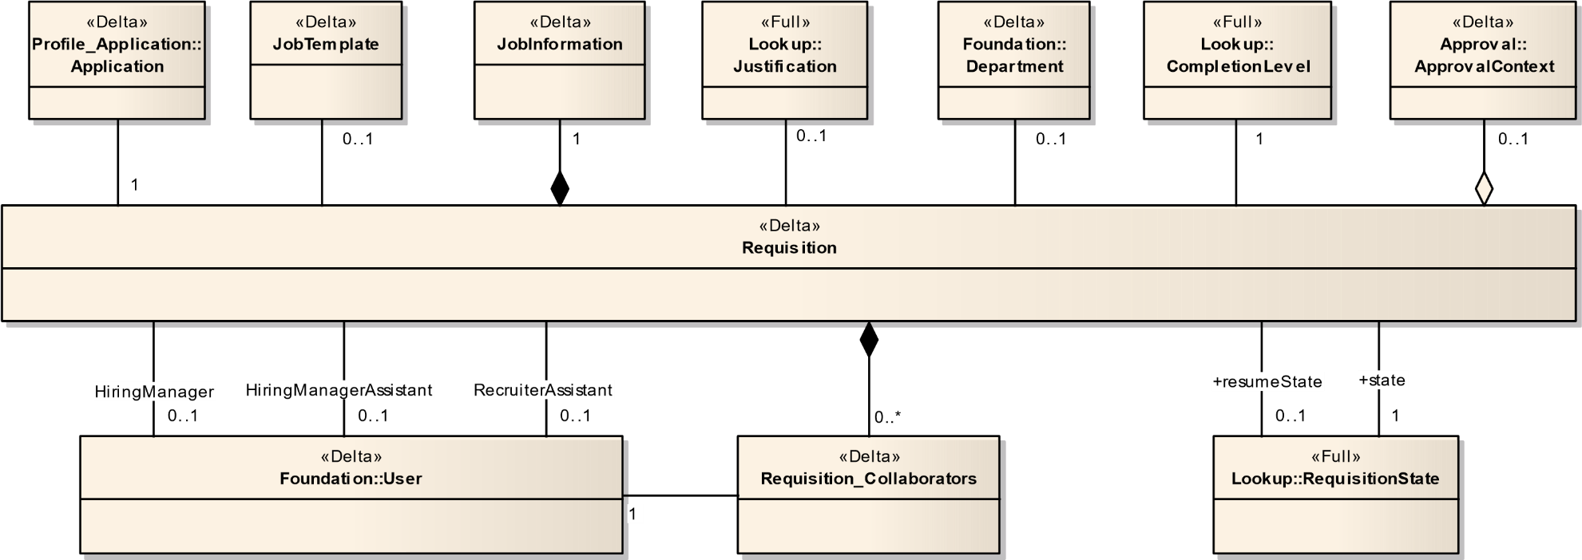

Figure 15 – Requisition

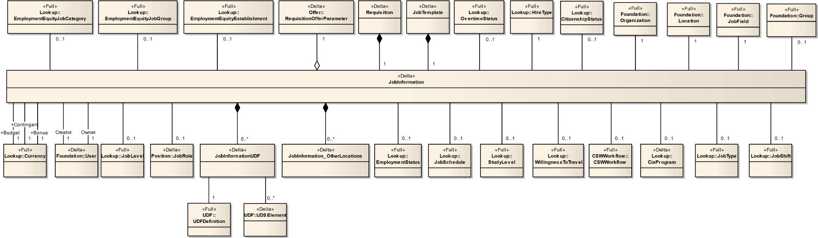

Figure 16 – JobInformation

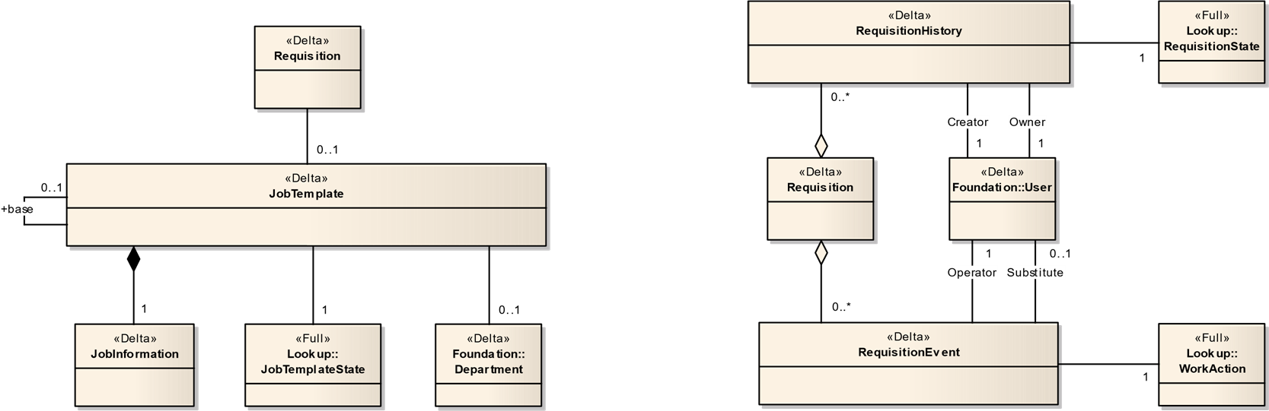

Figure 17 - Template – RequisitionHistory

### 4.2.10.1 JobInformation – (Delta)

Represents data that is common to Requisition and Job Template.

|  |  |  |  |  |  |  |
| --- | --- | --- | --- | --- | --- | --- |
| Field No | Field Name | Type | Nullable | Reference Table | Reference Field | Comments |
| 1 | Number | Number(18) | N |  |  |  |
| 2 | AdditionalInformation | Char(1000) | Y |  |  |  |
| 3 | AutoDeclineCandidates | Boolean | N |  |  |  |
| 4 | AutoRejectCandidates | Boolean | N |  |  |  |
| 5 | BillRateMedian | Number(15,3) | Y |  |  |  |
| 6 | BillRateNotToExceed | Number(15,3) | Y |  |  |  |
| 7 | CreationDate | DateTime | N |  |  |  |
| 8 | DescriptionBaseLocale | Boolean | N |  |  |  |
| 9 | DescriptionExternalHTML | Char(16000) | Y |  |  |  |
| 10 | DescriptionInternalHTML | Char(16000) | Y |  |  |  |
| 11 | ExternalBonusAmount | Number(30,15) | Y |  |  |  |
| 12 | ExternalBonusTracking | Boolean | Y |  |  |  |
| 13 | ExternalQualificationHTML | Char(16000) | Y |  |  |  |
| 14 | HighQuartileSalary | Number(30,15) | Y |  |  |  |
| 15 | InternalBonusAmount | Number(30,15) | Y |  |  |  |
| 16 | InternalBonusTracking | Boolean | Y |  |  |  |
| 17 | InternalQualificationHTML | Char(16000) | Y |  |  |  |
| 18 | IsAutoRejectCancelled | Boolean | Y |  |  |  |
| 19 | IsAutoRejectFilled | Boolean | Y |  |  |  |
| 20 | JobBoardDescription | Char(1000) | Y |  |  |  |
| 21 | JobGrade | Char(50) | Y |  |  |  |
| 22 | LastModifiedDate | DateTime | Y |  |  |  |
| 23 | LowQuartileSalary | Number(30,15) | Y |  |  |  |
| 24 | MidPointSalary | Number(30,15) | Y |  |  |  |
| 25 | NumberToHire | Number(3) | Y |  |  |  |
| 26 | OtherCosts | Char(50) | Y |  |  |  |
| 27 | RelocationCosts | Char(50) | Y |  |  |  |
| 28 | SourcingBudget | Char(50) | Y |  |  |  |
| 29 | Title | Char(255) | Y |  |  |  |
| 30 | TravelCosts | Char(50) | Y |  |  |  |
| 31 | UnlimitedHire | Boolean | N |  |  |  |
| 32 | BonusCurrency_Number | Number(18) | Y | Currency | Number |  |
| 33 | BudgetCurrency_Number | Number(18) | Y | Currency | Number |  |
| 34 | CitizenshipStatus_Number | Number(18) | Y | CitizenshipStatus | Number |  |
| 35 | ContingentCurrency_Number | Number(18) | Y | Currency | Number |  |
| 36 | Creator_UserNo | Number(18) | N | User | UserNo |  |
| 37 | CSWWorkflow_Number | Number(18) | Y | CSWWorkflow | Number |  |
| 38 | EEJobCategory_Number | Number(18) | Y | EmploymentEquityJobCategory | Number |  |
| 39 | EEEstablishment_Number | Number(18) | Y | EmploymentEquityEstablishment | Number |  |
| 40 | HireType_Number | Number(18) | N | HireType | Number |  |
| 41 | JobField_Number | Number(18) | N | JobField | Number |  |
| 42 | JobInformationGroup_Number | Number(18) | Y | Group | Number |  |
| 43 | JobLevel_Number | Number(18) | Y | JobLevel | Number |  |
| 44 | JobRole_Number | Number(18) | Y | JobRole | Number |  |
| 45 | JobSchedule_Number | Number(18) | Y | JobSchedule | Number |  |
| 46 | JobShift_Number | Number(18) | Y | JobShift | Number |  |
| 47 | JobType_Number | Number(18) | Y | JobType | Number |  |
| 48 | OfferParameter_Number | Number(18) | N | RequisitionOfferParameter | Number |  |
| 49 | Organization_Number | Number(18) | N | Organization | Number |  |
| 50 | OvertimeStatus_Number | Number(18) | Y | OvertimeStatus | Number |  |
| 51 | PrimaryLocation_Number | Number(18) | N | Location | Number |  |
| 52 | Program_Number | Number(18) | Y | CieProgram | Number |  |
| 53 | RecruiterOwner_UserNo | Number(18) | N | User | UserNo |  |
| 54 | StudyLevel_Number | Number(18) | Y | StudyLevel | Number |  |
| 55 | WillingnessToTravel_Number | Number(18) | Y | WillingnessToTravel | Number |  |

### 4.2.10.2 JobInformationUDFs – (Delta)

|  |  |  |  |  |  |  |
| --- | --- | --- | --- | --- | --- | --- |
| Field No | Field Name | Type | Nullable | Reference Table | Reference Field | Comments |
| 1 | NUM | Number(18) | N | JobInformation | Number |  |
| 2 | UDFName | Number(18) | N |  |  |  |
| 3 | TextValue | Char(4000) | Y |  |  |  |
| 4 | CodeValue | Char(100) | Y |  |  |  |
| 5 | NumberValue | Number(18) | Y |  |  |  |
| 6 | SelectionLookup | Number(18) | Y |  |  |  |
| 7 | SelectionName | Char(255) | Y |  |  |  |
| 8 | SelectionLarge | Boolean | Y |  |  |  |

### 4.2.10.3 JobInformation_OtherLocations – (Delta)

|  |  |  |  |  |  |  |
| --- | --- | --- | --- | --- | --- | --- |
| Field No | Field Name | Type | Nullable | Reference Table | Reference Field | Comments |
| 1 | JobInformation_Number | Number(18) | N | JobInformation | Number |  |
| 2 | Location_Number | Number(18) | N | Location | Number |  |

### 4.2.10.4 JobTemplate – (Delta)

JobTemplate represents a model for creating requisitions or other templates.

|  |  |  |  |  |  |  |
| --- | --- | --- | --- | --- | --- | --- |
| Field No | Field Name | Type | Nullable | Reference Table | Reference Field | Comments |
| 1 | Number | Number(18) | N |  |  |  |
| 2 | EffectiveFrom | DateTime | Y |  |  |  |
| 3 | EffectiveTill | DateTime | Y |  |  |  |
| 4 | JobCode | Char(150) | Y |  |  |  |
| 5 | BaseJobTemplate_Number | Number(18) | Y | JobTemplate | Number |  |
| 6 | Department_Number | Number(18) | Y | Department | Number |  |
| 7 | JobInformation_Number | Number(18) | N | JobInformation | Number |  |
| 8 | State_Number | Number(18) | N | JobTemplateState | Number |  |

### 4.2.10.5 Requisition – (Delta)

Represents a requisition.

|  |  |  |  |  |  |  |
| --- | --- | --- | --- | --- | --- | --- |
| Field No | Field Name | Type | Nullable | Reference Table | Reference Field | Comments |
| 1 | Number | Number(18) | N |  |  |  |
| 2 | AbstractInfo | Char(1000) | Y |  |  |  |
| 3 | AceCandidateAlertChoice | Number(18) | Y |  |  |  |
| 4 | AceCandidateAlertEnabled | Boolean | N |  |  |  |
| 5 | AceCandidateMinimalScore | Number(3) | Y |  |  |  |
| 6 | AceCandidateNumberRelevant | Number(3) | Y |  |  |  |
| 7 | ClosingDateExternal | DateTime | Y |  |  |  |
| 8 | ClosingDateInternal | DateTime | Y |  |  |  |
| 9 | ContestNumber | Char(20) | N |  |  |  |
| 10 | DailyRecruitingReportEnabled | Boolean | N |  |  |  |
| 11 | ExtendMoreOffers | Boolean | N |  |  |  |
| 12 | HasBeenApproved | Boolean | N |  |  |  |
| 13 | HotJob | Boolean | N |  |  |  |
| 14 | ManagerRequisitionTitle | Char(255) | Y |  |  |  |
| 15 | MixedPostedJobState | Number(18) | Y |  |  |  |
| 16 | OpeningDateExternal | DateTime | Y |  |  |  |
| 17 | OpeningDateInternal | DateTime | Y |  |  |  |
| 18 | PositionString | Char(255) | Y |  |  |  |
| 19 | PreventPosting | Boolean | N |  |  |  |
| 20 | RequestMoreInfo | Number(18) | Y |  |  |  |
| 21 | RequestMoreInfoAssetValue | Number(3) | Y |  |  |  |
| 22 | RequestMoreInfoByAssetEnabled | Boolean | Y |  |  |  |
| 23 | RequestMoreInfoByScoreEnabled | Boolean | Y |  |  |  |
| 24 | RequestMoreInfoScoreValue | Number(3) | Y |  |  |  |
| 25 | TargetStartDate | DateTime | Y |  |  |  |
| 26 | ApprovalContext_No | Number(18) | Y | ApprovalContext | Number |  |
| 27 | BaseJobTemplate_Number | Number(18) | Y | JobTemplate | Number |  |
| 28 | CompletionLevel_Number | Number(18) | N | CompletionLevel | Number |  |
| 29 | ContactEmailExternal_UserNo | Number(18) | Y | User | UserNo |  |
| 30 | ContactEmailInternal_UserNo | Number(18) | Y | User | UserNo |  |
| 31 | ContactNameExternal_UserNo | Number(18) | Y | User | UserNo |  |
| 32 | ContactNameInternal_UserNo | Number(18) | Y | User | UserNo |  |
| 33 | Department_Number | Number(18) | Y | Department | Number |  |
| 34 | HiringManager_UserNo | Number(18) | Y | User | UserNo |  |
| 35 | HiringManagerAssistant_UserNo | Number(18) | Y | User | UserNo |  |
| 36 | JobInformation_Number | Number(18) | N | JobInformation | Number |  |
| 37 | Justification_Number | Number(18) | Y | Justification | Number |  |
| 38 | RecruiterAssistant_UserNo | Number(18) | Y | User | UserNo |  |
| 39 | ResumeState_Number | Number(18) | Y | RequisitionState | Number |  |
| 40 | State_Number | Number(18) | N | RequisitionState | Number |  |

### 4.2.10.6 Requisition_Collaborators – (Delta)

|  |  |  |  |  |  |  |
| --- | --- | --- | --- | --- | --- | --- |
| Field No | Field Name | Type | Nullable | Reference Table | Reference Field | Comments |
| 1 | Requisition_Number | Number(18) | N |  |  |  |
| 2 | Collaborator_UserNo | Number(18) | Y |  |  |  |

### 4.2.10.7 Requisition_DepartmentUDFs

|  |  |  |  |  |  |  |
| --- | --- | --- | --- | --- | --- | --- |
| Field No | Field Name | Type | Nullable | Reference Table | Reference Field | Comments |
| 1 | NUM | Number(18) | N | Requisition | Number |  |
| 2 | UDFName | Number(18) | N |  |  |  |
| 3 | TextValue | Char(4000) | Y |  |  |  |
| 4 | CodeValue | Char(100) | Y |  |  |  |
| 5 | NumberValue | Number(18) | Y |  |  |  |
| 6 | SelectionLookup | Number(18) | Y |  |  |  |
| 7 | SelectionName | Char(255) | Y |  |  |  |
| 8 | SelectionLarge | Boolean | Y |  |  |  |

### 4.2.10.8 RequisitionEvent – (Delta)

The History Event is the main piece of information of the history. A History Event represents an occurrence of an event type. The list of the History Events constitutes the System History.

|  |  |  |  |  |  |  |
| --- | --- | --- | --- | --- | --- | --- |
| Field No | Field Name | Type | Nullable | Reference Table | Reference Field | Comments |
| 1 | Requisition_Number | Number(18) | N | Requisition | Number |  |
| 2 | WorkAction_Number | Number(18) | N | WorkAction | Number |  |
| 3 | EventDate | DateTime | N |  |  |  |
| 4 | Comments | Char(3000) | Y |  |  |  |
| 5 | Operator_UserNo | Number(18) | N | User | UserNo |  |

### 4.2.10.9 RequisitionHistory – (Delta)

Represents an element of the history of a requisition.

|  |  |  |  |  |  |  |
| --- | --- | --- | --- | --- | --- | --- |
| Field No | Field Name | Type | Nullable | Reference Table | Reference Field | Comments |
| 1 | Requisition_Number | Number(18) | N | Requisition | Number |  |
| 2 | CreationDate | DateTime | N |  |  |  |
| 3 | RequisitionState_Number | Number(18) | N | RequisitionState | Number |  |
| 4 | EndDate | DateTime | Y |  |  |  |
| 5 | Creator_UserNo | Number(18) | N | User | UserNo |  |
| 6 | RecruiterOwner_UserNo | Number(18) | N | User | UserNo |  |

## 4.2.11 Sourcing

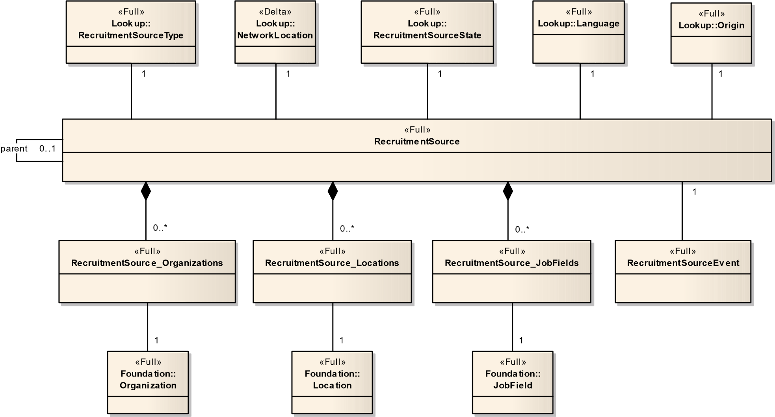

Figure 18 – RecruitmentSourcing

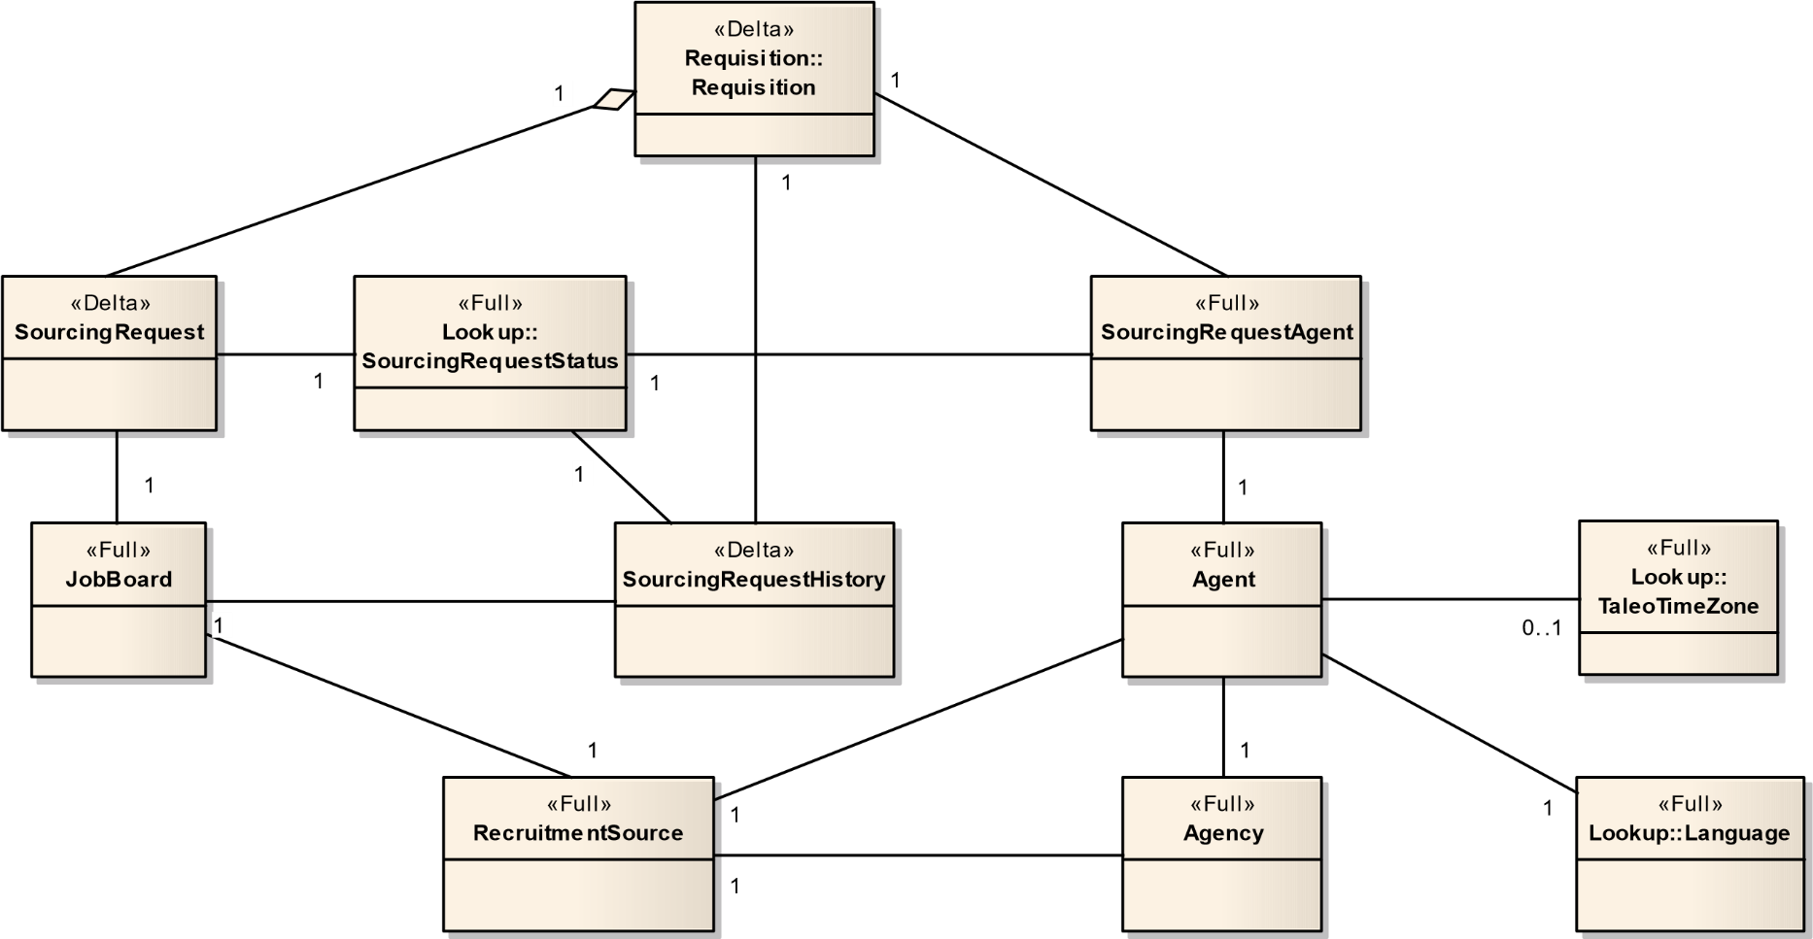

Figure 19 - Sourcing

### 4.2.11.1 JobBoard – (Full)

This entity is an electronic media defining a job site, a career site, a news group, a mailing list, etc. This is a site where the job offers are posted.

|  |  |  |  |  |  |  |
| --- | --- | --- | --- | --- | --- | --- |
| Field No | Field Name | Type | Nullable | Reference Table | Reference Field | Comments |
| 1 | Number | Number(18) | N |  |  |  |
| 2 | ExternalSystem | Number(18) | Y |  |  |  |
| 3 | IsPaying | Boolean | N |  |  |  |
| 4 | JobboardType_Number | Char(765) | N | JobBoardType | Number |  |
| 5 | RecruitmentSource_Number | Number(18) | N | RecruitmentSource | Number |  |

### 4.2.11.2 RecruitmentSource – (Full)

A Source is a medium or event through which a candidate has heard about the job you are posting or about your company. The candidate may also have applied on a job through different sources.

Sources may be as diverse as Internet job boards, job fairs, magazines and specialized trade publications, newspapers, professional associations, mailing lists, recruiting agencies, etc.

|  |  |  |  |  |  |  |
| --- | --- | --- | --- | --- | --- | --- |
| Field No | Field Name | Type | Nullable | Reference Table | Reference Field | Comments |
| 1 | Number | Number(18) | N |  |  |  |
| 2 | Description | Char(765) | Y |  |  |  |
| 3 | DescriptionBaseLocale | Char(100) | Y |  |  |  |
| 4 | Identifier | Char(50) | Y |  |  |  |
| 5 | PartnerId | Char(100) | Y |  |  |  |
| 6 | TableName | Char(30) | Y |  |  |  |
| 7 | NetworkLocation_Number | Number(18) | N | NetworkLocation | Number |  |
| 8 | ObjectOrigin_Number | Number(18) | N | Origin | Number |  |
| 9 | ParentSource_Number | Number(18) | Y | RecruitmentSource | Number |  |
| 10 | State_Number | Number(18) | N | RecruitmentSourceState | Number |  |
| 11 | Type_Number | Number(18) | N | RecruitmentSourceType | Number |  |
| 12 | Visibility_Number | Number(18) | N | RecruitmentSourceVisibility | Number |  |

### 4.2.11.3 RecruitmentSourceEvent – (Full)

An Event is a specific advertisement in a trade magazine, a recruiting event on a university campus (job fair), or a special recruiting event at your organization.

|  |  |  |  |  |  |  |
| --- | --- | --- | --- | --- | --- | --- |
| Field No | Field Name | Type | Nullable | Reference Table | Reference Field | Comments |
| 1 | Number | Number(18) | N |  |  |  |
| 2 | Source_Number | Number(18) | N | RecruitmentSource | Number |  |
| 3 | Cost | Number(10,2) | Y |  |  |  |
| 4 | Description | Char(50) | Y |  |  |  |
| 5 | EndDate | DateTime | Y |  |  |  |
| 6 | ExternalContactEmail | Char(100) | Y |  |  |  |
| 7 | ExternalContactName | Char(255) | Y |  |  |  |
| 8 | ExternalContactPhone | Char(50) | Y |  |  |  |
| 9 | ID | Char(50) | N |  |  |  |
| 10 | StartDate | DateTime | N |  |  |  |

### 4.2.11.4 SourcingRequest – (Delta)

This entity represents a requisition posted on a specific job board for a determined period of time.

|  |  |  |  |  |  |  |
| --- | --- | --- | --- | --- | --- | --- |
| Field No | Field Name | Type | Nullable | Reference Table | Reference Field | Comments |
| 1 | Requisition_Number | Number(18) | N | Requisition | Number |  |
| 2 | JobBoard_Number | Number(18) | N | JobBoard | Number |  |
| 3 | CreationDate | DateTime | N |  |  |  |
| 4 | ApplyOnlineEnabled | Boolean | N |  |  |  |
| 5 | CloseDate | DateTime | Y |  |  |  |
| 6 | OpenDate | DateTime | N |  |  |  |
| 7 | SourcingRequestStatus_Number | Number(18) | N | SourcingRequestStatus | Number |  |

### 4.2.11.5 SourcingRequestAgent – (Delta)

|  |  |  |  |  |  |  |
| --- | --- | --- | --- | --- | --- | --- |
| Field No | Field Name | Type | Nullable | Reference Table | Reference Field | Comments |
| 1 | CloseDate | DateTime | Y |  |  |  |
| 2 | OpenDate | Number(18) | Y |  |  |  |
| 3 | Agent_Number | Number(18) | Y | Agent | Number |  |
| 4 | Requisition_Number | Number(18) | Y | Requisiton | Number |  |
| 5 | SourcingRequestStatus_Number | Number(18) | Y | SourcingRequstStatus | Number |  |

### 4.2.11.6 SourcingRequestHistory– (Delta)

This entity represents the history of a requisition posted on a specific job board. Each time the posted job status changes, an entity is created with the last posted job status.

|  |  |  |  |  |  |  |
| --- | --- | --- | --- | --- | --- | --- |
| Field No | Field Name | Type | Nullable | Reference Table | Reference Field | Comments |
| 1 | Requisition_Number | Number(18) | N | Requisition | Number |  |
| 2 | JobBoard_Number | Number(18) | N | JobBoard | Number |  |
| 3 | CreationDate | DateTime | N |  |  |  |
| 4 | CloseDate | DateTime | Y |  |  |  |
| 5 | OpenDate | DateTime | N |  |  |  |
| 6 | SourcingRequestStatus_Number | Number(18) | N | SourcingRequestStatus | Number |  |

### 4.2.11.7 Agency – (Full)

|  |  |  |  |  |  |  |
| --- | --- | --- | --- | --- | --- | --- |
| Field No | Field Name | Type | Nullable | Reference Table | Reference Field | Comments |
| 1 | Number | Number(18) | N | JobInformation | Number |  |
| 2 | ContactName | Char(100) | Y |  |  |  |
| 3 | ContactPhoneNumber | Char(50) | Y |  |  |  |
| 4 | EmailAddress | Char(100) | Y |  |  |  |
| 5 | RecruitmentSource_Number | Number(18) | Y |  |  |  |

### 4.2.11.8 Agent – (Full)

|  |  |  |  |  |  |  |
| --- | --- | --- | --- | --- | --- | --- |
| Field No | Field Name | Type | Nullable | Reference Table | Reference Field | Comments |
| 1 | Number | Number(18) | N | JobInformation | Number |  |
| 2 | Address | Char(100) | Y |  |  |  |
| 3 | Address2 | Char(100) | Y |  |  |  |
| 4 | City | Char(100) | Y |  |  |  |
| 5 | CorrespondenceLocale | Char(100) | Y |  |  |  |
| 6 | CreationDate | DateTime | Y |  |  |  |
| 7 | EmailAddress | Char(100) | Y |  |  |  |
| 8 | Fax | Char(50) | Y |  |  |  |
| 9 | FirstName | Char(255) | Y |  |  |  |
| 10 | HomePhone | Char(50) | Y |  |  |  |
| 11 | LastName | Char(255) | Y |  |  |  |
| 12 | MobilePhone | Char(50) | Y |  |  |  |
| 13 | PagerPhone | Char(50) | Y |  |  |  |
| 14 | WorkPhone | Char(50) | Y |  |  |  |
| 15 | Zip | Char(20) | Y |  |  |  |
| 16 | Agency_Number | Number(18) | N | Agency | Number |  |
| 17 | RecruitmentSource_Number | Number(18) | Y | RecruitmentSource | Number |  |
| 18 | TimeZone_Number | Number(18) | Y | TaleoTimeZone | Number |  |

## 4.2.12 UDF

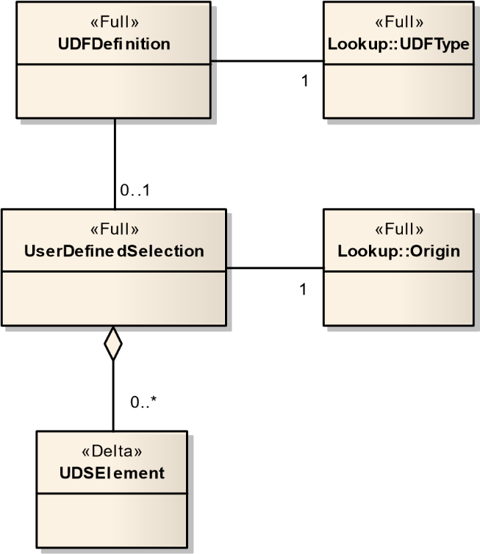

Figure 20 - UDF

### 4.2.12.1 UDFDefinition – (Full)

This entity contains the definition of a user-defined field.

|  |  |  |  |  |  |  |
| --- | --- | --- | --- | --- | --- | --- |
| Field No | Field Name | Type | Nullable | Reference Table | Reference Field | Comments |
| 1 | Number | Number(18) | Y |  |  |  |
| 2 | Entity | Char(90) | N |  |  | CSUSER: Candidate  DEPARTMENTINFORMATION: Department  EXPERIENCE: Experience  JOBINFORMATION: Requisition or JobTemplate OFFER: Offer  STUDY: Study |
| 3 | ID | Char(765) | N |  |  |  |
| 4 | Cardinality | Number(2) | N |  |  | 1: Single select, -1: Multi select |
| 5 | Description | Char(765) | N |  |  |  |
| 6 | OwnedUDS_Number | Number(18) | Y | UserDefinedSelection | Number |  |
| 7 | Type_Number | Number(5) | N | UDFType | Number |  |
| 8 | UserDefinedSelection_Number | Number(18) | N | UserDefinedSelection | Number |  |

### 4.2.12.2 UDSElement – (Delta)

The UDSElement entity models user-defined selection elements. A selection element is a possible value of the selection (discrete value). A selection element may then be used as a UDF (user-defined field) value.

|  |  |  |  |  |  |  |
| --- | --- | --- | --- | --- | --- | --- |
| Field No | Field Name | Type | Nullable | Reference Table | Reference Field | Comments |
| 1 | Number | Number(18) | N |  |  |  |
| 2 | UserDefinedSelection_Number | Number(18) | N | UserDefinedSelection | Number |  |
| 3 | Active | Boolean | N |  |  |  |
| 4 | Code | Char(50) | N |  |  |  |
| 5 | Complete | Boolean | N |  |  |  |
| 6 | Description | Char(765) | Y |  |  |  |
| 7 | EffectiveFrom | DateTime | Y |  |  |  |
| 8 | EffectiveUntil | DateTime | Y |  |  |  |
| 9 | LastModifiedDate | DateTime | Y |  |  |  |
| 10 | Sequence | Number(5) | N |  |  |  |

### 4.2.12.3 UserDefinedSelection – (Full)

The UserDefinedSelection entity model’s user-defined selections. A selection (domain of discrete values) may then be used to define user-defined fields.

|  |  |  |  |  |  |  |
| --- | --- | --- | --- | --- | --- | --- |
| Field No | Field Name | Type | Nullable | Reference Table | Reference Field | Comments |
| 1 | Number | Number(18) | N |  |  |  |
| 2 | Code | Char(50) | N |  |  |  |
| 3 | EffectiveDatingEnabled | Boolean | N |  |  |  |
| 4 | Large | Boolean | N |  |  |  |
| 5 | Name | Char(765) | Y |  |  |  |
| 6 | Origin_Number | Number(18) | N | Origin | Number |  |

## 4.2.13 Passport

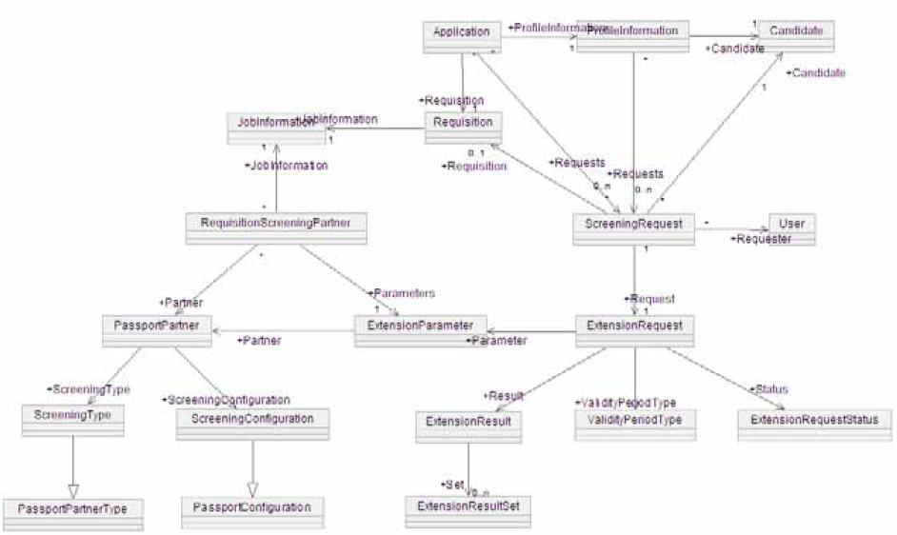

### 4.2.13.1 CandidateSourcingConfiguration – (Full)

|  |  |  |  |  |  |  |
| --- | --- | --- | --- | --- | --- | --- |
| **Field No** | **Field Name** | **Type** | **Nullable** | **Reference Table** | **Reference Field** | **Comments** |
| 1 | Number | Number(18) | N |  |  |  |
| 2 | Active | Boolean | Y |  |  |  |
| 3 | Base | Boolean | Y |  |  |  |
| 4 | Description | Char(255) | N |  |  |  |
| 5 | Name | Char(255) | N |  |  |  |
| 6 | ProviderDescription | Char(255) | N |  |  |  |
| 7 | ProviderName | Char(255) | N |  |  |  |
| 8 | TimeoutDelay | Integer | Y |  |  |  |

### 4.2.13.2 CandidateSourcingConfigurationsUDFs – (Full)

|  |  |  |  |  |  |  |
| --- | --- | --- | --- | --- | --- | --- |
| Field No | Field Name | Type | Nullable | Reference Table | Reference Field | Comments |
| 1 | NUM | Number(18) | N | CandidateSourcingConfiguration | Number |  |
| 2 | UDFName | Number(18) | N |  |  |  |
| 3 | TextValue | Char(4000) | Y |  |  |  |
| 4 | CodeValue | Char(100) | Y |  |  |  |
| 5 | NumberValue | Number(18) | Y |  |  |  |
| 6 | SelectionLookup | Number(18) | Y |  |  |  |
| 7 | SelectionName | Char(255) | Y |  |  |  |
| 8 | SelectionLarge | Boolean | Y |  |  |  |

### 4.2.13.3 ExtensionRequest – (Delta)

ExtensionRequest corresponds to a single Passport request submitted to a Partner. Passport partners reference that request when supplying processing results.

|  |  |  |  |  |  |  |
| --- | --- | --- | --- | --- | --- | --- |
| Field No | Field Name | Type | Nullable | Reference Table | Reference Field | Comments |
| 1 | Number | Number(18) | N |  |  |  |
| 2 | CreationDate | DateTime | N |  |  |  |
| 3 | ExternalReference | Char(255) | Y |  |  |  |
| 4 | InternalReference | Char(255) | Y |  |  |  |
| 5 | IsExpired | Boolean | Y |  |  |  |
| 6 | LastModifiedDate | DateTime | Y |  |  |  |
| 7 | ProviderStatus | Char(255) | Y |  |  |  |
| 8 | ValidityExpirationDate | DateTime | Y |  |  |  |
| 9 | Parameter_Number | Number(18) | Y | ExtensionParameter |  |  |
| 10 | Parameter_Partner_Number | Number(18) | Y | PassportPartner |  |  |
| 11 | Result_Number | Number(18) | Y | ExtensionResult |  |  |
| 12 | Status_Number | Number(18) | Y | ExtensionRequestStatus |  |  |
| 13 | ValidityPeriodType_Number | Number(18) | Y | ValidityPeriodType |  |  |

### 4.2.13.4 ExtensionRequest_ParameterUDFs – (Delta)

|  |  |  |  |  |  |  |
| --- | --- | --- | --- | --- | --- | --- |
| Field No | Field Name | Type | Nullable | Reference Table | Reference Field | Comments |
| 1 | NUM | Number(18) | N | ExtensionRequest | Number |  |
| 2 | UDFName | Number(18) | N |  |  |  |
| 3 | TextValue | Char(4000) | Y |  |  |  |
| 4 | CodeValue | Char(100) | Y |  |  |  |
| 5 | NumberValue | Number(18) | Y |  |  |  |
| 6 | SelectionLookup | Number(18) | Y |  |  |  |
| 7 | SelectionName | Char(255) | Y |  |  |  |
| 8 | SelectionLarge | Boolean | Y |  |  |  |

### 4.2.13.5 ExtensionRequest_ResultUDFs – (Delta)

|  |  |  |  |  |  |  |
| --- | --- | --- | --- | --- | --- | --- |
| Field No | Field Name | Type | Nullable | Reference Table | Reference Field | Comments |
| 1 | NUM | Number(18) | N | ExtensionRequest | Number |  |
| 2 | UDFName | Number(18) | N |  |  |  |
| 3 | TextValue | Char(4000) | Y |  |  |  |
| 4 | CodeValue | Char(100) | Y |  |  |  |
| 5 | NumberValue | Number(18) | Y |  |  |  |
| 6 | SelectionLookup | Number(18) | Y |  |  |  |
| 7 | SelectionName | Char(255) | Y |  |  |  |
| 8 | SelectionLarge | Boolean | Y |  |  |  |

### 4.2.13.6 ExtensionRequestStatus – (Full)

|  |  |  |  |  |  |  |
| --- | --- | --- | --- | --- | --- | --- |
| Field No | Field Name | Type | Nullable | Reference Table | Reference Field | Comments |
| 1 | Number | Number(18) | N |  |  |  |
| 2 | Code | Char(255) | Y |  |  |  |
| 3 | Description | Char(255) | Y |  |  |  |
| 4 | Type_Number | Number(18) | Y | ExtensionRequestStatusType |  |  |

### 4.2.13.7 ExtensionRequestStatusType – (Full)

|  |  |  |  |  |  |  |
| --- | --- | --- | --- | --- | --- | --- |
| Field No | Field Name | Type | Nullable | Reference Table | Reference Field | Comments |
| 1 | Number | Number(18) | N |  |  |  |
| 2 | Description | Char(255) | Y |  |  |  |
| 3 | ResourceNumber | Number(18) | Y |  |  |  |

### 4.2.13.8 ExtensionResult – (Delta)

Customizable entity that contains results associated to a specific request. It contains a list of fields, defined in the certification, that globally characterize the result of a request.

|  |  |  |  |  |  |  |
| --- | --- | --- | --- | --- | --- | --- |
| Field No | Field Name | Type | Nullable | Reference Table | Reference Field | Comments |
| 1 | Number | Number(18) | N |  |  |  |
| 2 | Request_Number | Number(18) | Y | ExtensionRequest | Number |  |
| 3 | Set_Number | Number(18) | Y |  |  |  |

### 4.2.13.9 PassportConnection – (Full)

|  |  |  |  |  |  |  |
| --- | --- | --- | --- | --- | --- | --- |
| **Field No** | **Field Name** | **Type** | **Nullable** | **Reference Table** | **Reference Field** | **Comments** |
| 1 | Number | Number(18) | N |  |  |  |
| 2 | Identifier | Char(255) | Y |  |  |  |
| 3 | Password | Char(255) | Y |  |  |  |
| 4 | URI | Char(255) | N |  |  |  |
| 5 | Username | Char(255) | N |  |  |  |

### 4.2.13.10 PassportFieldMapping – (Full)

|  |  |  |  |  |  |  |
| --- | --- | --- | --- | --- | --- | --- |
| **Field No** | **Field Name** | **Type** | **Nullable** | **Reference Table** | **Reference Field** | **Comments** |
| 1 | Number | Number(18) | N |  |  |  |
| 2 | Mandatory | Char(255) | Y |  |  |  |
| 3 | Name | Char(255) | Y |  |  |  |
| 4 | Partner_Number | Number(18) | N | PassportPartner | Number |  |

### 4.2.13.11 PassportPartner – (Full)

External service provider offering its services to Taleo customers through a Taleo product.

|  |  |  |  |  |  |  |
| --- | --- | --- | --- | --- | --- | --- |
| **Field No** | **Field Name** | **Type** | **Nullable** | **Reference Table** | **Reference Field** | **Comments** |
| 1 | Number | Number(18) | N |  |  |  |
| 2 | Code | Char(50) | Y |  |  |  |
| 3 | Name | Char(200) | N |  |  |  |
| 4 | Version | Char(255) | Y |  |  |  |
| 5 | CandidateSourcConfig_Number | Number(18) | N | CandidateSourcingConfiguration | Number |  |
| 6 | ScreeningConfiguration_Number | Number(18) | Y | ScreeningConfiguration | Number |  |
| 7 | ScreeningType_Number | Number(18) | N | ScreeningType | Number |  |

### 4.2.13.12 PassportPartner_Connections – (Full)

|  |  |  |  |  |  |  |
| --- | --- | --- | --- | --- | --- | --- |
| **Field No** | **Field Name** | **Type** | **Nullable** | **Reference Table** | **Reference Field** | **Comments** |
| 1 | Number | Number(18) | N |  |  |  |
| 2 | Connections_Number | Number(18) | Y | PassportConnections | Number |  |

### 4.2.13.13 RequisitionScreeningPartner – (Delta)

Defines the activation of a given partner on a given requisition. Use its BaseAdminEntity.status to manage activation. One instance of this class per Partner, per Requisition.

|  |  |  |  |  |  |  |
| --- | --- | --- | --- | --- | --- | --- |
| Field No | Field Name | Type | Nullable | Reference Table | Reference Field | Comments |
| 1 | JobInformation_Number | Number(18) | N | JobInformation | Number |  |
| 2 | Parameters_Number | Number(18) | Y | ExtensionParameter | Number |  |
| 3 | Partner_Number | Number(18) | Y | PassportPartner | Number |  |
| 4 | Status_Number | Number(18) | Y | AdminEntityStatys | Number |  |

### 4.1.13.14 RequisitionScreeningPartner_ParameterUDFs – (Delta)

|  |  |  |  |  |  |  |
| --- | --- | --- | --- | --- | --- | --- |
| Field No | Field Name | Type | Nullable | Reference Table | Reference Field | Comments |
| 1 | NUM | Number(18) | N | JobInformation | Number |  |
| 2 | UDFName | Number(18) | N |  |  |  |
| 3 | TextValue | Char(4000) | Y |  |  |  |
| 4 | CodeValue | Char(100) | Y |  |  |  |
| 5 | NumberValue | Number(18) | Y |  |  |  |
| 6 | SelectionLookup | Number(18) | Y |  |  |  |
| 7 | SelectionName | Char(255) | Y |  |  |  |
| 8 | SelectionLarge | Boolean | Y |  |  |  |

### 4.2.13.15 ScreeningConfiguration – (Full)

|  |  |  |  |  |  |  |
| --- | --- | --- | --- | --- | --- | --- |
| Field No | Field Name | Type | Nullable | Reference Table | Reference Field | Comments |
| 1 | Number | Number(18) | N |  |  |  |
| 2 | Active | Boolean | Y |  |  |  |
| 3 | Base | Boolean | Y |  |  |  |
| 4 | Description | Char(255) | Y |  |  |  |
| 5 | EmailTimeoutDelay | Number(18) | Y |  |  |  |
| 6 | MandatoryOnRequisition | Boolean | Y |  |  |  |
| 7 | Name | Char(255) | N |  |  |  |
| 8 | PopupFullscreen | Boolean | Y |  |  |  |
| 9 | ProviderDescription | Char(255) | N |  |  |  |
| 10 | ProviderName | Char(255) | N |  |  |  |
| 11 | TimeoutDelay | Number(18) | Y |  |  |  |
| 12 | ValidityPeriod | Number(18) | Y |  |  |  |
| 13 | ValidityPeriodType_Number | Number(18) | N | ValidityPeriodType | Number |  |

### 4.2.13.16 ScreeningConfigurationUDFs – (Full)

|  |  |  |  |  |  |  |
| --- | --- | --- | --- | --- | --- | --- |
| Field No | Field Name | Type | Nullable | Reference Table | Reference Field | Comments |
| 1 | NUM | Number(18) | N | ScreeningConfiguration | Number |  |
| 2 | UDFName | Number(18) | N |  |  |  |
| 3 | TextValue | Char(4000) | Y |  |  |  |
| 4 | CodeValue | Char(100) | Y |  |  |  |
| 5 | NumberValue | Number(18) | Y |  |  |  |
| 6 | SelectionLookup | Number(18) | Y |  |  |  |
| 7 | SelectionName | Char(255) | Y |  |  |  |
| 8 | SelectionLarge | Boolean | Y |  |  |  |

### 4.2.13.17 ScreeningRequest – (Delta)

Base entity used to track screening requests.

|  |  |  |  |  |  |  |
| --- | --- | --- | --- | --- | --- | --- |
| Field No | Field Name | Type | Nullable | Reference Table | Reference Field | Comments |
| 1 | No | Number(18) | N |  |  |  |
| 2 | Candidate_Number | Number(18) | Y | Candidate |  |  |
| 3 | Request_Number | Number(18) | Y | ExtensionRequest |  |  |
| 4 | Requester_UserNo | Number(18) | Y | User |  |  |
| 5 | Requisition_Number | Number(18) | Y | Requisiiton |  |  |

### 4.2.13.18 ScreeningType – (Full)

|  |  |  |  |  |  |  |
| --- | --- | --- | --- | --- | --- | --- |
| Field No | Field Name | Type | Nullable | Reference Table | Reference Field | Comments |
| 1 | Number | Number(18) | N |  |  |  |
| 2 | Code | Char(255) | Y |  |  |  |
| 3 | Description | Char(255) | Y |  |  |  |
| 4 | ResourceNumber | Number(18) | Y |  |  |  |

### 4.2.13.19 ValidityPeriodType – (Full)

|  |  |  |  |  |  |  |
| --- | --- | --- | --- | --- | --- | --- |
| Field No | Field Name | Type | Nullable | Reference Table | Reference Field | Comments |
| 1 | Number | Number(18) | N |  |  |  |
| 2 | Description | Char(255) | Y |  |  |  |
| 3 | ResourceNumber | Number(18) | Y |  |  |  |

## 4.2.14 Messages

### 4.2.14.1 Message – (Delta)

|  |  |  |  |  |  |  |
| --- | --- | --- | --- | --- | --- | --- |
| Field No | Field Name | Type | Nullable | Reference Table | Reference Field | Comments |
| 1 | Number | Number(18) | N |  |  |  |
| 2 | BccText | Char(1000) | Y |  |  |  |
| 3 | Body | Char(MAX) | Y |  |  |  |
| 4 | CcText | Char(1000) | Y |  |  |  |
| 5 | Comment | Char(765) | Y |  |  |  |
| 6 | DateSent | DateTime | Y |  |  |  |
| 7 | FromText | Char(1000) | Y |  |  |  |
| 8 | Locale | Char(255) | Y |  |  |  |
| 9 | PlainText | Char(MAX) | Y |  |  |  |
| 10 | Subject | Char(1000) | Y |  |  |  |
| 11 | TemplateName | Char(255) | Y |  |  |  |
| 12 | ToText | Char(1000) | Y |  |  |  |
| 13 | DeliveryTransport_Number | Number(18) | Y | MessageDeliveryTransport | Number |  |
| 14 | MessageTemplate_Number | Number(18) | Y | MessageTemplate | Number |  |

### 4.2.14.2 MessageDeliveryTransport – (Full)

|  |  |  |  |  |  |  |
| --- | --- | --- | --- | --- | --- | --- |
| Field No | Field Name | Type | Nullable | Reference Table | Reference Field | Comments |
| 1 | Number | Number(18) | N |  |  |  |
| 2 | Description | Char(255) | Y |  |  |  |
| 3 | ResourceNumber | Integer | Y |  |  |  |

### 4.2.14.3 MessageTemplate – (Full)

|  |  |  |  |  |  |  |
| --- | --- | --- | --- | --- | --- | --- |
| Field No | Field Name | Type | Nullable | Reference Table | Reference Field | Comments |
| 1 | Number | Number(18) | N |  |  |  |
| 2 | Active | Char(255) | Y |  |  |  |
| 3 | Base | Integer | Y |  |  |  |
| 4 | Code | Char(50) | Y |  |  |  |
| 5 | Name | Char(200) | Y |  |  |  |
| 6 | Subject | Char(756) | Y |  |  |  |
| 7 | Status_Number | Number(18) | Y | AdminEntityStatus |  |  |

1. Shared aggregation as used here does not correspond exactly to the official definition found in text books on object modeling, but we used it as such to serve our specific purposes about parent-child relations.